**Fertilization and implantation**

**Somatic cells and germ cells**somatic cells are diploid   
- Diploid have 2 copies of each chromosome  
- Mature germ cell(sperm or egg) have one copy of each chromosome and are haploid.

**Fertilization:-**- The sperm penetrates the cumulus cell layer and subsequently interact with egg-specific surface receptors  
in the zona pellucida, a thick glycoprotein sheet covering the cytoplasmic membrane of the egg.

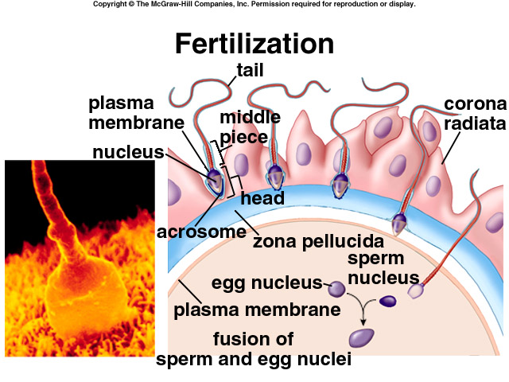The sperm head transform into a male pronucleus  
- Similarly the egg must complete its meiotic division II to form the haploid female pronucleus and second polar body.  
- Fertilization ends with successful fusion of the male and female pronuclei resulting in a single cell called a Zygote.  
- Soon after, anaphase and telophase are completed, and the one cell Zygote becomes a two-cell embryo.

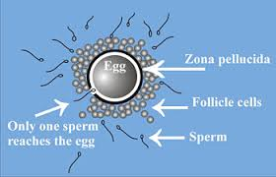**The follicle:-**-having passed the first meiotic division, at birth, the primary oocyte is found arrested at metaphase of second meiotic division until puberty.  
-Meiosis in not resumed until after the luteinizing hormone (LH) surge.  
-Completion of first meiotic division results in extrusion and release of the first polar body.  
-The oocyte now described as an ovum, has acquired the competence to be fertilized.

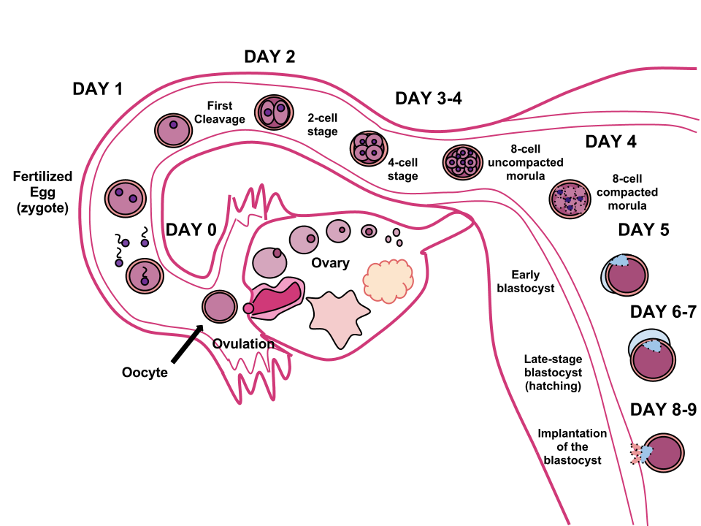

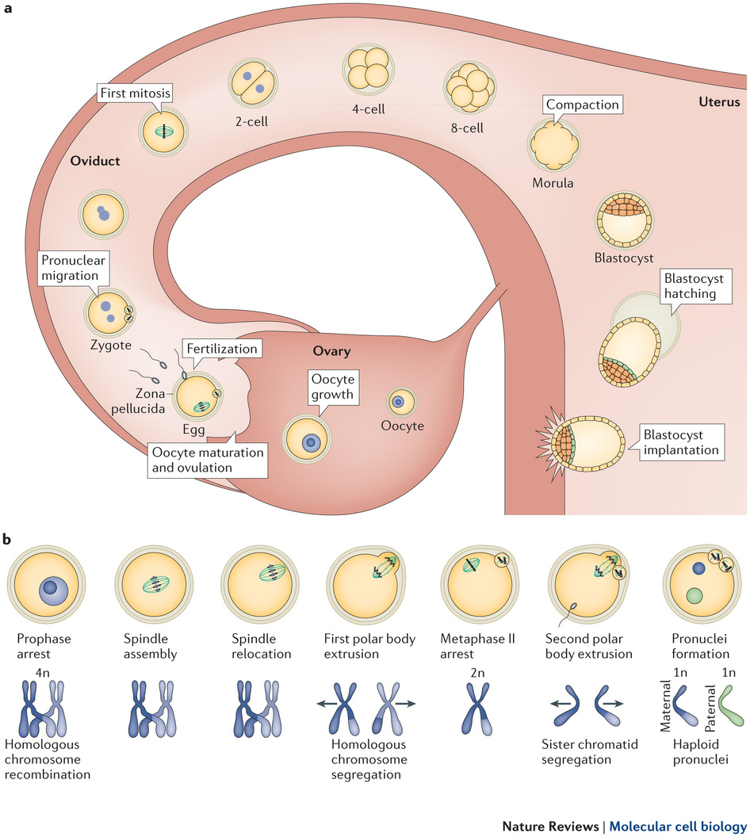

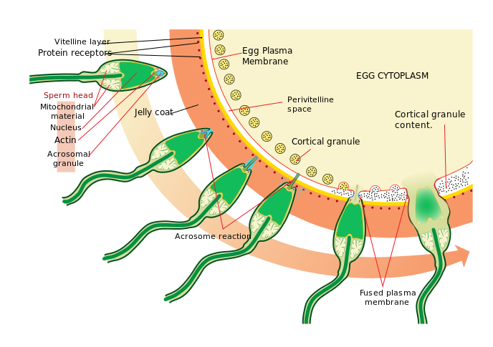**Implantation:-**As soon as the Zygote is formed, it begins dividing very rapidly and within 5 days a tiny mass of cells, the blastocyst is formed.  
- The embryo has to escape from the Zona pellucida and the outer covering of the egg and then begin to burrow into the decidua.  
- The embryo remains in the fallopian tube for 3-4 days until it reaches the morula stage (8-32 cell stage), the embryo proceeds through the isthmus to the uterine cavity where it will float freely for 72 hrs.

- By the sixth days, begins to penetrate decidua by piercing its basement membrane   
- Secretion of human chorionic gonadotropin by the trophoblastic cell leading to the maternal recognition of pregnancy.

- Twelve Days after fertilization, the embryo is embedded within the decidual stroma, the trophoblastic having already differentiated into cyto-trophoblastic and invasive syncytio-trophoblast.  
- By 14-21 days, the trophoblastic structure at the periphery of the embryo resembles the villi of the mature placenta as the inner cell mass has begun to undergo embryogenesis.

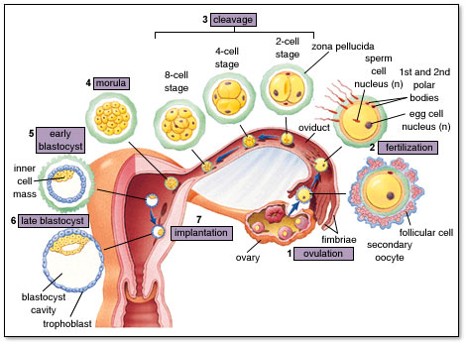**Fetal Development:-**

* During this wk the embryonic disk folds into an embryonic cylinder within which is a cranio-cuadal, blind-ending tube which has three segments, the foregut, the mid-gut opened to the developing yolk sac and the hindgut, this stage mark the start of organogenesis.
* The first organ to become apparent is the primitive heart in the shape of a forward buckling loop. Cardiac activity is evident by day 22 past fertilization.
* Neural plate becomes a deep groove on the dorsal aspect of the embryo, it sinks deeper and the opposing crest fuse, generating the neural tube.
* The cephalic neuropore closes during day26 and the caudal neuropore at the end of the 4th wk.

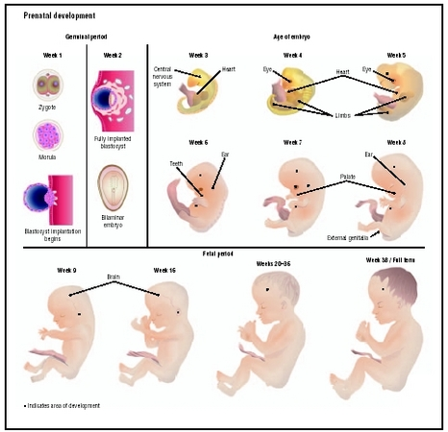

* 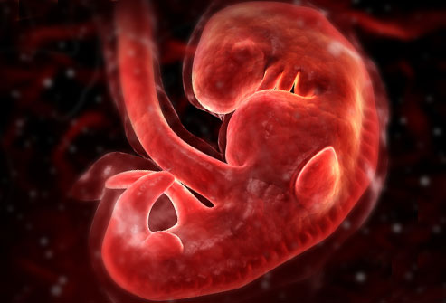Towards the end of the 4th wk., the foregut septates along the midline into the respiratory and digestive primitive elements.
* The lower respiratory system appears as septation of the foregut. Two lung buds are evident at the end of the4th wk.
* By the day26the mesonephric duct andmesonephros differentiate.
* At 28 day the ureteric buds and the metaphors are defined structures
* By the end of the 4th wk., almost all organ systems immature, but can be readily identified.
* In the cephalic pole of the embryo, five pharyngeal arches appear in succession. Towards the end of the 4th wk., the buccopharyngeal membrane perforates.
* Towards the end of the 4th the body of the embryo is attached to the yolk sac by a broad Vitelline duct and two connecting Vitelline bld vessels.
* Changes in the external appearance
* The head starts to grow faster than the rest of the body and is bent forward until the end of the 7th wk.
* The face is formed by a series of transformations of the pharyngeal arches.
* The eyes are in a lateral position and after the34th wk. they appear pigmented.
* The eyelids develop after the 6th wk. and by the end of the the8 the wk. the eyes are closed by the eyelids, which fuse with one another. The eyelids will separate after the20th wk.
* The ears differentiate at either side of the neck, early during the 5th wk.
* The nose is present early during the 6th wk. and the nostrils will be plugged with keratin until after the 20th wk.
* The mouth can be recognized after 6th wk. the palatal shelves will only fuse during the 8th wk.
* The upper limb buds appear at about the 27th day
* Early during the 6th wk. the hand plate presents lobulations which anticipate digit differentiation.
* By the end of 8th, both the upper and lower limbs are fully differentiated, the head is slightly up right and the embryo has a distinct human appearance.