|  |  |  |
| --- | --- | --- |
| **Fifth stage** | **ENT** | **Lec-1** |
| **د.سعد** | **4/10/2015** |

**The Nose**

**Embryology:**

The nose develops from a number of mesenchymal processes around the primitive mouth .The nasal cavity is first recognizable in the 4th week of intrauterine life as an ectodermal thickening called olfactory or nasal placode. Any interruption to pregnancy at this time (4th week) will lead to congenital anomaly of the nose.

**Anatomy:**

**The external nose** (fig.1&2)is supported by bone and cartilage. The bony part is formed mainly by the nasal bones on each side, and the frontal process of the maxillary bone. The cartilaginous portion is formed by several cartilages which support and give shape to the lower part of the nose and nasal tip. Attached to the cartilages are the muscles for dilating the nares.

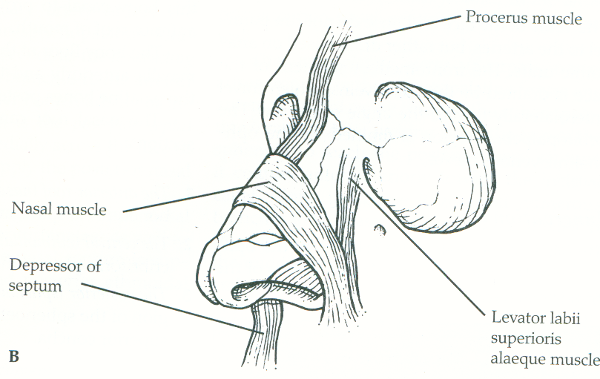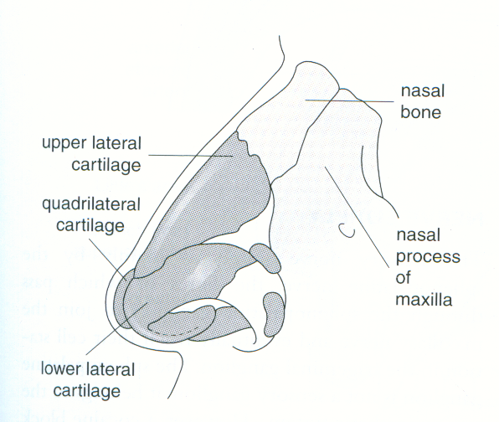

Fig.1 Fig.2

**The vestibule** (fig.4) is the dilated passageway leading from the external nares into nasal cavity and is lined by skin bearing coarse hear (vibrissae), sebaceous glands and sweat glands.

**The nasal cavity** is lined by mucus membrane (ciliated columnar epithelium ) and divided by the nasal septum into two parts which have similar anatomical structure but may be asymmetrical.

**The septum (**fig.3) Is the midline partition of the nasal cavity. It is formed by:

Anteriorly → quadrilateral cartilage.

Posterosuperiorly → perpendicular plate of ethmoid.

Posteroinferiorly → vomer.

The septum is covered with perichondrium where there is cartilage, with periostium where there is bone, and superficially with mucus membrane.

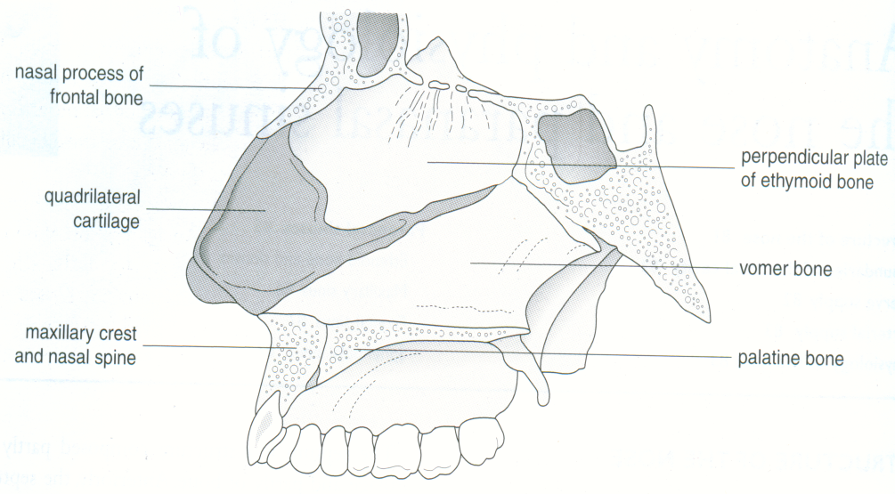

Fig.3

On the **lateral wall** (Fig.4) there is a system of ridges known as the turbinates (chonchae), each of which overhangs a groove known as a meatus .There are three turbinates: inferior, middle and superior. The inferior turbinate forms a bone by itself, attached to the lateral wall of the nose. The middle and superior turbinates are part of the ethmoid bone .The turbinates are covered with mucous membrane (columnar ciliated epithelium). Underlying the mucous membrane there is erectile tissue.

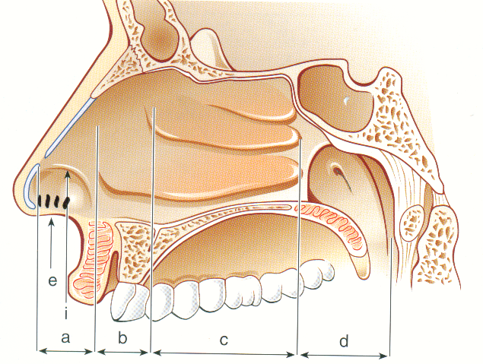

Fig.4

In the inferior meatus, the nasolacrimal duct is opened and trauma to the inferior turbinate may affect this duct (Fig5) .

(Fig5) 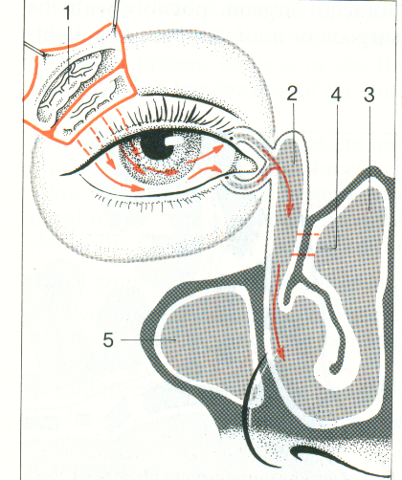

Inferior meatus

Nasolacrimal duct

Lacrimal gland

Most of paranasal sinuses opened into the middle meatus (maxillary, anterior ethmoid and frontal sinuses)(Fig6 &7). Therefore evaluation of the middle meatus and its surrounding is considered the most important step during nasoendoscopy and this entire area is called osteo-meatal complex and pathology in this region is indicative of underlying sinus disease (Fig.7). The posterior ethmoid sinus opens into the superior meatus and the sphenoid into the sphenoethmoidal recess.

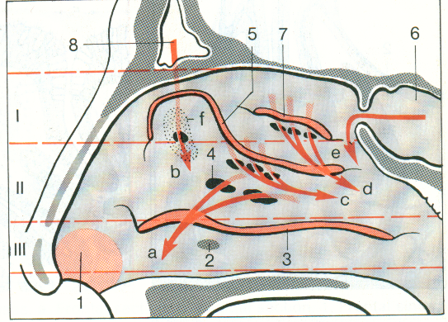 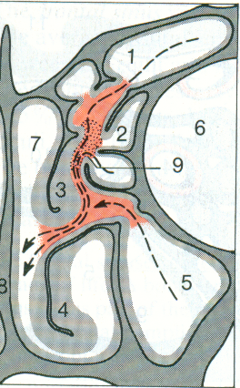

Sphenoid Sinus

Frontal sinus

Osteo-meatal complex

Frontal s.

Maxillary S.

Orbit

Fig.6 Fig.7

**The floor** isformed by the hard palate and the **roof** is formed by the nasal bones, cribriform plate and the body of sphenoid (Fig.4).

**Posteriorly,** the nasal cavity is connected to the nasopharynx through two apertures lying on both sides of the posterior end of the septum, known as posterior choanae. The nasopharynx is connected to the middle ear via Eustachian tube; therefore, rhinosinusitis may be a cause of otitis media (Fig.4) .

**Nerve supply**:

The **sensory** nerve supply is from trigeminal nerve mainly by the sphenopalatine nerve (maxillary division) and anterior ethmoid nerve (ophthalmic division). **Secretory** nerve supply comes through Vidian nerve (nerve of pterygoid canal) which is formed by the junction of the greater petrosal nerve, a branch of the facial nerve (parasympathetic) and the deep petrosal nerve (sympathetic) derived from the sympathetic plexus on the internal carotid artery .

The **olfactory** nerves enter the nose through the cribriform plate in the roof.

- Greater petrosal nerve (parasymp.) → Dilates blood vessels + enhance gland secretion.

- Deep petrosal nerve (symp.) → constricts blood vessels.

**Arterial supply:** ( Fig.8)

The nose is supplied by branches from the int.&ext. carotid arteries which anastomose freely in the nose .An aggregation of poorly supported vessels on the anterior part of the septum just behind the skin margin is known as **Little`s area** (Kiesselbach`s plexus).This area is a common site of epistaxis and is formed by anastomoses of anterior ethmoid artery, superior labial artery, sphenopalatine artery and greater palatine artery.

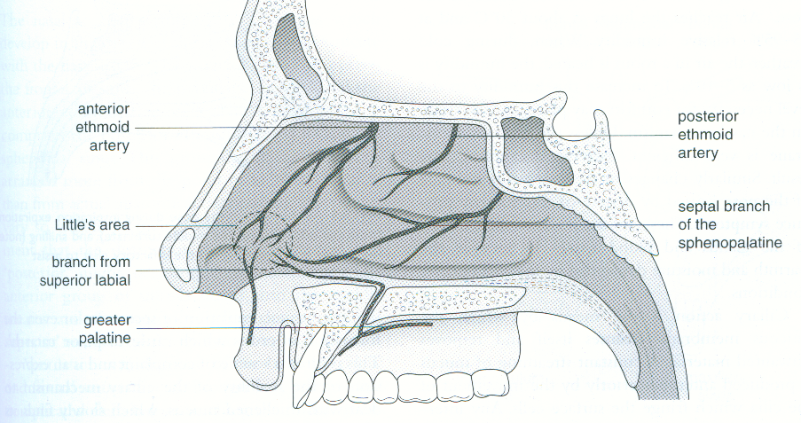

( Fig.8)

Venous Drainage; Facial + ophthalmic vein → cavernous sinus.

The lymphatic vessels drain posteriorly to the superior deep cervical group.

**Physiology of the nose:**

The chief functions of the nose are:

1) Olfaction.

2) Filtration.

3) Humidification.

There are other functions, such as vocal resonance, self-cleansing and the provision of moisture for the protection of mucous membrane.

**Paranasal sinuses:**

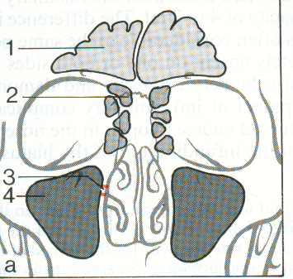 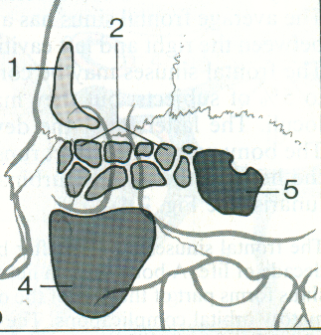

Fig.9 (a) Ant. view Fig.9 (b)Lat..view

These are air spaces which develop in the bones of the skull and communicate with the nasal cavity. They are arranged in pairs and are functionally divided into anterior and posterior groups. All the anterior group – frontal anterior ethmoid and maxillary – drain into the middle meatus. The posterior ethmoid cells drain into the superior meatus and the sphenoid into the sphenoethmoid recess.

**The maxillary sinus: (The antrum)**

This sinus is pyramidal in shape. It is the largest sinus (average size 15 ml in adult). Its roof is the floor of the orbit and its floor is related to the tooth roots, particularly those of the second premolar and first molar, which may project into the sinus and may be covered only by a thin plate of bone, therefore maxillary sinusitis may be due to apical tooth abscess. Extraction of such poorly covered tooth can result in oroantral fistula. Its medial boundary (the base) forms the lateral nasal wall. The ostium of the sinus is sited high in the medial wall (1 cm) and hence drainage is dependent on ciliary action and not gravity.

**The frontal sinus:**

The sinus is not present at birth but appear at the age of 5 years. The sinus is frontal in location but ethmoidal in origin. The frontal sinuses are rarely symmetrical and they are separated by a thin bone. The roof of the orbit forms the floor of the frontal sinus.

**The ethmoid sinus (the ethmoid air cells):**

The ethmoidal sinuses are multiple air cells (7-15)in number and dividedinto anterior and posterior groups which drain respectively below and above the middle turbinate. They are separated from the orbit by a thin plate of bone known as lamina papyracea.

**The saphenoidal sinus:**

This sinus occupies the body of the sphenoid bone and drains into the sphenoethmoidal recess. The pituitary gland is located on its roof whereas the lateral wall is in contact with the cavernous sinus. The Vidian nerve passes below this sinus.

**Function of paranasal sinuses:**

The physiological role of paranasal sinuses is uncertain. They are a continuation of the respiratory cavity and covered by respiratory mucosa. They may have the following functions;

1. Decrease the weight of the skull.
2. Warming and moistening of the air.
3. Add resonance to the laryngeal voice.
4. Temperature buffer.

Symptoms of Nasal Diseases

1. **Nasal obstruction:**
   1. Anatomical abnormality: Congenital choanal atresia or deviated nasal septum.
   2. Abnormality of the mucous membrane: Nasal polyposis or turbinate hypertrophy.
   3. Abnormalities of autonomic control of the mucosa: Vasomotor rhinitis.

**II. Nasal Discharge:**

1. Watery clear discharge: Onset of common cold, allergic rhinitis or CSF rhinorrhea.
2. Mucopurulent:

-Yellow pus: Sinusitis.

-Unilateral foul discharge in a child: FB in the nose.

-Crusts in adults: Atrophic rhinitis.

1. Thick blood stained discharge: Tumour.
2. Postnasal mucopurulent discharge: Disease of the posterior group of sinuses.

**III. Sneezing**: Allergic rhinitis or common cold.

**IV. Pain:**

1. Severe local pain: Folliculitis.
2. Early morning headache: Sinusitis.

**V. Epistaxis**.

**VI**. **Disturbance of smell**

--------------------------------------------------

Inflammatory conditions of the nose

1. **Inflammations confined mainly to the external nose** ;
2. Common skin disease ; e.g. Impetigo , Acne and Lupus Erythematosus.
3. Others which are particularly important in the nasal area ;e.g. nasal eczema vestibulitis, furunculosis, Herpes simplex and Herpes zoster, rhinophyma …etc.

**(2) Inflammations mainly confined to the nasal cavity :**

(A)Allergic rhinitis.

(B) Viral rhinitis (coryza).

(C) Non-Allergic rhinitis (intrinsic or vasomotor rhinitis).

(D) Atrophic rhinitis.

**FURUNCULOSIS:**

(Furuncle =boil) It is an acute infection of a hair follicle with staphylococcus aureus. The hair bearing area of the nasal vestibule is a vulnerable site due to the strong hairs and mechanical trauma to this area. It starts as a hard tender red nodule which enlarges and becomes more painful and fluctuant. The majority discharge into the nasal vestibule and resolves. A serious (although rare) complication is the spread of the infection through the valveless superior ophthalmic veins to the cavernous sinus leading to **cavernous sinus thrombosis** which characterized by severe illness with fever, prostration and convulsion. Local changes include oedema with cyanosis of the eyelids and base of the nose and chemosis due to obstruction of the ophthalmic vein. Ophthalmoplegia and papillary changes (dilated or small immobile) are common. Retinal haemorrhage and papilloedema are late events.

**TREATMENT:**

* 1. Avoid squeezing the nose.
  2. Systemic antibiotic (against staphylococcus aureus like ampiclox or lincomycin).
  3. Analgesic.
  4. Soothing ointment.

**VESTIBULITIS:**

Is inflammation of the vestibule with recurrent crusting and pain, usually due to infection with staphylococcus aureus .It may also be caused by an irritant dermatitis- like reaction due to watery rhinorrhoea (e.g. in acute coryza and allergic rhinitis). Unilateral vestibulitis in a child or mentally impaired person should raise suspicion of a foreign body. Offensive discharge is a further strong evidence.

TREATMENT:

1) Management of underlying predisposing factors (e.g. by giving antihistamine in rhinorrhoea caused by allergy or viral infection and by removal of foreign body )

2) Mild topical (corticosteroid + antibiotic) ointment.