|  |  |  |
| --- | --- | --- |
| **Fifth stage** | **Medicine** | **Lec-** |
| **د.خالد نافع** | **24/11/2015** |

**CHRONIC LYMPHOCYTIC LEUKAEMIA**

**CLL**

* CLL is the most common leukemia in Westren countries, accounting for one-third of cases.
* The disease is rare in Asians; 90% of patients are older than 50, median age at presentation is between 65 and 70 years
* Men are affected more often than women by a ratio of 2:1.

**PATHOOGY AND NATURAL HISTORY**

* *PATHOLOGY*;
* CLL RESULTS FROM SUPPRESION OF PROGRAMMED CELL DEATH(APOPTOSIS) OF MATURE B CELL.
* SURFACE MEMBRANE ANTIGENS INCLUDE THE B CELL ANTIGENS *CD 19, CD 20, CD23 . CD5 IS ALWAYS PRESENT ON CLL CELLS.*
* *CD38 HAS BEEN ASSOCIATED WITH UNFAVORABLE PROGNOSIS*

**NATURAL HISTORY**

**1. Immunological abnrmalities;**

* a. Advanced disease is associated with hypogammaglobulinemia and decreased humoral respnses to antigens.
* b. Avariety of in vitro lymphocyte function test are abnormal.
* c. Coomb`s postive warm antibody hemolytic anemia occurs in 10% & immune thrombocytopenia in about 5%.

**2. Clinical course**

* \**Survival is closely correlated with the stage of disease at time of diagnosis.*
* \**Because most of patients are elderly at time of diagnosis ; more than 30% die of diseases untrelated to leukemia.*

**A. Manifestation**. In 70% of patients CLL is first recognized at routine physical exam.or by routine CBC.

* Clinical manifestation develop as the leukemic cell acumalate on lymph nodes ,liver ,spleen & bone marrow .
* Presenting problems may be anaemia, infections,painless lymphadenopathy, and systemic symptoms such as night sweats or weight loss. However, these more often occur later in the course of the disease.
* Transformation in to a diffuse large B-cell lymphoma(Richter`s syndrome) or ***prolymphocytic leukemia*** occurs in less than 5% of patients.

**B. *progressive disease***

*Death is usually due to infection , bleeding or other complicatin of the disease.

1.HERPES ZOSTER is the cause of 10% infection in CLL.

2.Bacterial pathogens associated with

hypogammoglobuliemia include *Streptococus pneumoniae*

*,Staphylococcus auerus and Hemophilus influenzae .*

*3.Pneumocystis jirovecii*

***Laboratory studies***

*1. Hemogram*

*a.Erythrcytes; anemia may be caused by*

*1.bone marrow infiltration.*

*2.hypersplenism*

*3.autoimmune hemolysis*

*b. Lymphocytes; the absolute count ranges from;*

*10x109/l - 200x109/l but may exceed 500x109/l.*

*\*When blod smears are made , the cells are easily ruptured , producing typical “basket” or “smudge” cells.*

* *c . Granulocyte; absolute counts are normal or increased until late in the disease.*
* *d .Platelets; thrombocytopenia may prodused by bone marrow infiltration , hypersplenism, immune thrombocytopenia*

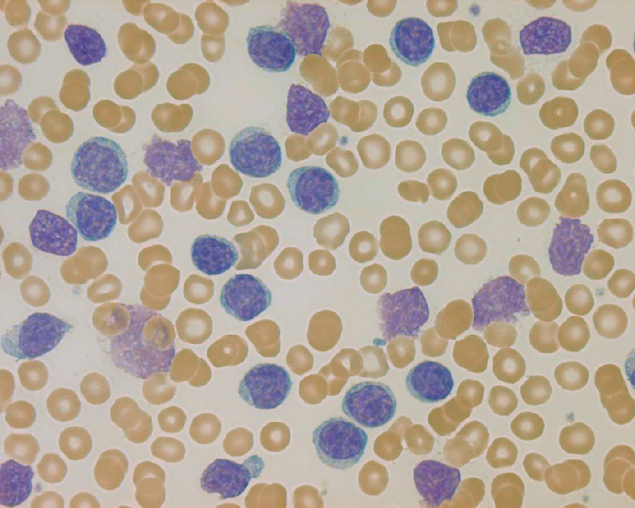

**lymphocytes**

**‘smudge’ cells**

**CHRONIC LYMPHOCYTIC LEUKEMIA**

**\*DIAGNOSIS**

* 1. Lymphocytes ( x109/L) > 5;
* > 1 B-cell marker (CD 19, CD20 , CD 23) + CD5
* 2. Atypical cells (prolymphocyte) (%) < 55
* 3. Bone marrow lymphocytes ( %) >30

***Binet Staging System***

**\*Area of involvement considered for staging.**

* 1. Head & neck , including the Waldeyer ring ( this counts as one area even if more than one group of nodes are enlarged )
* 2. Axillae ( involvement of both axillae count as one area)
* 3. Groins, including superficial femorals counts as one area.

***Binet Staging System***

* ***Stage A.*** Hb > 100 g /L & platelets > 100 x109/L & up to two of the above lymph node involved.
* ***Stage B.*** Hb > 100 g / L & platelets > 100 x109 / L & three or more areas of nodal or organ enlargement.
* ***Stage C.*** All patients , irrespective of organomegaly in whom Hb < 100 g / L & or platelets < 100 x 109 / L.

**Indications for Therapy in B cell- CLL**

* Anemia
* Thrombocytopenia
* Disease- related symptoms
* Markedly enlarged or painful spleen
* symptomatic lymphadenopathy
* Blood lymphocyte count doubling time < 6 months
* Prolymphocytic transformation
* Richter`s transformation

**RESPONSE CRITERIA**

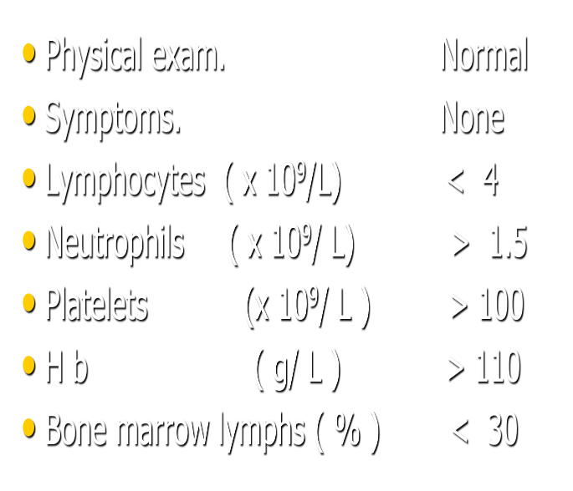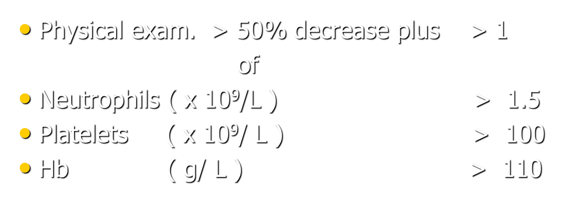

**Complete remission(CR)**

**PARTIAL REMISSION(PR)**

**TREATMENT**

* 1-WATCH AND WAIT
* 2-GLUCOCORTICOIDS  
  3-ALKYLATING AGENTS
* Chlorambcil (leukeran); alkylating agents.*Daily oral dose or Intermittently total oral dose every 2-4 weeks
* CYCLOPHOSPHAMIDE
* 4-FLUDARABINE; Inhibit adenosine deaminase IV infusion 25- 30 mg/ m² daily for 5 days repeated 5-6 times every 3 - 4 weeks.
* 5- Anti-CD20 Rituximab.
* Rituximab+Fludarabine+cyclophosphamide

**\*\*Prolymphocytic leukaemia**

**\*\*Hairy cell leukaemia**