Lec 6 **اساسيات الطب** first stage

د.هيثم بدر medical terminology 18/1/2016

**Main Objective:  
Learn Medical Terminology**

Even to a native English speakers, new medical students often bewildered by strange medical Terms, its spelling and pronunciation

**Why ?**  
Approximately 75% of Medical Terms are based on either Greek or Latin

**Origins of medical language**

Current medical vocabulary includes terms **built from Greek and Latin word parts**, some which were used by Hippocrates and Aristotle over 2000 years ago.

Use proper medical terminology to communicate with other health care professinolas

Example of medical term you may hear from your collogue

What???????

Don’t be shocked. The subjects is simpler than what you think !!!!!. You need to learn the principles of building and analyzing medical term.

Why we use strange terms?

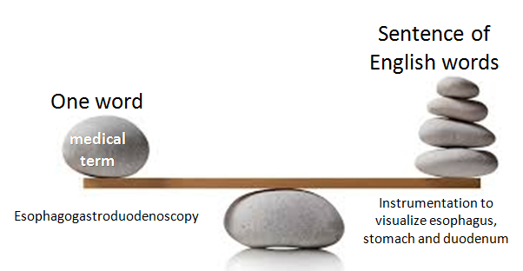

**Objectives of the course**

Upon completion of this unit you will be able to:

🗹Identify and define the four component of medical terms

🗹 Analyze and define medical terms

🗹 Build medical terms for given definitions

**Word Parts / Building Blocks of medical term**

Medical terms are built from word parts with some or all of the following components:

1. Word roots

2. Suffixes

3. Prefixes

4. Combining vowels

5.comining forms

**How to Define Medical Terms**

|  |  |
| --- | --- |
| https://i.ytimg.com/vi/B3j2ODcSerI/hqdefault.jpg |  |

Terms can easily be defined by determining the meaning of their parts.

Read left to right, but define by interpreting the suffix, then the prefix, then the combining form.

e.g. Define ***heminephrectomy***?

**prefix Root suffix**

hemi- neph -ectomy

(Half) (Kidney) (Removal)

Then ***heminephrectomy*** means Remove half of kidney

**Word root**

The word root is the central and foundation of the medical term Usually indicates the part of the body involved All medical terms must have one or more word roots

|  |  |
| --- | --- |
| http://anneborrellgraphicdesign.com/wp-content/themes/anniesTheme/images/rootsTree.png |  |

**combining vowel**

* Usually an ‘o’ and occasionally an ‘I’
* Has no meaning of its own
* Makes pronunciation easier
* Can be found between word roots
* Can be found between word roots and a suffix

When a vowel is added to a root word, it is called a combining form

**Examples of combining form according to systems**

1. **Combining form for Body Systems Cardiovascular**

* angi/o vessel
* aorto/o aorta
* arteri/o artery
* cardi/o heart
* coron/o heart
* phleb/o vein
* ven/o vein

**2- Combining form for Body Systems Digestive**

* an/o anus
* append/o appendix
* cholecyst/o gallbladder
* col/o colon
* duoden/o duodenum
* esophag/o esophagus
* gastr/o stomach
* hepat/o liver
* ile/o ileum
* jejun/o jejunum
* or/o mouth
* pancreat/o pancreas
* pharyng/o pharynx
* proct/o aus and rectum
* rect/o rectum
* sigmoid/o sigmoid
* stomat/o mouth

**3- Combining form for Body Systems Endocrine**

* adren/o adrenal
* hypophys/o pituitary
* oophor/o ovary
* ovari/o ovarian
* orchi/o testis
* pancreat/o pancreas
* parathyroid/o parathyroid
* pituitar/o pituitary
* thym/o thymus
* thyroid/o thyroid

**4- Combining form for Body Systems Reproductive**

* cervic/o cervix
* vagin/o vagina
* hyster/o uterus
* mamm/o breast
* uter/o uterine
* oophor/o ovary
* salping/o fallopian tube
* balan/o penis
* orch/o testis
* prostat/o prostate
* scrot/o scrotum

**5- Combining form for Body Systems Skeletal**

* arthr/o joint
* chondr/o cartilage
* cost/o rib
* crani/o skull
* ligament/o ligament
* my/o muscle
* muscul/o muscle
* myel/o bone marrow
* oste/o bone
* pelv/o pelvis
* vertebr/o vertebra

**6- Combining form for Body Systems Respiratory**

* alveol/o alveolar
* bronch/o bronchial tube
* cyan/o blue
* laryng/o larynx
* nas/o nose
* rhin/o nose
* pharyng/o pharynx
* phren/o diaphragm
* pneumon/o lung
* tonsill/o tonsils
* trache/o trachea

**7- Combining form for Body Systems Urinary**

* cyst/o urinary bladder
* nephr/o kidney
* ren/o renal
* pyl/o renal pelvis
* ureter/o ureter
* urethr/o urethra

**8- Combining form for Body Systems Nervous**

* cerebell/o cerebellum
* cerebr/o cerebrum
* encephal/o brain
* medull/o medulla
* myel/o spinal cord
* neur/o nerve

**9- Combining form for Body Systems Miscellaneous**

* aur/o ear
* ot/o ear
* cutane/o skin
* derm/o skin
* myring/o eardrum
* ocul/o eye
* onych/o nail
* ophthalm/o eye
* pil/o hair
* retin/o retina
* trich/o hair
* ungu/o nail

**Prefixes**

Syllable located at the beginning of a word Changes the meaning of the word Usually indicates a number, time, position, direction, color, size etc. or sense of negation

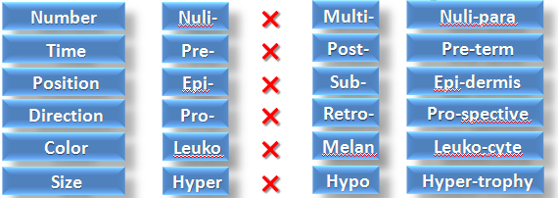

*Numerical prefixes*

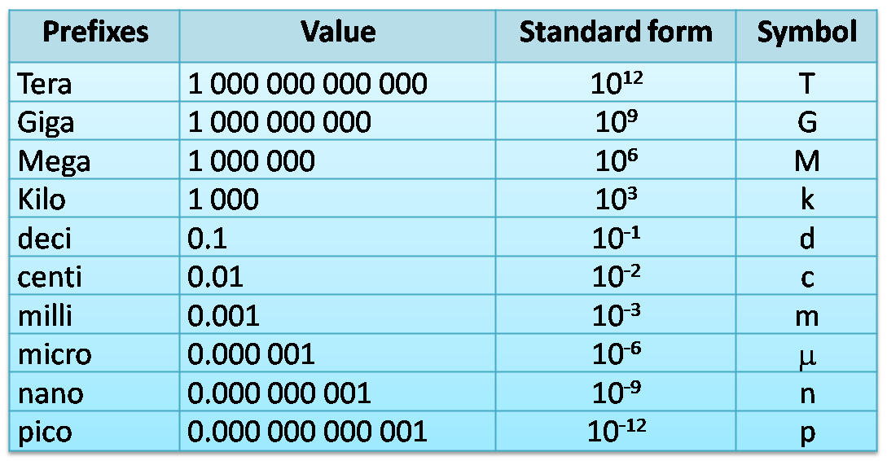

*Color prefixes*

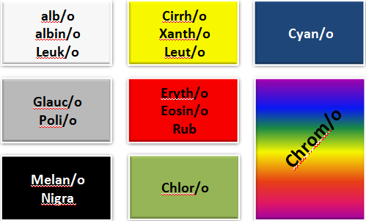

*Prefixes of position*

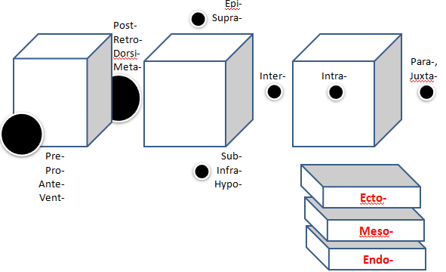

*Prefixes of direction*

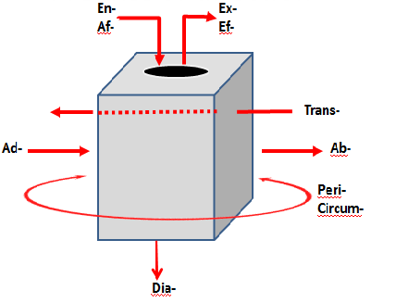

*Prefixes of direction*

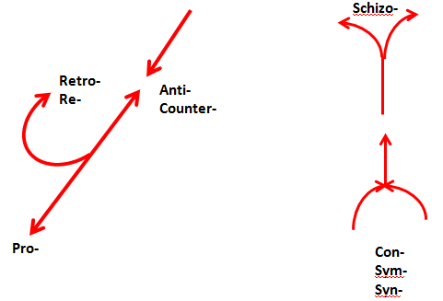

*Miscellaneous prefixes*

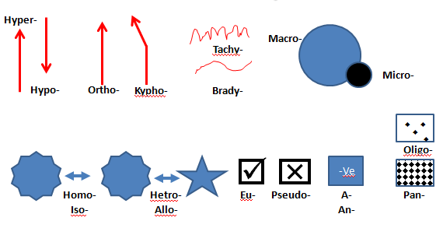

***Suffixes***

🔾 Suffix is the word part attached to the end of the word root to modify its meaning.

🔾 The suffix usually indicates the surgical procedure, diagnosis & pathology.

🔾 All medical terms must have a suffix.

*Surgical suffixes*

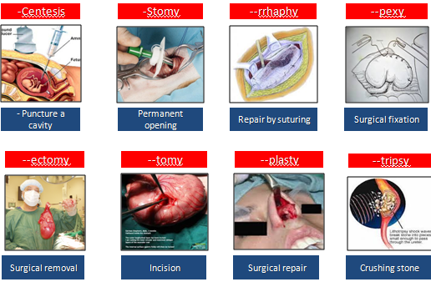

*Diagnostic suffixes*

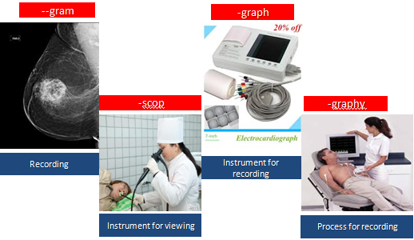

*Pathology- related suffixes*

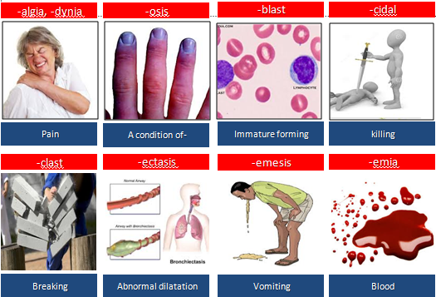

Pluralizing medical term

If singular form of term end in **------** , the plural is usually formed by changing to

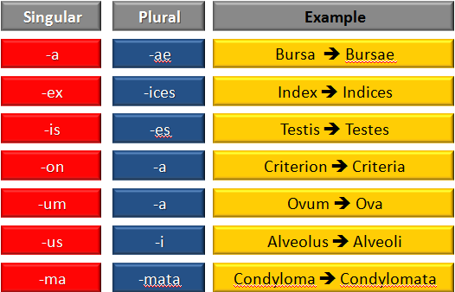

**Suffixes**

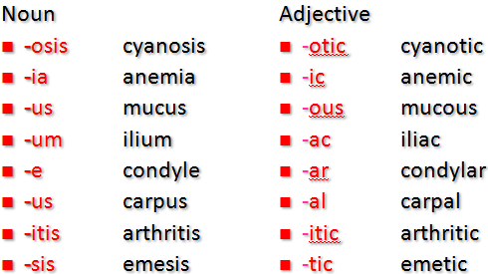

**Suffix – Noun**

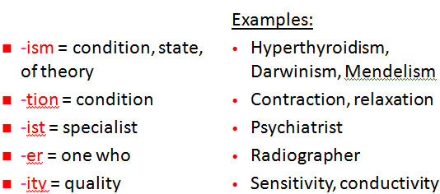

**Suffixes – Adjective**

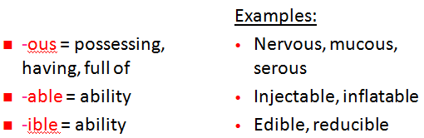

*edited by****:-*** *Abdulla mahmod*