16/4/2016 د. تيماء الغلامي
Electricity Within the Body
Electricity plays an important role in medicine .There are two aspects of electricity and magnetism in medicine :
1.electrical and magnetic effects generated inside the body ,
2.applications of electricity and magnetism to the surface of the body.
The electricity generated inside the body serves for the control and operation of the nerves , muscles ,and organs .The forces of muscles are caused by the attraction and repulsion of electrical charges. The action of the brain is basically electrical. All nerve signals to and from the brain involve the flow of electrical current.

Membrane potential:

When inside the cell being negative with respect to outside

Action potential
When inside the cell being positive with respect to outside the cell .

potential waveform 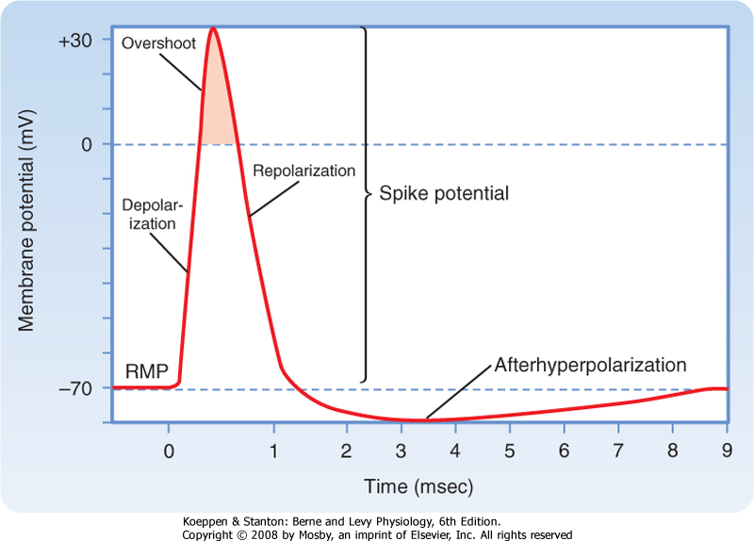

Electrical Signals from Muscle

One means of obtaining diagnostic information about muscles is to measure their electrical activity. The transition of the action potential from the axon into the muscle causes muscle contraction .

Electromyography
Electromyography is a technique of recording electric activity produced by the muscles at rest and during contraction ,figure 1.This technique is used for investigation of various neurological conditions and determinate the site and duration of action potential of muscle
relaxants .

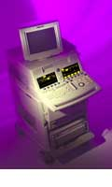

Figure(1a : Electromyography technique.

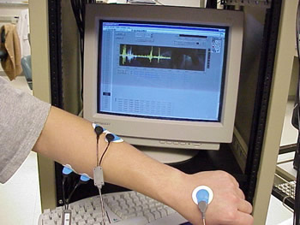

Figure(1b : Electromyography technique.

Muscle action potential picked up by electrodes placed near the surface of interest . There are different types of electrodes surface , needle and disc electrodes , as shown in figure 2 .
[
EMG signal can be recorded by applying stimuli to ulnar nerve with surface electrodes and observing the contraction of muscles, as shown in figure 3.One nerve supply 100–300 muscle fibers which make up a motor unit ; so when a nerve is stimulated a large of muscle fibers are
activated , figure 3 .
Figure 3 :Instrument arrangement for obtaining an EMG during
electrical stimulation of a motor unit .
EMG electrodes record the electrical activity from several fibers . So single muscle cell are usually not monitored in an EMG examination because it is difficult to isolate a single fiber.
To record the action potential of a single muscle cell a very tiny electrode ( microelectrode ) is used which inserted in the muscle membrane . the reference electrode is immersed in the fluid surrounding the cell (figure 4 ) .
Figure 4 : Instrument arrangement for measuring the action
potential in a single muscle cell .

The amplitude of the response from a motor unit varies between 100µ V and 1.5 mV , depending on the size of the unit and the position of the electrodes .The response from single muscle fiber is last about 1 ms while the response from motor unit is more complex has a duration of 6 – 12 m sec (figure 5 ).
If there is a disease in muscle the amplitude of the signal decreased and there is a cut off in signal .
figure 5 : (a) minimal contraction showing the action potential
from a single motor unit .(b )maximal contraction
showing the action potential from many motor units .

EMG signals are small in amplitude and can be amplified by an amplifier .
The electrodes being the input of the amplifier(figure 6) , and the output of amplifier is connected to different monitoring:
1 . oscilloscope to visual the signal and display it .
2 . audio speaker to allow acoustic monitoring of the potentials .
3 . recorder to record the signal and storage .

An EMG obtained during electrical stimulation of a motor unit is shown in figure 3 .the action potential appear in the EMG after a latency period ,figure 7 .

Latency: is defined as the time between the stimulation and beginning response .
figure 7 : electrical stimulation of the sensory and motor nerves .

Nerve conduction velocity

The velocity of the action potential in motor nerves can be determined using EMG machine .stimuli are applied at two locations , and the latency period for each response is measured , as shown in figure 8.

The difference between the two latency periods is the time required for the action potential to travel the distance between them ; the velocity of the action potential is this distance divided by this time .

Typical velocities are 40 to 60 m /sec ;
a velocity below 10 m /sec would indicate a problem .

Nerve conduction= Distance between two stimuli
velocity Latency 1 - latency 2

The conduction velocity for sensory nerves can be measured by stimulating at one site and recording at several locations that are known distances from the point of stimulation , as shown in figure 9 .

Many times nerve damage results in a decreased conduction velocity .

Electrical signals from the heart
The rhythmical action of the heart is controlled by an electrical signal initiated by spontaneous stimulation of special muscle cells located in the right atrium .These cells make up the senatorial (SA) node , or pacemaker (figure 1) .
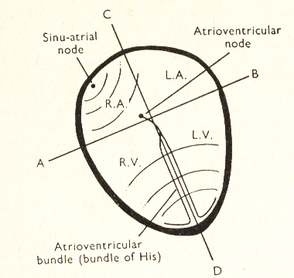
Figure 1 :The spread of cardiac impulse .
The SA node fires at regular intervals at regular intervals. The electrical signal from the SA node initiates the depolarization of the nerves and muscles of both atria causing the atria to contract and pump blood into the ventricles. Re -polarization of the atria follows .The electrical signal then passes into the atrioventricullar node ( AV ) node , which initiates the depolarization of the right and left ventricles , causing them to contract and force blood into the pulmonary and general circulation's .The ventricle nerves and muscles then repolarize and the sequence begins again . The nerves and muscles of the heart can be regarded as sources of electricity enclosed in an electrical conductor . The nerves and muscles of the heart can be regarded as sources of electricity enclosed in an electrical conductor . The potentials produced by the heart spread to the surface of the body and detected by the electrodes . The potential lines is similar to the lines from an electric dipole ( figure 2 ) .
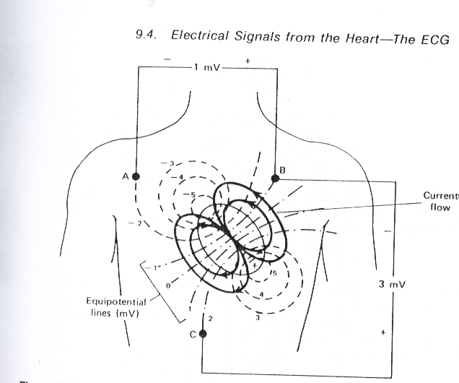
Figure 2 The potential distribution on the chest at the moment when the ventricles are one half depolarized .

Electrodes located at A, B, and C would indicate the potentials at that moment. An electric dipole is produced when equal positive and negative charges are separated from each other . It can be represented by a vector . The electrical (cardiac ) potential that we measure on the surfaces of the body is merely the instantaneous projection of the electric dipole vector in a particular direction .As the vector changes with time , so does the projected potential .

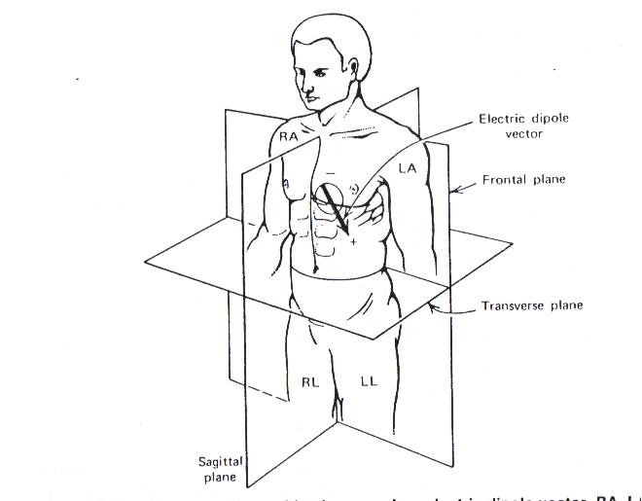

figure 3:electrocardiographic planes and dipole vector. RA, LA, RL,and LL indicate electrode locations on the right and left arms and legs.
The wave form of ECG is some time positive and in other
cases it is negative . The sign of the waveform depends upon
the direction of the electric dipole vector and the polarity and position of the electrodes.
Electrocardiograph (ECG)
The potentials produced by the heart spread to the surface of the body and detected by electrodes placed there.
The process of recording these potentials is known as ECG . The potentials are small so that they require to be electrically amplified before they are recorded (figure 4) .
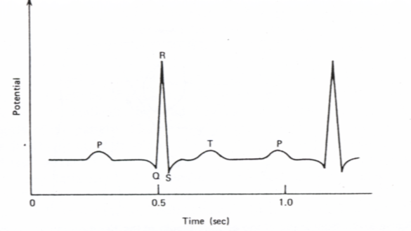 Figure 4: Typical ECG . P represents the atrial depolarization and contraction. The QRS complex
indicates the ventricular depolarization.
The ventricular contraction between S and T.
T- represents the ventricular repolarization.

ECG Recording
In order to make a recording , two input connections must be made to the amplifier and there is usually a switch on the ECG apparatus which makes the appropriate connections internally when a particular lead is chosen .

To record the standard limb leads
1.Biopolar: Electrodes are applied to the left arm , right arm and left leg(figure 5,and figure 6).
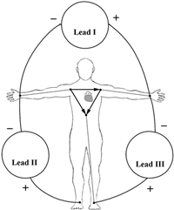
Figure 5 :The position of lead I , lead II, and Lead II .
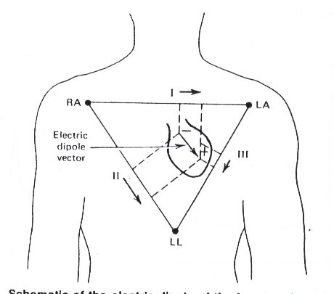
Figure 6:Schematic of the electric dipole of the heart projected on the frontal plane.
For electrical purposes the three electrodes (RA,LA, and LL) can be thought of as the points of a triangle ,the Einthoven triangle . The potential in lead I at any moment is proportional to the projection of the dipole vector on the line RA –LA ; the potentials in Leads II and Lead III are proportional to the projections on the other sides of the triangle.
.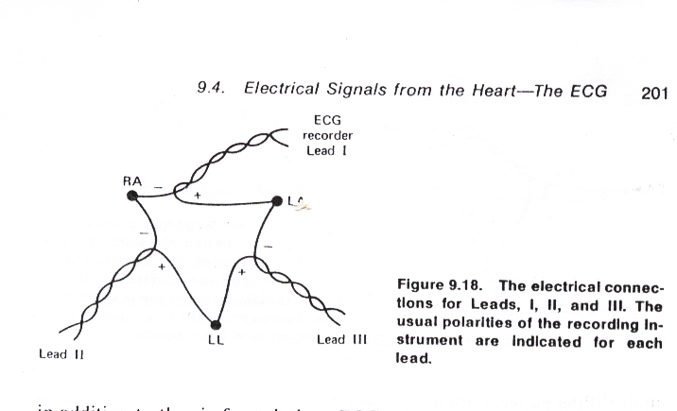
Figure 7 : The electrical connections for Lead I , II ,and III .The usual polarities of the recording instrument are indicated for each lead .
When the switch of ECG apparatus is at lead I the electrodes on the R and L arms are connected to the amplifier (figure 8 ) .
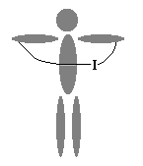
Figure 8 :Lead I
The amplifier then records record the potential difference between the right and left arm .
Lead I measure the potential difference between the RA and LA.
Lead II measure the potential difference between RA and LF(figure 9).
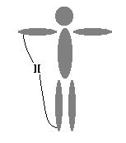
Figure 9: Lead II .
Lead III measure the potential difference between LA and LF(figure 10) .
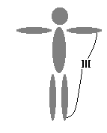
Figure 10 : Lead III
Lead I , Lead II , and Lead III are referred to as bipolar leads , because the measured signal is the difference in potential between two electrodes .
2. Unipolar measurements. are made by recording the potential at one electrode with respect to the average of the other two potentials . These are referred as aV_{R} , aV_{L} and aV_{F} leads. These leads are recorded by connecting the amplifier between one limb and the junction of two resistance which are connected to the other two limbs as shown in figure11
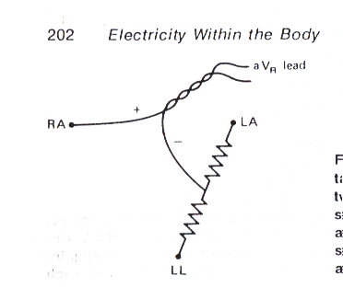
Figure11 :An augmented lead is obtained by placing a pair of resistors between two of the electrodes. The center of the resistor pair is used as one of the connection.
aV_{R} measure the potential difference between
RA and ( LA + LF ) /2 as shown in figure 12.
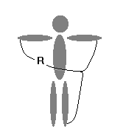
Figure 12:Lead aV_{R}

aV_{L} measure the potential difference between LA and (RA+LF )/2 as shown in figure13.
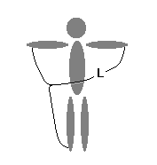
Figure 13 : Lead aV_{L}

aV_{F} measure the potential difference between
LF and (RA +LA ) /2 as shown in figure 14.
.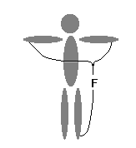
Figure 14 : Lead aV_{F}
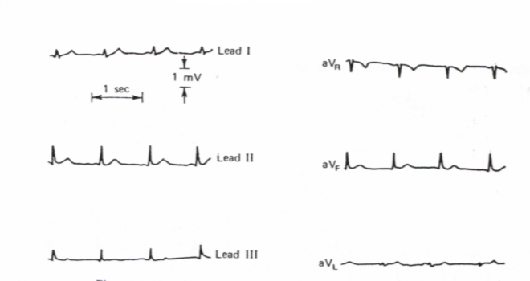
Figure 15: Six frontal plane ECG s for a normal subject .

3.chest leads: Are recorded by connecting the amplifier between the chest electrode and resistance connected to all three limbs (RA+LA+LF) as shown in figure 16.
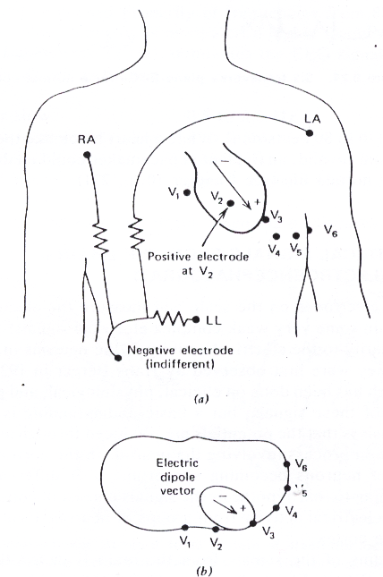
Figure16 :Transverse plane ECG positions . (a ) Frontal view(b) Top view .
So, the chest electrode is being one input of the amplifier and the other input is connected to an electrically neutral point V which is obtained by joining the three limb leads together through a resistance's . Such a recording is designed V1 , V2, V3 , V4 , V5, and V6 according to the position of the electrode on the chest , as shown in figure 17 .

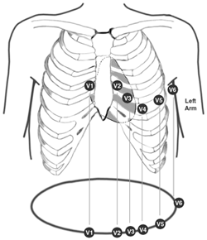
Figure 17 :Chest electrodes

Figure 18 shows six transverse plane ECGs for a normal subject .Figure 19 shows the routine ECG .
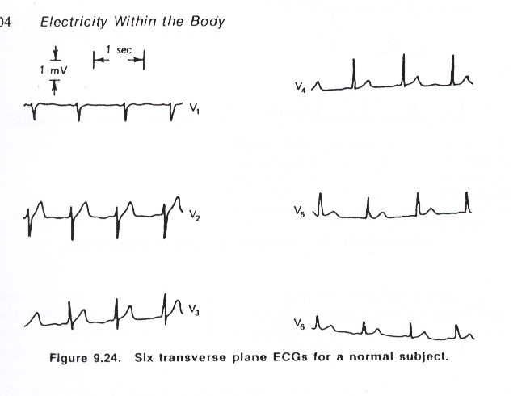
Figure 18: Six transverse plane ECGs for a normal subject .
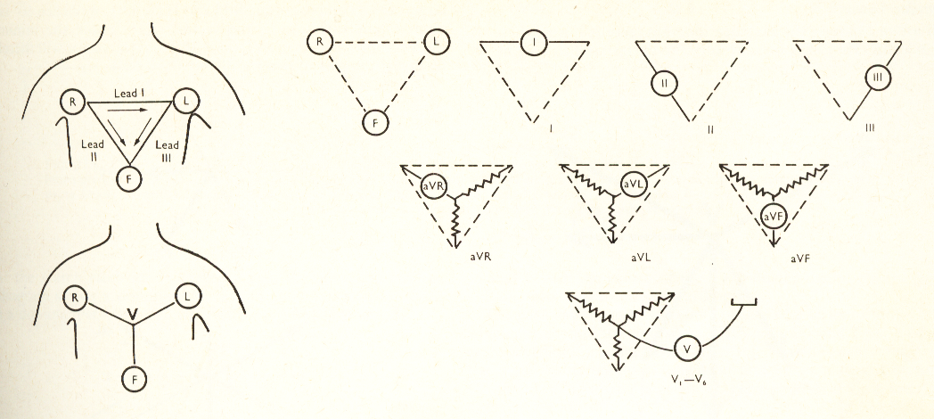

Figure 19: The standard electrocardiogram leads.

/4/6201 الفيزياء الطبيه د. تيماء الغلامي

Electroencephalograph (EEG)
EEG is a technique of recording electrical activity of the brain through the intact skull (figure 1) .

Electrodes are applied on the scalp( figure 2) and potential difference recorded and amplified and present for interpretation as an inked tracing on moving paper (figure3).
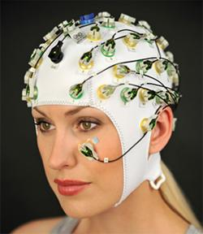

figure(3a): EEG head box

Machines in common use have eight or sixteen or more channels so that it is possible to record the activity from different areas of the head simultaneously. The technique is relatively simple and entirely harmless and may give information which is of great important in neurological diagnosis.The frequency of the EEG signals depend on the mental activity of the subject(figure 4)
For example a relaxed person usually has an EEG signal composed primarily of frequencies from 8 to 13 Hz, or alpha waves .When a person is more alert a higher frequency range , the beta wave range (above 13 Hz), dominates the EEG signal (figure 5).

The frequencies of the EEG signals are classified as follows :

Alpha wave (α) 8 to 13 Hz indicate a relaxed awareness and inattention.

Beta(β) 14 to 50 Hz walking rhythm associated with
active thinking .
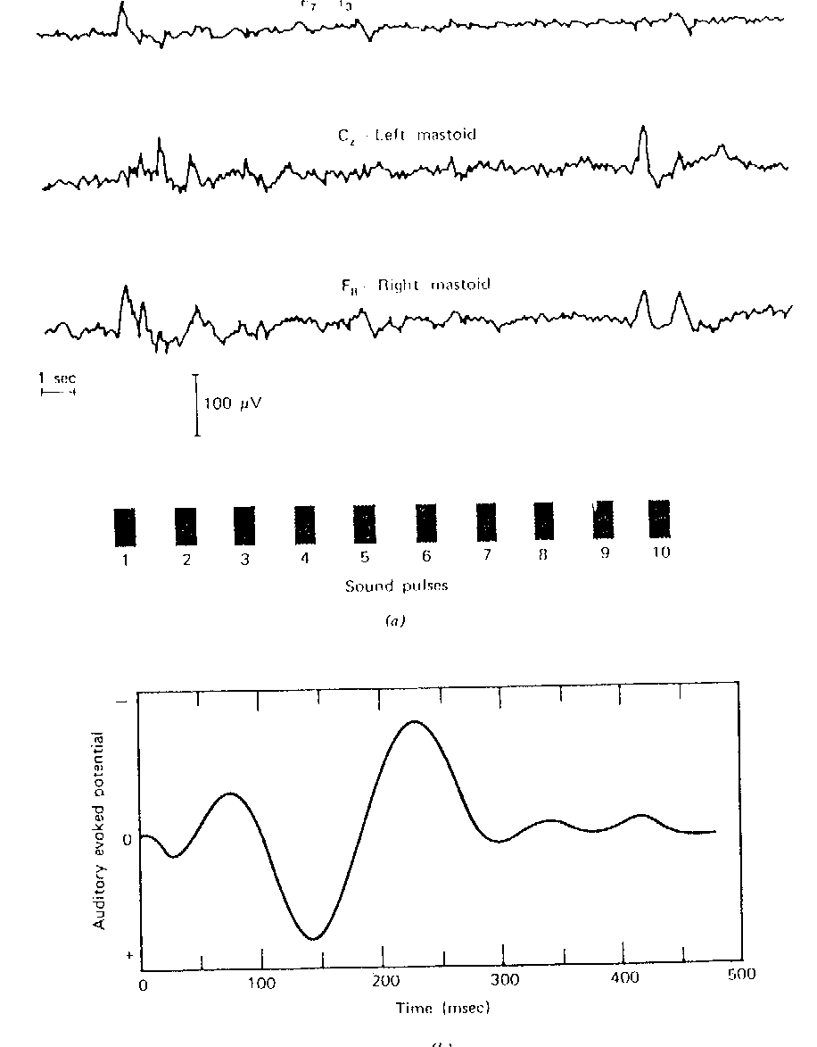
Figure (5a) : EEG waveform .

The amplitude of the EEG signals is low (about 50μv) ,and interference from external electrical signals often causes problems in EEG signals processing . Even if external noise is controlled ,the potentials of muscle activity such as eye movement can cause artifacts in the record .
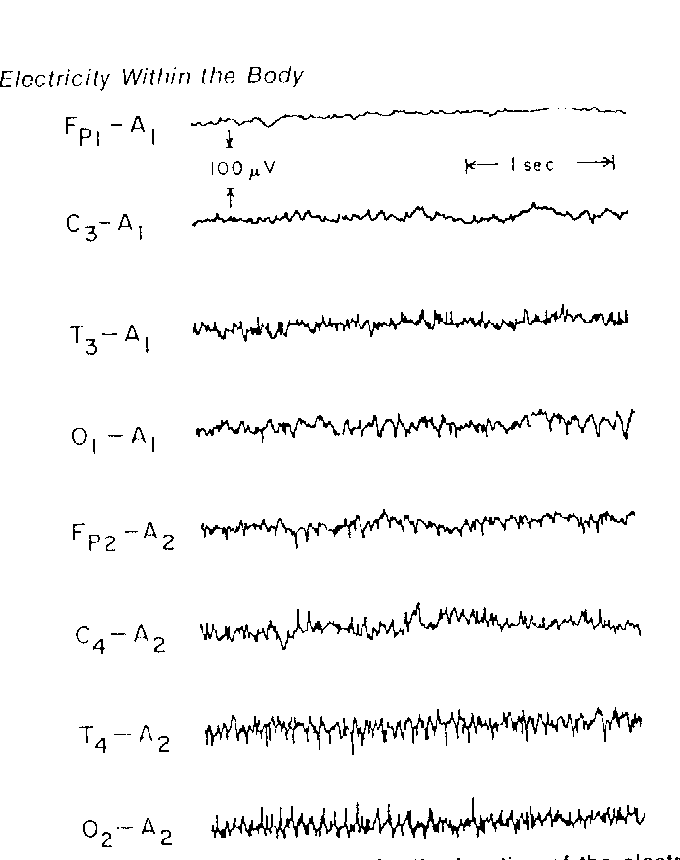

Figure (5b ) : EEG recording .

EEG as investigation method of brain activity
The main present clinical application of EEG are the following:
1 . to investigate lesion in the brain , because lesion can
provided abnormal activity of the brain . Abnormality in the
signals could be in its amplitude , width or its sequence .
2. Abnormality in EEG output occurs with people having
epilepsy .EEG may be help to distinguish between different
type of epilepsy .
3. Many medical conditions produce cerebral complications that can
be simply detected .
4. Spinal cord abnormality can be detected and investigated
using EEG technique .

There are different types of electrodes used in EEG technique , such as pad, disc , and silver chloride electrodes .

Electrode Placement

How to apply electrodes on the subject head ?
The 10 –20 system is used in applying the 19 electrodes on the scalp (figure 6) . Thus , measure the head distance from Nasion to Inion along the middle line and mark the point C at the midpoint and divided this distance by 20% and 10% . Then , measure the distance from right to left and divided by 20% of this distance (figure 6). Thus all electrodes are applied on the head according to 20 % of the head distances .When all electrodes are fixed on the head , each is injected with electrode jelly . The 19 electrodes are hold in the head by head cap . Then , all electrodes are connected to the head box in which it connected to the amplifiers (figure 8) .

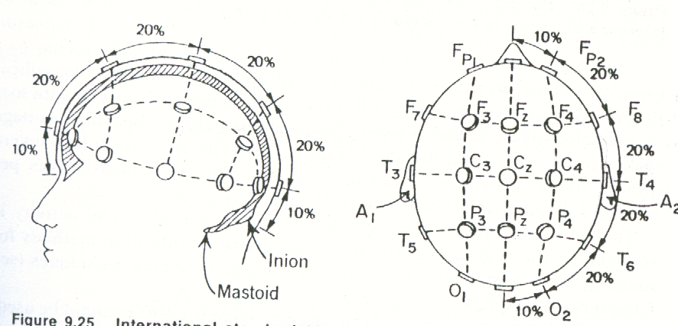

Figure 6 : International 10 -20 system of location electrodes for
EEG recording
F –Frontal , T- Temporal , P – Parietal , and
O –Occipital.


Figure 7 :Measure the distance between nasion and inion

The 10 – 20 system is used to ensure that the inter electrodes spacing are equal along longitudinal or transverse line , and to determine the distribution of electrical potential over the scalp completely and accurately .

Electrodes used , type , and characteristics :
Electrodes used in EEG are of special design , and must have the following characteristics:
1. Electrode impedance must be less than 5 kΩ , between
2-5 kΩ , to avoid drop in the signal potential .
2 . Electrodes used must be very high purity , because impurity
increased the signal artifacts .
3 . All electrodes used should have the same input impedance to
avoid the recording unbalance due to the phase shift.
4 . All electrodes should be stable potential , because unstable
potential will produce artifacts very much larger than EEGُُ
signal
5 . Electrodes must be cheap , easy to apply , easy to prepare ,
and to maintain , and it should be without hazard to patient .

How to connect electrodes with the amplifier
There are three basic methods of deriving electrical signals from electrodes
1. Bipolar :
For bipolar each channel is connected between two electrodes
both of which are likely to be affected by appreciable EEG potential Each amplifier measures the potential difference between the electrodes to which it is connected.

The input signal to the amplifier is
V1 = e1 –e2
V2 = e2 – e3
V3 = e3 – e4

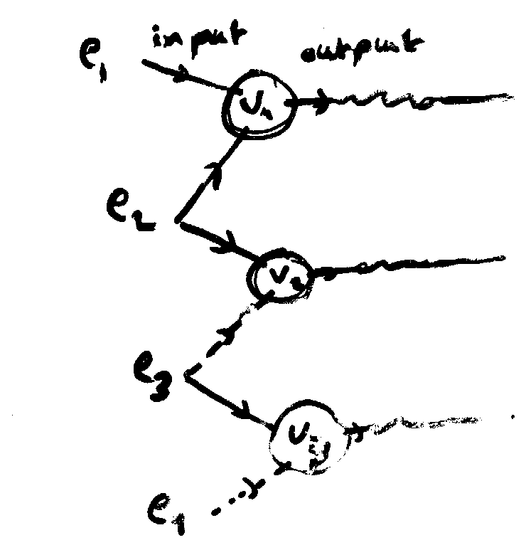

2 . Common reference derivation
In this method one electrode is common to all group
of channels . Each amplifier is connected between an active electrode and reference electrode .

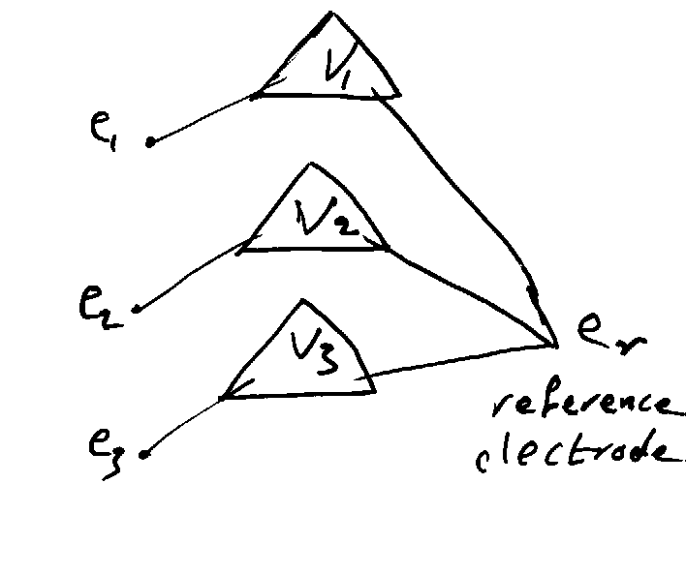
Amplifier input signal is:
V1 = e1 – er
V2 = e2 –er
V3 = e3 – er
In common reference , there is no phase reversal .

3 . average reference derivation
The electrodes on the scalp are connected through equal resistance to single point which is used as a common reference .
The potential at this point is the average of the potential of the scalp electrodes .

Each amplifier is connected between an active electrode and average reference electrode through equal resistance.

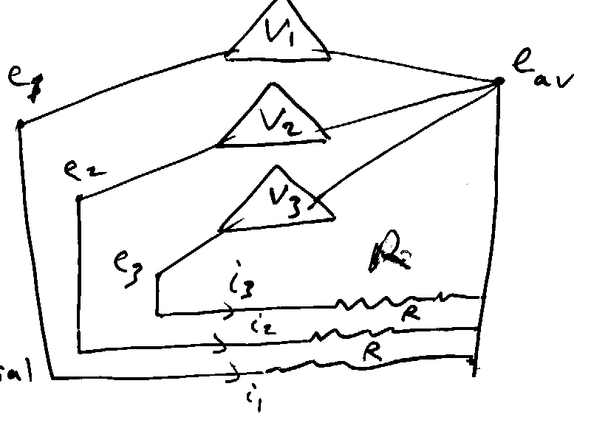

Amplifier input signal is
V1 = e1 – eav
V2 = e2 – eav
V3 = e3 – eav

