**Otorhinolaryngology**

**Lec: 8**

**Objectives:**

**To through a light on:**

**1- Anatomy of external ear.**

**2- Diseases of external ear.**

**The ear is divided into:**

1- External ear

2- Middle ear

3- Inner ear

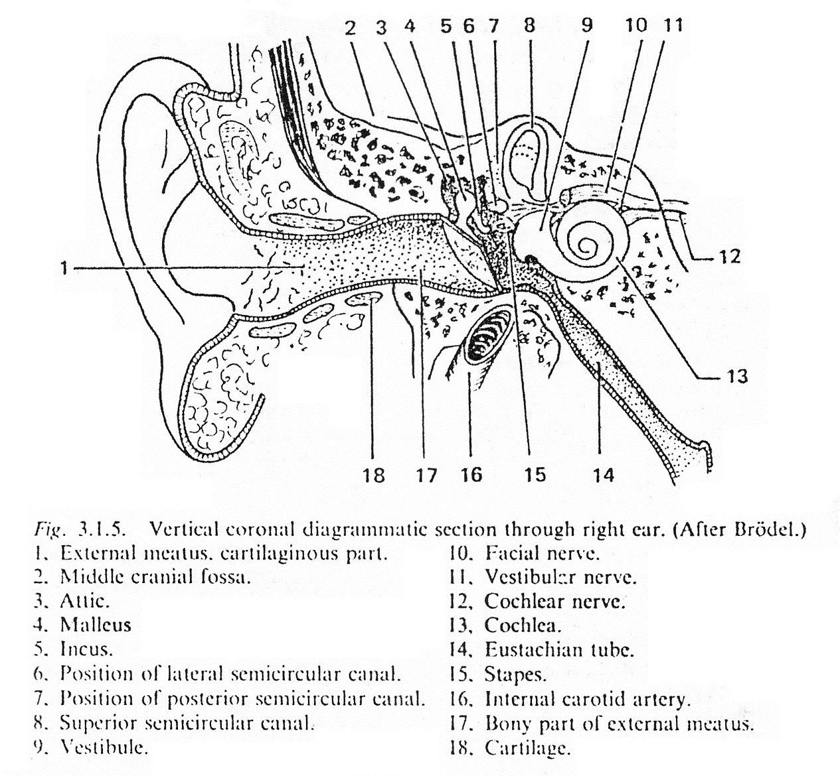

**Surgical Anatomy of External Ear:**

**1- The** **Auricle** has a framework of elastic fibrocartilage which is absent in the lobule and in the area between the crus of helix and the tragus. The lobule is formed by fat and fibroareolar tissue. The auricle has two surfaces, lateral and medial surfaces. Parts of the lateral surfaces are as follows:

* The curved rim is the helix. Anterior to and parallel with the helix is another prominence, the antihelix. Superiorly, this divides into two crura between which is the triangular fossa. The scaphoid fossa lies above the superior of the two crura. In front of the antihelix is the concha. Below the crura of the helix and opposite the concha, across the external auditory meatus is the tragus which is small triangular prominence. Opposite the tragus is the antitragus which is separated from the tragus by intertragic notch. The lobule lies below the antitragus and it is soft composed of fibrous and adipose tissue. The skin of auricle is thin and closely adherent to the perichondrium on the lateral surface.

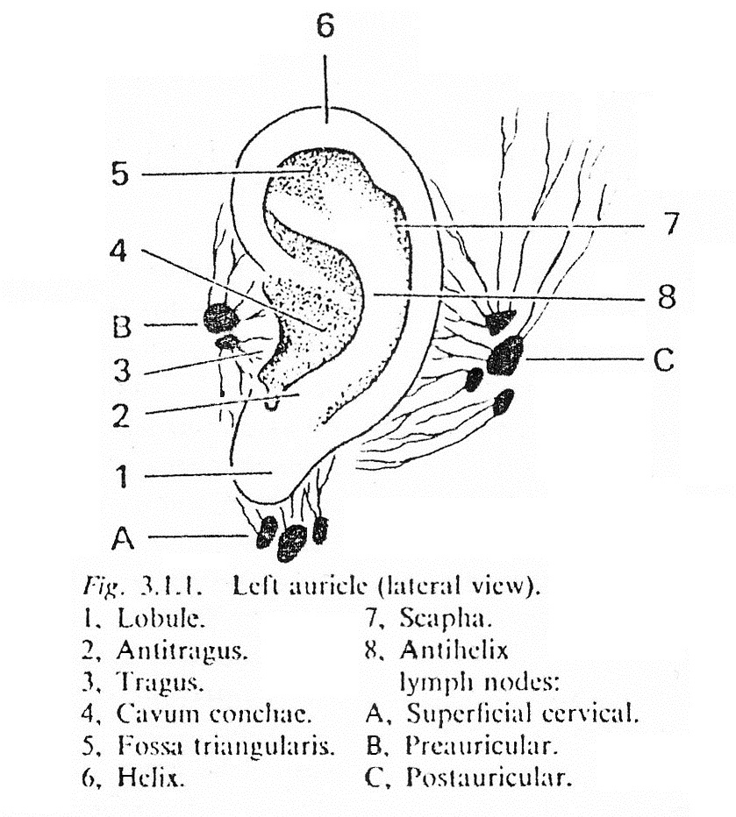

The auricle is attached to the side of the head by ligaments and the largely functionless anterior, superior and posterior auricular muscles.

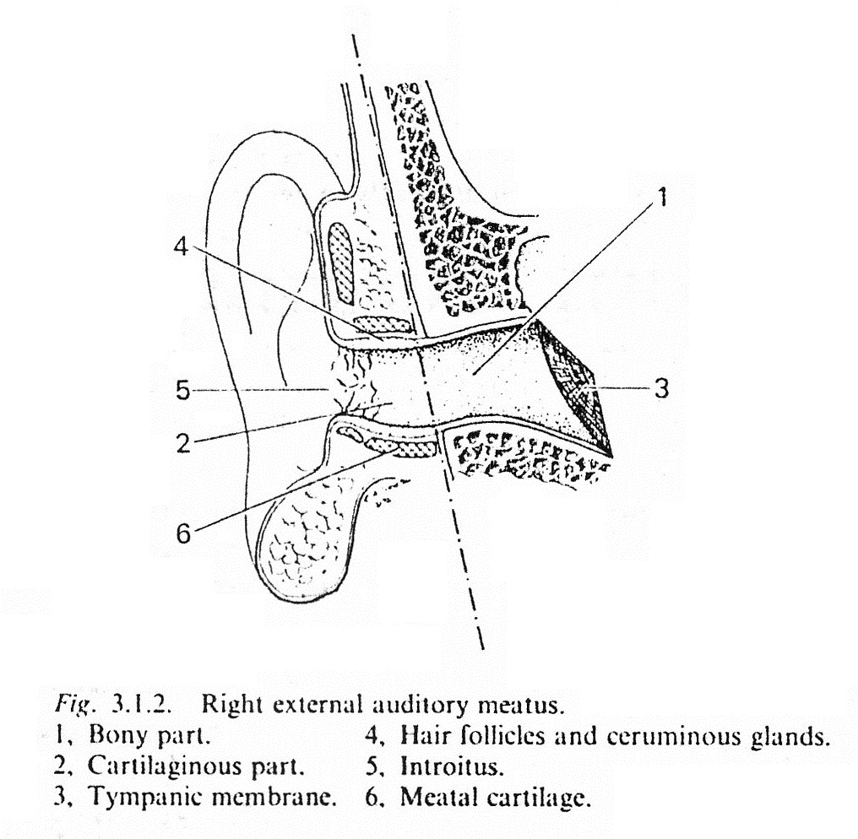

**2-External Acoustic (Auditory) Meatus:**

* In adults the external auditory meatus measures about 24 mm from the concha to the tympanic membrane which is the medial limit of the meatus. Since the tympanic membrane lies obliquely at the inner end of the meatus, so the anterior and inferior walls are longer than the posterior and superior walls.
* The meatus is composed of ***two parts***:

1- Outer cartilaginous third which is directed medially, upward and backwards. The cartilage of the outer 1/3 of the meatus is continuous with the cartilage of the auricle. Inconstant deficiencies of the cartilaginous meatus occur, known as the fissures of Suntorini.

The skin lining the cartilaginous part of the meatus contain hair follicles, sebaceous glands and ceruminous glands.

2- Inner bony 2/3 which is formed by tympanic plate and a small postero-superior portion is formed by squamous bone. The direction of the inner bony two-third, of the external meatus is medially, downwards and forwards (so that the meatus may be partially straightened in an adult by pulling the auricle upward, outwards and backwards). The skin lining the bony meatus does not contain hair follicle, sebaceous or ceruminous glands, so that the wax secreted only from skin lining the outer cartilaginous meatus.

* There are two constrictions in the external auditory meatus:

1- At the junction of cartilaginous and bony meatus.

2- In the bony meatus about 5 mm from the tympanic membrane called the isthmus.

* From the isthmus the floor of the meatus dips downwards and forwards to form the anterior recess, it is difficult to remove debris from this recess.

**Nerve Supply of the Auricle:**

* Greater auricular n. → supply medial surface of the auricle and posterior portion of the lateral surface.
* Lesser occipital n. → supply upper part of medial surface of auricle.
* Auricular branch of vagus → supply concha and some supply of medial surface of the auricle.
* Facial n. → supply part of concha.
* Auriculo-temporal n. (V) → supply the lateral surface of the auricle.

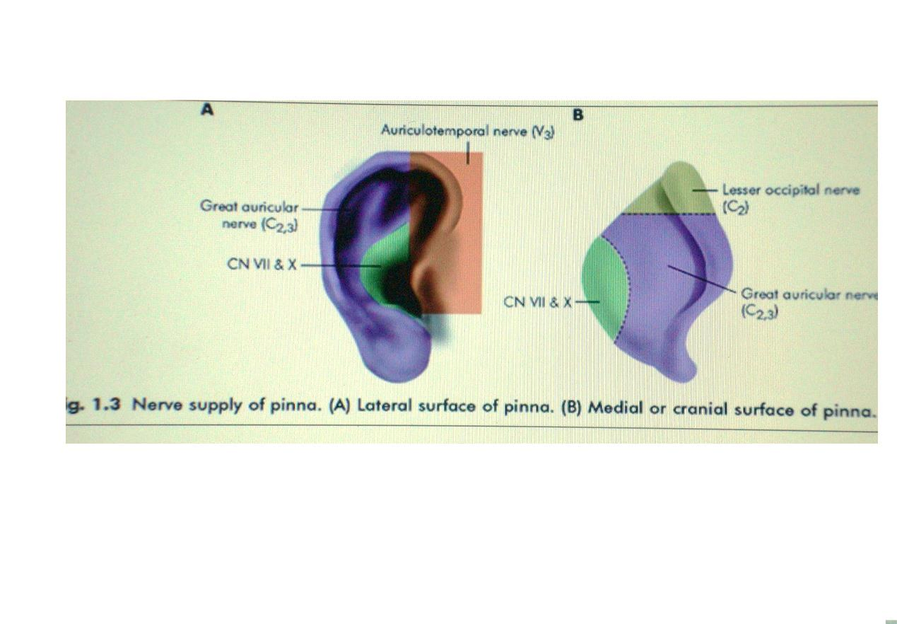

**Arterial blood supply of the auricle:**

* Superficial temporal a. → supply lateral surface of auricle.
* Posterior auricular a. → supply the medial surface of the auricle.

**Nerve supply of the external auditory canal:**

* Auriculo-temporal n. → supply anterior and superior walls of the canal.
* Auricular branch of vagus n. → supply posterior and inferior walls of the canal.

**Arterial blood supply of external auditory canal:**

* Superficial temporal a. → supply anterior part of the canal.
* Posterior auricular a. → supply posterior part of the canal.

**Lymphatic drainage of external ear:**

* Anteriorly → preauricular L.N.
* Posteriorly → postauricular L.N.
* Inferiorly → upper deep cervical L.N.

**(Embryology):**

* During development there are six branchial arches and between these arches there are five branchial pouches internally and five branchial clefts externally. The auricle is developed from six tubercles derived from the 1st and 2nd branchial arches. The dorsal part of 1st branchial cleft gives rise to external auditory canal; the ventral part of the 1st branchial cleft normally disappears, but sometimes persists as preauricular sinus, cyst or collaural fistula.

**Congenital anomalies:**

**1-Accessory tragi (accessory auricles):**

* They result from abnormal growth of tubercles of 1st & 2nd branchial arches. They are presented as small elevations of skin containing elastic cartilage, usually found in preauricular region and may occur anywhere along a line passing from tragus to the angle of the mouth. Excision is done only for cosmetic reasons, otherwise no treatment is required.

**2-Periauricular sinuses and cysts:**

* Result from abnormal growth of 1st branchial cleft. Periauricular sinus is a blind tracks lined by squamous epithelium usually found in preauricular area and can occur along a line from tragus to angle of mouth. Sometimes it gets infected leading to pain and pus discharge. Excision is required only when the sinus is symptomatic. Periauricular cyst usually found in preauricular region and usually asymptomatic, sometime if it gets infected leading to abscess formation. Excision is required only when it is symptomatic.

**3-Collaural fistula:**

* Result from abnormal growth of 1st branchial cleft. It opens superiorly in the floor of external auditory canal and opens interiorly at the anterior border of sternomastoid muscle behind the angle of the jaw. It is lined by squamous epithelium. Sometimes it gets infected leading to pain and pus discharge. Excision is required only when it is symptomatic.

**4-Protruding ears (Bat ears):**

* In bat ears the main features are underdevelopment or absence of the antihelix and an over developed concha. Treatment is by plastic surgical reconstruction at 6 years of age.

**5-Complete or partial absence of auricle:**

* Due to failure of development of 1st and 2nd branchial arches.

**6-Atresia of external auditory meatus:**

* Due to defect in inward growth and canalization of epithelial anlage. It causes conductive deafness.

**Injuries of Auricle:**

**1-Haematoma auris:**

* Due to a blow to the auricle as in boxing and sometimes occur spontaneously in elderly. There is rupture of a blood vessels and extravasation of blood between the cartilage and the perichondrium clinically there is soft doughy swelling of the auricle.

**Treatment:**

* Aspiration using wide bore needle (If the patient is seen shortly after injury).
* Incision and evacuation of haematoma (In longer standing cases).
* The aspiration or incision should be under complete aseptic technique to avoid the occurrence of perichondritis. After evacuation of haematoma, silastic sheets can be applied to both surfaces of the auricle and held by transfixation suture to prevent recurrence of the haemotoma.

**Complications:**

* When the haematoma did not treated → organization of blood thickening of auricle → cauliflower ear deformity.

**2-Lacerations:**

* It should be treated by skin - skin suture (the sutures should not pass through the cartilage). Complication of skin lacerations is auricular perichondritis.

**3-Total amputation (avulsion) of auricle:**

* The best treatment is reimplantation

**4-Frostbite:**

* At first red or blue areas appear on the helix, then the areas become white in color. After that auricle (except the lobule) becomes swollen, painful and red in color and finally become gangrenous.

**Treatment:**

* In the early stages by gentle re-warming.
* In the later stages as for gangrene.

**Infections of the Auricle:**

* ***Auricular Perichondritis:***

**Definition:**

* It is infection of auricular perichondrium usually caused by *Pseudomonas aeruginosa.*

**Aetiology:**

* Exposure of the auricular cartilage as a result of external trauma, or surgery e.g. aspiration of haematoma.
* Damage of the auricular cartilage by frostbite or burn.
* Spread of superficial infection of the auricle to involve the perichondrium.

**Clinical Features:**

* Pain, fever.
* Red, swollen auricle with tenderness.
* Formation of subperichondial abscess → deprivation of the cartilage from blood supply → necrosis of the cartilage → deformity of pinna.

**Investigations:**

* Swab for culture and sensitivity when there is pus discharge.

**Treatment:**

* Immediate treatment by I.V antibiotic effective against *Pseudomonas aeruginosa*
* Incision and drainage when there is subperichondrial abscess
* Analgesia.

**Otitis Externa:**

**Definition**:

* Is an inflammation of skin of the external auditory meatus (EAM).

**Predisposing Factors:**

* Heat, humidity, bathing, swimming
* Trauma by dirty fingernails
* Inherited e.g. narrow ear canal, excessive wax, eczema
* Underlying otitis media.

**Classification:**

**1-Infective:**

**A-Bacterial:**

* ***Diffuse otitis externa*** caused by *Pseudomonas aeruginosa*,  *S. aureus* and *Proteus*.
* ***Furunculosis*** caused by *S. aureus*.
* ***Malignant otitis externa*** caused usually by *Pseudomonas aeruginosa* or occasionally by *S. aureus*.
* ***Erysipelas*** caused by *Streptococcus pyogenes*.
* ***Impetigo:*** on infection of superficial layers of the epidermis, usually caused by *S. aureus* or occasionally *S. pyogenes*.
* ***Secondary to acute or chronic otitis media.***

**B-Fungal**:

* *Aspergillus niger*.
* *Aspergillus fumigates*.
* *Candida albicans*.

**C-Viral:**

* Herpes simplex.
* Herpes zoster.
* Otitis externa haemorrhagica.

**2-Reactive:**

Eczema.

* Seborrhaeic dermatitis.
* Neurodermatitis.
* Keratosis obturans.

Psoriasis

**Furunculosis:**

* It is bacterial infection of hair follicles in the outer cartilaginous EAM caused by *S. aureus*. Clinically there is painful; tender red pustule in the outer 1/3 of EAM. Pain increased by jaw movement and tenderness by pressure on tragus there may be conductive deafness. The infection may spread to LN → lymphadenopathy. Most furunculosis drain spontaneously.

***Investigations:***swab for C/S when there is discharge and FBS.

***Treatment:***

* Aural toilet.
* Wick soaked in a steroid / antibiotic cream or wick soaked with 10% ethanol in glycerine to reduce meatal oedema due to its hygroscopic action.
* Oral antistaphylococcal antibiotics e.g. flucloxacillin or erythromycin.
* Analgesia.
* Neomycin cream applied to nasal vestibule to eliminate *S. aureus* from the nasal vestibule.
* Incision is rarely needed.

**Diffuse Otitis Externa:** 2 Stages:

* ***Acute stage:***Clinically there is pain aggravated by jaw movement deafness, tenderness by pressure on tragus, redness and swelling of the meatal skin, pus in the meatus and red tympanic membrane.
* ***Chronic stage:***There is deafness discharge, redness and thickening of meatal skin and granulations on the surface of tympanic membrane. There is discomfort but not sever pain as in acute stage.

***Investigations:***Swab for C/S. Fasting blood sugar to exclude D.M.

* ***Treatment:*** *protection of water entry into ear canal.

*Cleaning of ear canal by mopping or suction.

* Insertion of wick in the ear canal soaked with neomycin/steroid cream (should be changed daily until the canal is clean.
* Analgesia.
* Wick of 10% ethanol in glycerine is used to reduce meatal skin swelling.
* Systemic antibiotic effective against the causative organism.

**Fungal Otitis Externa (Otomycosis):**

***Predisposing factors:***

* Bacterial infection e.g. chronic suppurative otitis media.
* Topical and systemic antibiotic → change the physiochemical environment of the meatus and facilitate fungal growth.
* Those with open mastoid cavity and these using hearing aids.
* Hot and humid climates.
* Steroids.
* ***Clinically*** there is itching and deafness due to presence of debris in the ear canal, in *Candida albicans* the debris is grayish-white debris like wet newspaper. The conidiophores of *Aspergillus niger* appears as black specks. Diagnosis is confirmed by microscopical examination of the debris and by culture.

***Treatment:***

1-Cleaning of the ear canal by mopping or suction (special attention is to clean the anterior inferior recess).

2-Fungicides:

* Nystatin cream (effective for *Candida albicans* infection)
* Clotrimazole 1% cream (highly effective fungicide).
* Gentian violet (effective for all types but has disadvantage of staining the skin).