**Introduction In Anatomy**

**Objective :**

1. **What is anatomy?**
2. **Why we study anatomy**

**3. How to approach to anatomy**

**4. Branches of anatomy**

**5. Division of gross anatomy**

**What is anatomy ?**

* **Anatomy, is a visual, descriptive science studies the structures of all parts of the body and their functions, microscopic organization, and process by which they developed.**
* **The word anatomy is Greek ward (anatemnein) that mean "to cut up" or "to dissect.**

**Why we study anatomy ?**

**Anatomy forms the basis for the practice of medicine.**

**Anatomy leads the physician towards an understanding of a patient's disease.**

**Observation and visualization are the primary techniques a student should use to learn anatomy. Anatomy is much more than just memorization of lists.**

**Anatomy can be studied by:**

**1. Regional approach :each region of the body is studied separately.**

**For example, if the Thorax is to be studied, all of its structures are examined. This includes the vasculature, the nerves, the bones, the muscles and all other structures and organs located in the thorax.**

**2-Systemic approach: each *system* of the body is studied and followed throughout the entire body. Example :studying the nervous system (brain, spinal cord and all the nerves) in detail.**

**Anatomy is divided into:**

**1.Gross Anatomy : ( cadaveric anatomy ,general anatomy ,macroscopical anatomy ) is the study of anatomical structures that can be seen by unaided vision with the naked eye.**

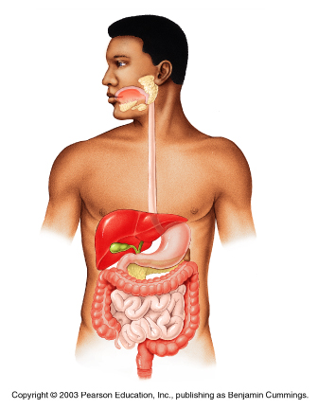

**2-Neuroanatomy : Studying of the anatomy of the central nervous system**

**(C.N.S anatomy)**

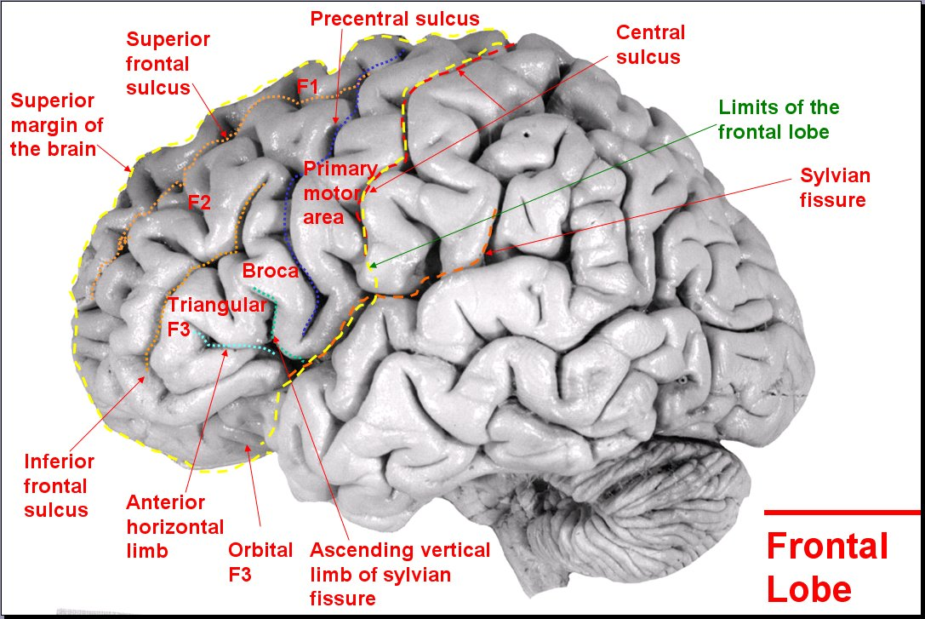

**3.Microscopical Anatomy(Cytology & histology) which study:**

**\*Very small structures**

**\*Only viewed with microscope ( cells and tissuesorgans of the body**

**14.04_Stomach_3.jpg                                            00051837
Hard_Drive                     B746AFEA:**

**4-Developmental anatomy (embryology) which study the process by which the**

**structures developed in uterus**

**5. Pathological anatomy: The study of structural changes in cells, tissues, and organs caused by disease.**

**6..Radiologic anatomy :To study anatomy by the aid of :**

1. Radiograph (x-ray film) is the most common form of radiographic anatomy which provides a two-dimensional image of the interior of the body.

b.Computed tomography (CT) scanning or computerized axial tomography

( CAT) scanning permits the study of tissue slices so

C. Magnetic resonance imaging (MRI)

**7. Comparative anatomy:**

**Study the differences between the anatomy of human and animals .**

**Surface anatomy: Is the study external feature as a bony**

**projection which serve as a land mark to locate deeper structures.**

**Or: The study of anatomical landmarks that can be readily seen from the contours or the surface of the body.**

**Applied anatomy :Clinical anatomy is the simplest terms of applied anatomy ,it is the application of anatomical knowledge to medical and surgical practice. OR** is the study of the macroscopic structure and function of the body as it relates to the practice of medicine and other health sciences.

**Sectional Anatomy:**

**Any slice through a three-dimensional object can be described with reference to three sectional planes.**

**Anatomical position :**

**The anatomical position is a standardized method of observing or imaging the body**

**\*Standing upright**

**\*Eyes facing to the front**

**\*Feet flat on the floor (a parted)**

**\*Arms at the sides**

**\*Palms turned to the front**

**A person is standing up straight( erect ), with arms at the sides and palms facing forwards with the fingers extended. The feet head &eyes are facing forward**.

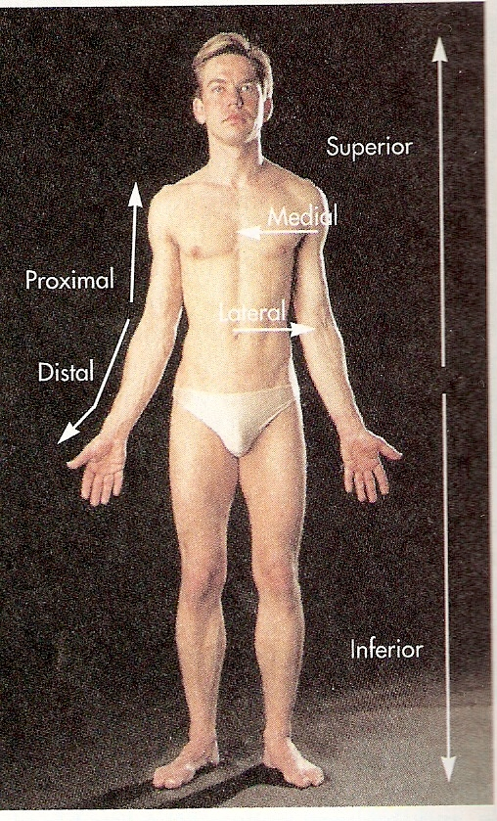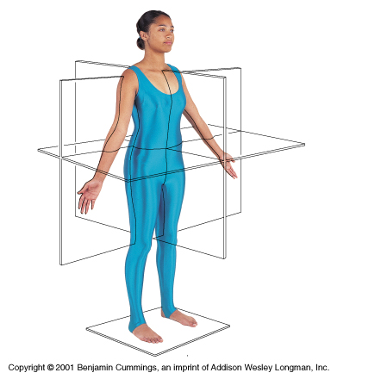

Planes Of the body:

* **A plane is an imaginary surface that slices the body into specific sections.**

**The three major anatomic planes of reference are the coronal, transverse, and sagittal planes.**

* **Median sagittal plane or median plane: extends through the body or organ vertically and divides the structure into right and left halves.**
* **Para median plane : A plane that is parallel to the mid sagittal plane, but either to the left or the right of it, is termed parasagittal plane**
* **Oblique plane: plane cut neither vertical nor horizontal ,pass through body between transverse and one of vertical planes..**
* **Horizontal or transverse plane: also called cross section plane runs left to right through the body and divides it into upper and lower sections.**
* **Coronal plane: runs through the body, divides it into front and rear halves.**

**It is vertical at right angle to the median plane**

**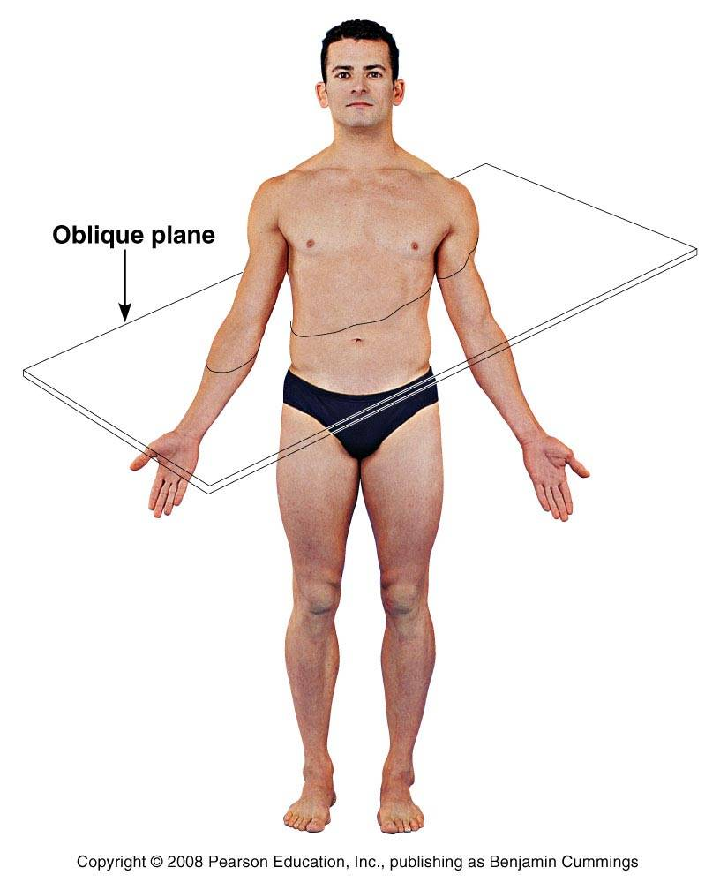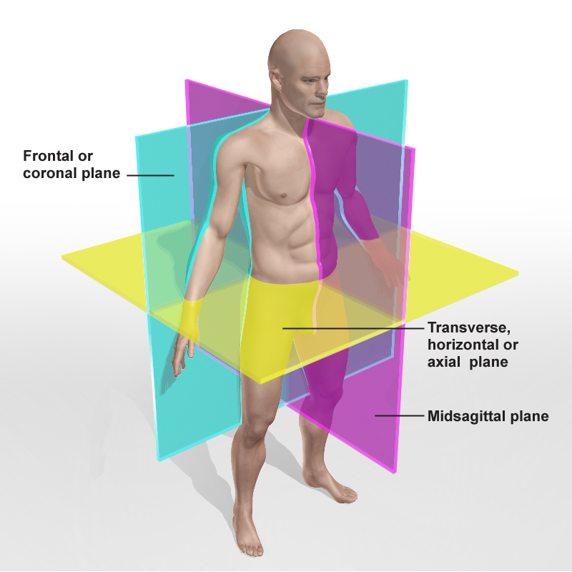**

**Question 1 :Name the following sections :**

a:--------------------------------------------

b:-------------------------------------------

c.-------------------------------------------

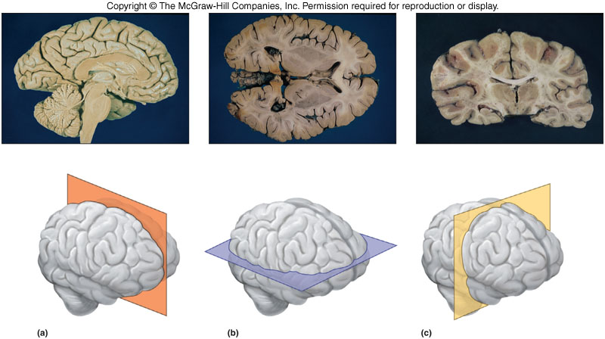

**Question 2 : Describe the anatomical position**