**Metallic Denture Base**

**مادة سنية / د . نشوى**

**ثاني اسنان موصل**

**2 / 5 / 2016**

**Denture framework materials**

1. Metallic; Co/Cr, Ni/Cr, Gold, Ti alloys.

2. Nonmetallic; acrylic resins, flexible denture base materials.

Dental metals and alloys play an important role in dentistry. These materials are used in all aspects of dental practice including:

1. Direct dental restorations eg. amalgam alloys, gold alloys.

2. Inlays and onlays eg. Gold alloys.

3. Crowns and bridges eg. Gold alloys, nickel- chromium alloys, palladium alloys, titanium alloys.

4. Denture base frameworks eg. cobalt chromium alloys, Gold alloys.

5. Implants eg. Pure titanium and titanium alloys.

6. Endodontic posts eg. Ni-Cr.

7. Endodontic and general dental instruments eg. cobalt chromium nickel alloys, stainless steel nickel titanium alloy

8. Orthodontic wires and brackets, and surgical wires eg, stainless steel wires, titanium alloys.

ALLOY :a mixture of two or more metals or metalloids that are mutually soluble in the molten state; distinguished as binary, ternary, quaternary, etc., depending on the number of metals within the mixture.

Alloying elements are added to alter the hardness, strength, and toughness of a metallic element, thus obtaining properties not found in a pure metal.

Casting that means something that has been cast in a mold; an object formed by the solidification of a fluid that has been poured or injected into a mold.

Today the dental profession has access to a wide variety of casting alloys, these alloys are designed for specific clinical purposes .

Denture base: Is that part of the removable partial or complete denture which rests on oral mucosa and to which teeth are attached.

**Materials used in fabrication of metallic denture base:**

* Cobalt chromium alloy
* Nickel chromium alloy
* Gold
* Stainless steel

The base metal removable partial denture alloys were introduced in the 1930s. since that time both Nickel-chromium and cobalt-chromium formulations have become increasingly popular compared with conventional Type IV gold alloys.

**Cobalt Chromium Alloys**

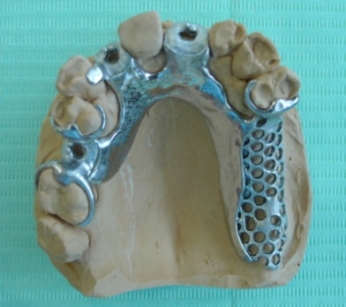

Composition:

Cobalt main constituent

Chromium no less than 25%

Molybdenum no less than 4%

Cobalt + nickel + chromium no less than 85%

A typical material would contain 35–65% cobalt, 25–35% chromium, 0–30% nickel, a little molybdenum and trace quantities of other elements such as beryllium, silicon and carbon. Cobalt and nickel are hard, strong metals.

The main purpose of the *chromium* is to further harden the alloy by solution hardening and also to impart corrosion resistance by the passivating effect. Chromium exposed at the surface of the alloy rapidly becomes oxidized to form a thin, passive, surface layer of chromic oxide which prevents further attack on the bulk of the alloy.

The concentrations of the *minor constituents* have a greater effect on the physical properties of the alloys than do the relative cobalt–chromium–nickel concentrations. The minor elements are generally added to improve casting and handling characteristics and modify mechanical properties. For example, silicon imparts good casting properties to a nickel containing alloy and increases its ductility. Likewise, molybdenum and beryllium are added to refine the grain structure and improve the behavior of base metal alloys during casting.

Carbon affects the hardness, strength and ductility of the alloys and the exact concentration of carbon is one of the major factors controlling alloy properties.

The carbon forms carbides with any of the components and its concentration depends on both the amount added by the manufacturer and that which may be inadvertently introduced during casting if the alloy is melted with an oxyacetylene torch. The presence of too much carbon results in a brittle alloy with very low ductility and an increased danger of fracture.

*Cobalt* is the main constituent of cobalt-based metal-ceramic alloys, with chromium added for strength and to provide corrosion resistance via passivation.

Cobalt–chromium alloys are the most common base-metal alternative for patients known to be allergic to nickel. Second highest melting point of all dental casting alloy. It is substitute for type IV gold alloy.

**FEATURES**

* High hardeness, good gloss, mechanical strength, resistance to corrosion and cheap.

**ADVANTAGES**

* Cheap
* Very light
* More durable adjusting hooks

**DISADVANTAGES**

* Excessive hardness
* Minor casting accuracy
* Complicated heat treatment
* Difficult laboratory procedures ( casting, finishing, polishing).
* Incompatibility in CTE between Co-Cr alloy and porcelain.
* Co-Cr alloys are used for the metal framework of cast partial dentures, since they are much less ductile than Ni-Cr.
* These-alloys are not used for metal ceramic prostheses, since the oxide layer formed on these alloys are susceptible to delamination and adversely affect the bonding with porcelain.

**Nickel Chromium Alloys**

Composition:

The chemical composition of these alloys specified in the ISO Standard for Dental Base Metal Casting Alloys (Part 2) is as follows:

Nickel main constituent

Chromium no less than 20%

Molybdenum no less than 4%

Beryllium no more than 2%

Nickel + cobalt + chromium no less than 85%

As for the Co/Cr alloys the concentrations of minor ingredients can have a profound effect on properties. The concentration of carbon and the nature of the grain boundaries are major factors in controlling the properties of these alloys. It’s a substitute for type III gold alloy.

***Role of each elements:***

Cobalt ,,,,,,, increase ( strength, hardness, modulus of elasticity)

Nickel ,,,,,,, increase ( strength, hardness, modulus of elasticity, ductility)

Nickel is allergic [ female > male ], more so in females (4.5%) than males (1.5%). It results in contact dermatitis and hypersensitivity. therefore nickel free base metal alloys has been introduced.

Chromium ,,,,,,, it increase tarnish and corrosion resistance by formation of passive layer.

Oxide layer with specific properties.

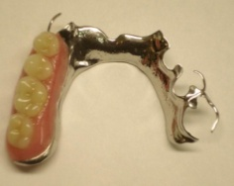

* Thin
* Uniform
* Non porous
* Adherent
* transparent

***Reasons for the use of nickel-chromium alloys in dentistry (*ADVANTAGES)*:***

* Nickel is combined with chromium to form a highly corrosion resistant alloy.
* It is low cost alloy as compared to Gold based alloys.
* Alloys such as Ticonium-100 have been used in removable partial denture frameworks for many years with few reports of allergic reactions.
* Nickel alloys have excellent mechanical properties, such as high elastic modulus (stiffness), high hardness, and a reasonably high elongation (ductility).

**Gold Alloys**

Pure gold is a soft, malleable, ductile metal that does not oxidize under atmospheric conditions and is attached by only a few of most powerful oxidizing agents. It has a rich yellow colour with a strong metallic luster. Although it is the most ductile and malleable of all metals, it ranks much lower in strength. Air (or) water at any temperature does not affect (or) tarnish gold. Gold is not soluble in sulfuric, nitric, (or) hydrochloric acids.

Gold is nearly as soft as lead, with the result that in dental alloys, coins, and articles of jewellery it must be alloyed with copper, silver, platinum and other metals to develop the necessary hardness, durability and elasticity.

Small amount of impurities have a pronounced effect on the mechanical properties of gold and its alloys. The presence of less than 0.2% lead will cause gold to be extremely brittle. Mercury in small quantities also has a harmful effect on its properties.

General composition of gold alloys are; gold, silver, copper, platinum, palladium and zinc. The other element are added to the gold to improve its physical properties. There are 4 types of gold alloys that differ in their percentages of their composition. Consequently they differ from each other in their physical properties;

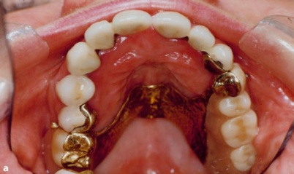 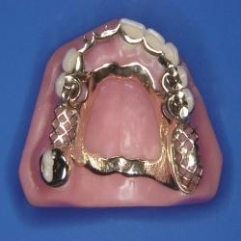

**Uses of gold alloy types;**

Type I: small inlays and direct dental restorations.

Type II: medium inlays.

Type III: large inlays, onlays, crowns and bridges.

Type IV: crowns and bridges and denture base frameworks.

**Stainless Steel**

Use of stainless steel, silver and its alloys as denture base materials has been reported in past. Currently base metal alloys are gaining popularity in place of gold alloys and aluminum alloys. Ni-Cr and Co-Cr alloys were obtained 1907 but it was not until 1937 that laboratories perfected the materials and techniques for use of these alloys. Since their introduction, these alloys made steady gains in popularity, but their increased use can be attributed to their low density, low material cost, light weight, higher resistance to tarnish and corrosion and high modulus of elasticity. Difficulty in adjustment and polishing and concerns over the reported Ni and Be allergies posed a challenge to the use of base metal alloys.

Stainless steel denture bases are formed from very thin pressed/rolled sheets of wrought stainless steel. The method used for forming a stainless steel denture base deserves special mention.

The wrought stainless steel sheets have high values of modulus of elasticity and proportional limit. This enables sufficient rigidity to be achieved with a very thin sheet of material. The weight of the denture can thus be kept to a minimum A further advantage of stainless steel denture bases is that they conduct heat rapidly through the thin metallic sheet, thus ensuring that the patient retains a normal reflex reaction to hot and cold stimuli. The main disadvantages are the lack of surface detail on the swaged plate and, perhaps more significantly, the involved technique required for swaging, attaching retention tags by welding and processing of the acrylic parts of the denture.

**Advantages of metallic denture base superior to acrylic ones:**

|  |  |  |  |
| --- | --- | --- | --- |
| **Acrylic** | **Metallic** | **Properties** |  |
| lesser accuracy and lesser maintenance of its accuracy intraorally | High accuracy and high maintenance of its accuracy intraorally | **Accuracy** | 1 |
| lesser retention due to its lesser intimate contact with tissue surface | Good retention due to its intimate contact with tissue surface | **Retention** | 2 |
| Weaker leads to low distortion resistance | Harder leads to high distortion resistance | **Hardness** | 3 |
| More | Lesser | **Weight and bulk** | 4 |
| Lesser due to its affinity to accumulate food particles | Good due to its great density and bacteriostatic activity contributed by ionization and oxidation of metal | **Hygienicity** | 5 |
| Insulator | Conductor | **Thermal conductivity** | 6 |
| It does not stimulate underlying tissues leads to more alveolar ridge atrophy | It stimulates underlying tissues therefore it minimizes alveolar ridge atrophy | **Stimulation to underlying tissues** | 7 |
| Low | High | **Resistance to abrasion caused by cleaning agents** | 8 |