|  |  |  |
| --- | --- | --- |
| **4th stage** | **Medicine** | **Lec** |
| **د.عماد** | **5/4/2016** |

Pituitary gland

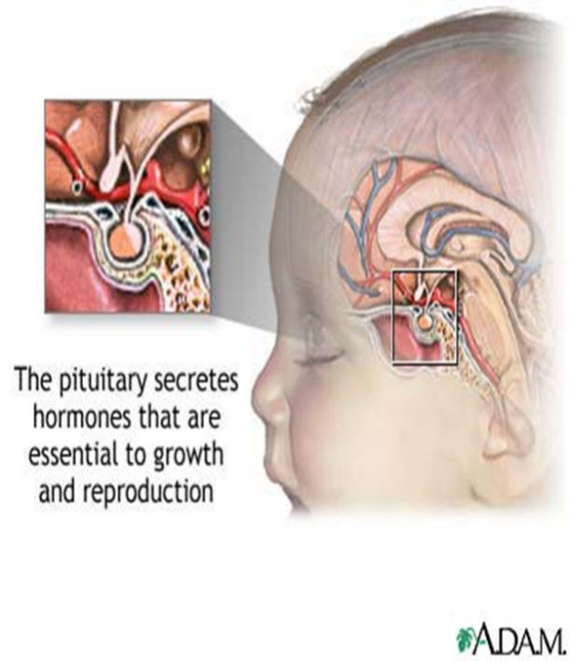The pituitary is located at the base of the brain, in a small depression of the sphenoid bone (sella turcica).

**Purpose:** control the activity of many other endocrine glands “ Master gland”

Has **two** lobes, the anterior & posterior lobes.

**Boundaries :-**

1. Superiorly : optic chiasma
2. Inferiorly : sphenoidal sinuses
3. Lateral : cavernous sinuses ( contain 3rd , 4th and 6th cr. Nerves + internal carotid artery )

**Structure :-**

Composed of anterior and posterior lobes , connected to pituitary by infundibular stalk , portal vessels carry blood from hypothalamus to anterior lobe of pituitary   
nerve fibers to posterior lobes .

**Physiology :-**

* **Hormones secreted from anterior pituitary**(controlled by substances produced in hypothalamus and released into portal blood flow down pit stalk)

1. LH,FSH
2. TSH
3. Prolactin
4. GH
5. ACTH

* **Hormones secreted from post pituitary** (synthesized in hypothalamus and transported through nerve axon down to be released from pos pit gland

1. ADH (anti diuretic hormone ) 2. Oxytosin

**Anatomy :-**

* 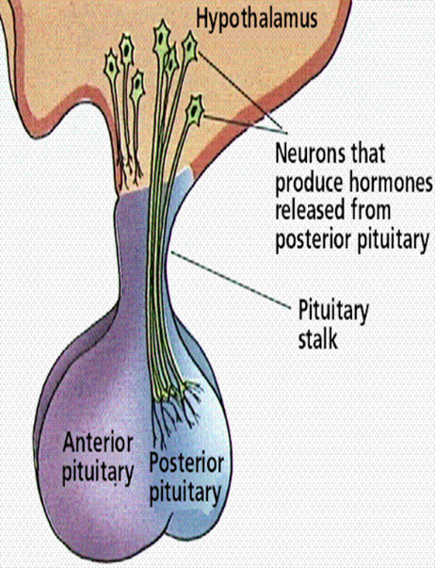Anterior lobe: glandular tissue, accounts for 75% of total weight. Hormones in this lobe are controlled by regulating hormones from the hypothalmus (stimulate or inhibit)
* Posterior: nerve tissue & contains axons that originate in the hypothalmus. Therefore this lobe does not produce hormones but stores those produced by the neurosecretory cells in the hypothalmus. Release of hormones is triggered by receptors in the hypothalmus.

**Anterior Pituitary Secretes :**

* **GH:**stimulates growth of bone and muscle , promotes protein synthesis and fat metabolism.
* **ACTH**(Adrenocorticotropin ): stimulates adrenal gland cortex secretion of mineralcorticoids (aldosterone) & glucocorticoids (cortisol).
* **TSH:** stimulates thyroid to increase secretion of thyroxine, its control is from regulating hormones in the hypothalmus
* **Prolactin:**stimulates milk production from the breasts after childbirth to enable nursing. Oxytoxin from posterior lobe controls milk ejection.
* **FSH:** promotes sperm production in men and stimulates the ovaries to enable ovulation in women. LH and FSH work together to cause normal function of the ovaries and testes.
* **LH:** regulates testosterone in men and estrogen, progesterone in women.

**Posterior Pituitary secrets :**

* **Antidiuretic hormone or ADH** - also called vasopressin, vasoconstricts arterioles to increase arterial pressure; increases water reabsorption in distal tubules.
* **Oxytocin**: stimulates uterus to contract at childbirth; stimulates mammary ducts to contract (milk ejection in lactation).

**Presenting problems in hypothalamic and pituitary diseses**

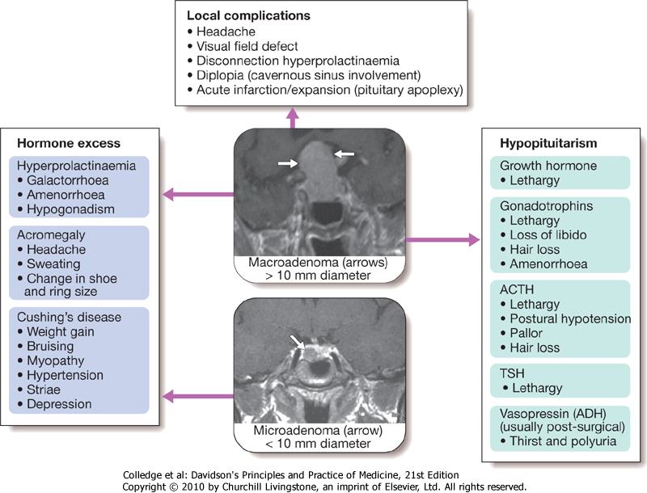

**A-Hypopituitarism**   
1-**anterior pituitary hormone deficiency**

* Combined deficiency of any of the ant pituitary hormones.
* Clinical presentation vary.
* Most common cause is *pituitary macroadenoma*

**Causes** of ant pituitary hormone deficiency :

**1.Structuralprimary pit tumor**

Adenoma, carcinoma, Craniopharyngioma, Meningioma, Heamorrhage (apoplexy), Langerhans cell histocytosis, Arachnoid cyst, Secondary tumour (leukemia, lymphoma), Chordoma

**2.Inflammatory / infiltrative**

sarcoidosis, haemochromatosis, infections (pit abscess, TB, syphlis,encephalitis).

**3.Congenital deficiencies**

GnRh (kallmann’s syndrome), TRH, GHRH, CRH

**4. Functional**

chronic systemic illness, excessive excersise, anorexia nervosa

**5.Other**

head injury, parasellar radiotherapy and surgery, post partum necrosis (Sheehan's syndrome)

**Clinical assessment**

**1-Progressive loss** of pit. functions in following consequences

**- GH :**

-Lethargy, muscle weakness, increased fat mass

**-Gonadotrophines (LH,FSH) :**

in male Loss of libido, gynecomastie, decrease shaving

in female oligomenorrhea or amenorrhea

absent pubic hair in both sexes with fine & wrinkled skin

chronic anemia

- **ACTH** (loss of cortisol, with maintenance of aldosteron )

hyponatremia and postural hypotension with normal K+

pallor due to lack of melanocyte stimulation by B-Lipotrophic hormone

-**TSH** (Secondary hypothyroidism)

apathy and cold intolerance

**2. Acute presentation**

* acute glucocorticoid deficiency ppt by infection or injury

* in secondary apoplexy.

**Investigations :**

1. **ACTH deficiency**

Short ACTH stimulation test Insulin tolerance test only if uncertainty in interpretation of short ACTH stimulation test (e.g. acute presentation)

1. **LH/FSH deficiency**

In the male, measure random serum testosterone, LH and FSH

In the pre-menopausal female, ask if menses are regular

In the post-menopausal female, measure random serum LH and FSH (which would normally be > 30 mU/L)

1. **TSH deficiency**

Measure random serum T4

Note that TSH is often detectable in secondary hypothyroidism, due to inactive TSH isoforms in the blood

1. **Growth hormone deficiency**

Only investigate if growth hormone replacement therapy is being contemplated

Measure immediately after exercise

Consider other stimulatory tests

**2-posterior pituitary hormone deficiency :**

* Cranial diabetes insipidus

Only investigate if patient complains of polyuria/polydipsia, which may be masked by ACTH or TSH deficiency

* Exclude other causes of polyuria with blood glucose, potassium and calcium measurements
* Water deprivation test or 5% saline infusion test

**Management :**

**A-Chronic hormone replacement therapy:**

1. Cortisol replacement (hydrocortisone )

2. Thyroid hormone replacement (thyroxin 100-150 microgram)

3. Sex hormone replacement (restore normal sexual function and prevent osteoporosis)

4. GH Replacment

- daily subcutaneous self injection of GH to children and adolescents before epiphysis fusion

- can be given in some adults

-monitoring by measurement of serum insulin like growth factor (IGF-1)

-Side effects Na retention with peripheral edema ad carpal- tunnul syndome

**B- Identify hormone excess :**

Hyperprolactinemia ,

Acromegaly ,

Cushing’s syndrome

**PITUITARY TUMOUR :**

**Way of presentation:**

* Mass effect depending on size and location

- most intraseller tmors are macroadenoma

- majority of extrasellar tumors are craniophryngiomas

- most paraseller masses are meningiomas

* Incidentally by CT or MRI

**Clinical presentation :**

1-Headache

2-Visual field defect

*bitemporal hemianopia, or upper quadrianopia (optic chiasma compression)

* unilateral loss of acuity or scotoma (optic n compression due to supraseller extension of tumour)

*homonymous hemianopia (optic tract compresion)

3- Optic atrophy by fundoscopy

4- Diplopia and strabismus  
 (compression on 3rd, 4th, and 6th cranial n due to lat extension to cavernous sinus)

5-Acute onset hypopituitarism due to apoplexy  
(bleeding into cystic lesion, or tumour infarct)

6-Non hemorrhagic infarction in a normal pit

)Obstetric hmg (Sheehan's syndrome

DM

Inc intracranial pressure

**Investigations :**

* MRI or CT scan for suspected patients
* Biopsy for definite diagnosis (at time of operation)

**Management :**

1. Treatment of associated hypopituitarism
2. Urgent management for visual pathway pressure (within 4 months)

*measure prolactin first if >5000 mU/L with suspicion of macroprolactinoma then trial of dopamine agonist surgery

1. Surgical approach

* Trans-sphenoidal approach via nostrils in most cases

* Trans-frontal via craniotomy for suprasellar t

* Repeat pit function tests 4-6 wk following surgery

* Repeat imaging after few months

1. External radiotherapy

*for radiosensitive tumours,

*avoid in emergency condition

*risk of hypopit in 50-70%

*impair cognitive functions, cause vascular changes, induce primary brain tumours

1. For nonfunctioning tumours

*repeated imaging



**SH.J**