**Short Stature**

**Dr.athal - pediatric - 5th stage**

Normal growth is the final common pathway of many factors, including endocrine, environmental, nutritional, metabolic and genetic influences.

Maintenance of a normal linear growth pattern is good evidence of overall health and can be considered a "**bioassay" for the well-being of the whole child.**

**Definition**

1. **Short stature:** is defined as subnormal height relative to other children of the same sex and age, taking family heights into consideration.
2. It can be considered as the height below -2SD for age and gender, which is far below the 3rd percentile.
3. OR SS defined as height more than 2 SD below the midparental target height.

**Etiology**

**1. Variations of Normal:**

* Constitutional SS.
* Genetic (familial SS)

**2. Endocrine Disorders:**

* GH deficiency (congenital or acquired)
* GH insenstivity (Laron dwarfism)
* Hypothyroidism
* Glucocorticoid excess
* Diabetes mellitus under poor control

**3. Malnutrition:**

* Kwashiorkor & marasmus
* Iron deficiency
* Zinc deficiency

**4. Chronic systemic disease:**

* Cardiac disorders, e.g. HF
* Pulmonary disorders, e.g. asthma
* Gastrointestinal disorders, e.g. celiac
* Hepatic disorders
* Renal disorders, e.g. CRF
* Hematologic disorders, e.g. thalassemia
* Rheumatologic disorder, e.g. SLE
* Chronic infection, e.g. TB, AIDS

**5. Skeletal Dysplasias:**

* Osteogenesis imperfecta
* Osteochondroplasias

**6. Lysosomal Storage Diseases:**

* Mucopolysaccharidoses
* Mucolipidoses

**7. Syndromes of Short Stature:**

* Down syndrome
* Turner syndrome

**Approach to child with SS**

* **Is the child short? Take accurate assesment of growth & plotting on growth chart**
* **Take Full history**
* **Make complete physical examination**
* **Investigation**

**Assessment of Growth- Length/Height:**

* Accurate measurement is a critical component of growth assessment.
* For baby **< 2 years**, length is most accurately measured by two examiners, with the child supine on a measuring board.
* The measurement should be obtained in the “**Frankfurt plane**” which places children in the supine position in full extension and the line between outer canthus of the eyes and the external auditory meatus perpendicular to the long axis of the trunk.
* **For older children,** the measure is **stature or height,** taken without shoes, using a stadiometer.
* **At measuring the stature:**
* The child should be Bare feet.
* Four points touching the vertical plane of the stadiometer (back of the head, thoracic spine, buttocks, and heels.
* Both length and height should be measured three times.
* upper-to-lower (U/L) body segment ratio should measured.

**Assessment of growth – Height velocity (HV)**

Serial measurements taken to assess growth velocity should be obtained by the **same individual** to eliminate variations between examiners or equipment. Recording of data over **12 months** is preferable (minimum 6 months)

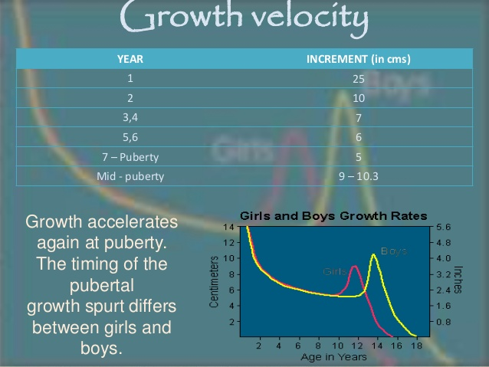

**Statural growth is a continuous but not linear process.**

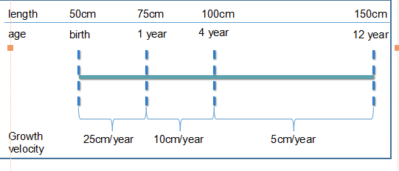  
**Assessment of growth -Body proportions**

* OFC, sitting height, upper-to-lower (U/L) body segment ratio, and arm span are useful in the assessment of short stature, and markedly delayed or disproportionate growth.
* Detection of U/L ratio **above** expected is characteristic of short stature owing to some genetic conditions (eg, Turner syndrome). whereas a ratio **below** expected is observed in short stature due to spinal irradiation.
* **Megalocephaly & rhizomelia** (shortness of proximal legs &arms) are observed in patient with **achondroplasia.**

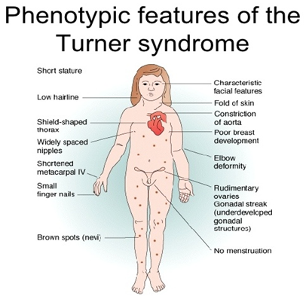

**Growth Charts**

* Measurement of the child should plotted accurately on given chart.
* Growth charts should always be selected based on gender, whether height or length will be plotted, and, if relevant, underlying syndrome.

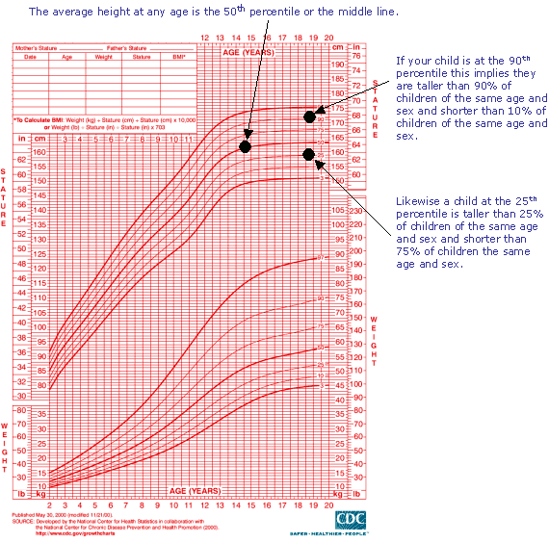

**Prediction of Adult Height and Parental Target Height**

* Assessment of the PAH is frequently used in conjunction with the mid-parental target height (MPH), which takes into account the familial genetic factors in growth and height potential.

**The MPH(target):**

**Girls: ( father's height - 13 cm) + mother's height**

**2**

**Boys: ( mother's + 13 cm) + father's height height** 2

Disparity in the child’s growth percentile (ie, ±10 cm) from the MPH percentile should prompt further investigation.

**Predicted Height:**

* Calculation of predicted height on the basis of:
* current height, bone age, MPH

**History**

* Complete pre, peri & postnatal history including birth length.
* Developmental & school performances.
* Parental & child growth concerns(height relative to the peer group in school).
* Systemic review to exclude any chronic disease as a cause of SS.
* Nutritional history
* Drug that can impair growth (as corticosteroid).
* Psychosocial impact on SS.
* Family history.

**Examination**

* Anthropometric measurements
* Undress the child … and watch

- proportions, skin, skeletal, hands, scars,rash …

* Dysmorphic features  
   - facial dysmorphy(feature of turner,prader willi...ect)
* Pubertal signs
* Thyroid goiter

Midline structural abnormalities e.g.bifid uvula, central maxillary incisor--- hypopituitarism.

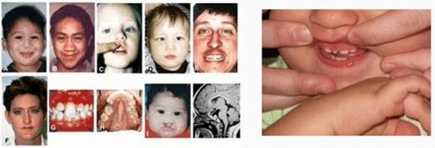

**Investigation**

**Step 1:**

* CBP & differential count, ESR.
* RBS
* GUE
* Ca++, phosphate
* Ferrtine level
* Renal function test
* Liver function test
* Serology & jujenal biopsy for celiac
* Wrist x-ray for bone age
* Skull x-ray to exclude intracranial pathology

**Bone Age**

**Greulich & Pyle**: *Radiographic Atlas of Skeletal Development of the Hand and Wrist,* This method involves a complex comparison of all the bones in the hand and wrist against reference radiographs of different ages.

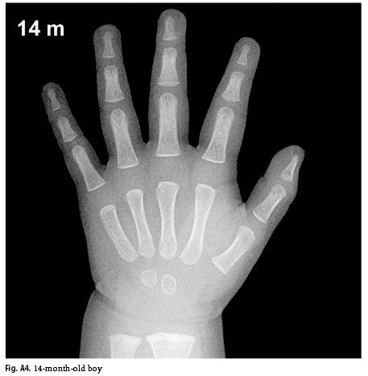

* Delay of 2 years or more in bone age is significant.

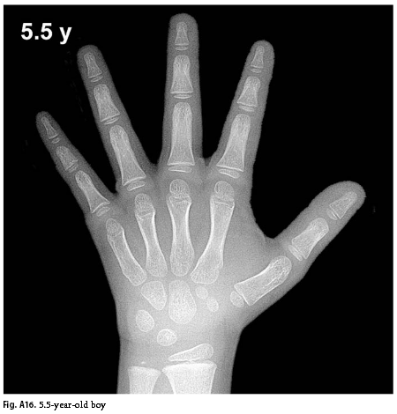

**Skull X-ray & MRI of brain:**

* Not routine
* To assess:
* pituitary
* Any malformations
* exclude masses

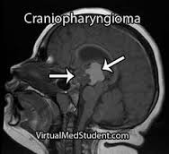

**Step2:**

* Thyroid function test
* Growth factors: IGF1, IGH_BP3
* Growth hormone stimulation test

**Familial (Genetic) SS**

* hallmarks of familial (genetic) short stature is **normal bone age**, normal growth velocity, and predicted adult height appropriate to the familial pattern.
* Ht age < chronological age
* Bone age = chronological age
* Puberty at normal time

**Constitutional SS**

* It is consider as **normal variation in growth**, more in male.
* Positive family history of the same pattern.
* constitutional growth delay is characterized by **delayed bone age** and predicted adult height appropriate to the familial pattern.
* Between 12 and 28 months of age, usually there is slow linear growth and by 3 years of age begin to display normal growth velocity for age.
* **Final height is usually within the normal range** because of the longer period of growth prior to bone maturation but usually in the lower part of the MPH.

**Growth hormon deficiency :**

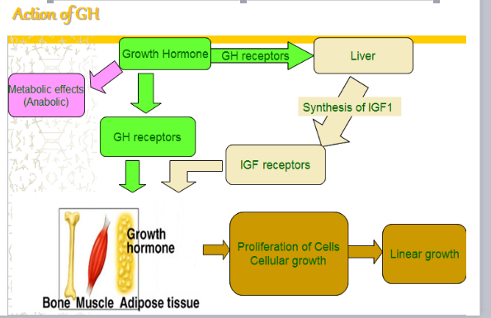

**Growth hormon deficiency**

**Congenital:** (isolated or multiple pituitary hor def)

**Acquired**: (CNS tumer, CNS infection, cranial irradiation, head injury)

**Criteria indicative for GHD**

**Infancy:**

* hypoglycemia
* prolonged jaundice
* obesity
* Microphallus
* Fontanelle closure is often delayed
* The voice infantile because of hypoplasia of the larynx
* Associated midline defects may be present as cleft-palate and lip.
* normal birth length!

**Childhood & Puberty:**

* Delayed bone age.
* height velocity < 25th centile

**Other:**

* Consanguinity and/or affected family member

