***Pleural Effusion***

Definition

Causes

Clinical presentation

Investigation

Treatment

* Regarding pleural effusion: all false except.

1- PE definied as accumulation of non-serous fluid within the pleural space

2- Myxoedema is one of the common causes of PE which is always bilateral.

3- In progression of disease , pleural rub often precede the development of an effusion.

4-Around 200 mL of fluid is required to be detectable on ultrasound or CT.

5- if Pleural fluid aspiration reveal; protein :serum protein ratio > 0.5 that represent transudate pleural effusion.

***Pleura***

The pleura is a thin membrane that covers the entire surface of the lung as well as the inner surface of the rib cage, diaphragm, and mediastinum.

There are two pleural membranes: the visceral pleura, and the parietal pleura, space between them is the *pleural space*.

A small amount of fluid normally in this space

Pleural fluid serves as a lubricant for the visceral and parietal pleura as they move against each other during inspiration and expiration.

The pressure within the pleural space is subatmospheric during quiet breathing.

Pleural fluid usually contains a small amount of protein and a small number of cells that are mostly mononuclear cells.

.

*Definition of pleural effusion:* The accumulation of serous fluid within the pleural space is termed pleural effusion.

***While:***

-The accumulation of frank pus is termed empyema

-The accumulation of blood is haemothorax,

-The accumulation of chyle is chylothorax.

-Pleural fluid accumulates as a result of two ways either:

1-Transudative effusion: increased hydrostatic pressure or decreased osmotic pressure (as seen in cardiac, liver or renal failure),

2- Exudative effusion: increased micro vascular pressure due to disease of the pleural surface itself or injury in the adjacent lung.

***Causes of pleural effusion  
 Common causes***

Pneumonia ('para-pneumonic effusion')

Tuberculosis

Pulmonary infarction*

Malignant disease

Cardiac failure*

Subdiaphragmatic disorders (subphrenic abscess, pancreatitis etc.)

**Uncommon causes**

Hypoproteinaemia* (nephrotic syndrome, liver failure, malnutrition)

Connective tissue diseases* (particularly systemic lupus erythematosus (SLE) and rheumatoid arthritis)

Acute rheumatic fever -- Post-myocardial infarction syndrome

Meigs' syndrome (ovarian tumour plus pleural effusion)

Myxoedema* Uraemia*

Asbestos-related benign pleural effusion

*Clinical presentation*

*Signs and symptom*

* The onset either acute or may be insidious.
* Breathlessness is the only symptom related to the effusion itself, and its severity depends on the size and rate of accumulation
* Decrease chest expansion
* Stony dullness in percussion
* Diminish air entry on auscultation
* Signs of pleurisy (a pleural rub) often precede the development of an effusion, especially in patients with underlying pneumonia, pulmonary infarction or connective tissue disease.

*What findings on physical examination are suggestive of a pleural effusion?*

&Small effusions (< 500 mL) frequently have minimal findings.

&Larger effusions: dullness to percussion, diminished breath sounds, and reduced tactile and vocal fremitus over the involved hemithorax.

&Large effusions (> 1500 mL), with concomitant atelectasis: bronchial breath sounds, egophony,

&Pleural friction rubs may be noted in the early stages or near resolution

***Investigations***   
*imaging*

**- (CXR) :**The classical appearance of pleural fluid on the erect PA chest film is of a curved shadow at the lung base, blunting the costophrenic angle and ascending towards the axilla

* Fluid appears to track up the lateral chest wall.
* Around 200 mL of fluid is required to be detectable on a PA chest X-ray, but smaller effusions can be identified by ultrasound or CT.
* Pleural fluid localised below the lower lobe ('subpulmonary effusion') simulates an elevated hemidiaphragm.
* Fluid localised within an oblique fissure may produce a rounded opacity, simulating a tumour.

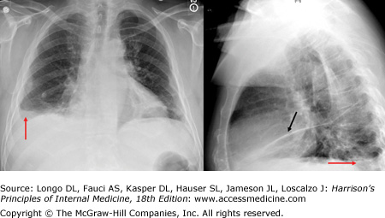

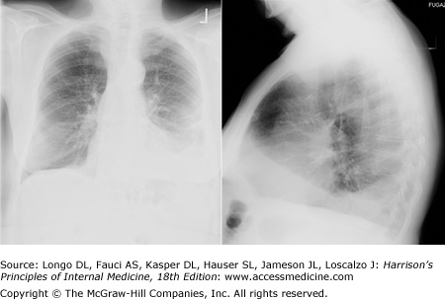

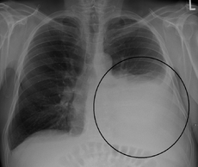

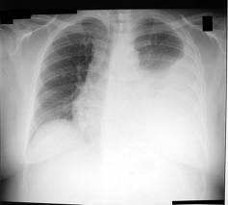

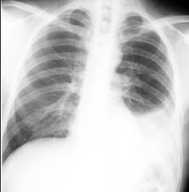

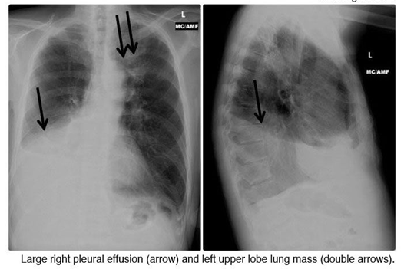

-**Ultrasonography** is more accurate than plain chest radiography for determining the volume of pleural fluid and frequently provides additional helpful information.

* Visualization of fluid facilitates skin marking to indicate a site for safe needle aspiration and guides pleural biopsy, increasing diagnostic yield

-**CT** displays pleural abnormalities more readily than either plain radiography or ultrasound, and may distinguish benign from malignant pleural disease

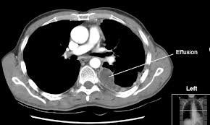

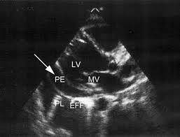

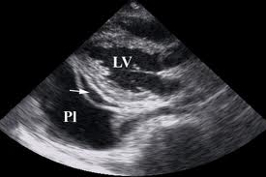

*What other diagnostic procedures are available?*

**-Bronchoscopy,** if the patient has a parenchymal abnormality on chest x-ray or CT scan.

**-Thoracoscopy,** which allows direct visualization of the pleural surface, and guided or open pleural biopsy.

-Pleural aspiration and biopsy

**-Combining pleural aspiration with biopsy** increases the diagnostic yield, particularly when guided by either ultrasound or CT..

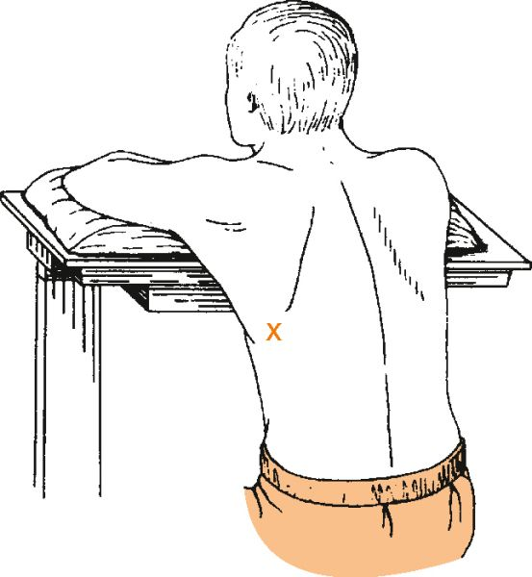 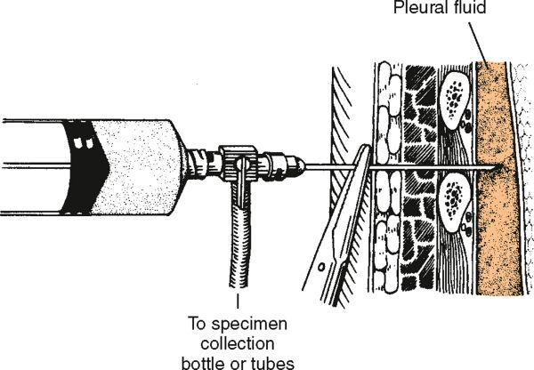

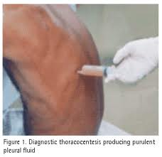

***Simple aspiration provides information***

**-colour and texture** of fluid and on appearance alone may immediately suggest an empyema or chylothorax. Or infection TB

**The presence of blood** is consistent with pulmonary infarction or malignancy, but may represent a traumatic tap.

**Biochemical analysis** allows differentiation of transudates from exudates

**Gram stain** may indicate parapneumonic effusion.

**Cytological examination** is essential, as the predominant cell type provides useful information.

**A low pH** suggests infection but may also be seen in rheumatoid arthritis, ruptured oesophagus or advanced malignancy.

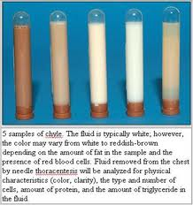

***Pleural aspiration and biopsy***

*((Light's criteria for distinguishing pleural ((exudate from transudate*

**Pleural fluid is an exudate if one or more of the following criteria are met:**

1-Protein <3 g/dL

2-Pleural fluid protein:serum protein ratio > 0.5

3-Pleural fluid LDH:serum LDH ratio > 0.6

4-Pleural fluid LDH > two-thirds of the upper limit of normal serum LDH

***Pleural effusion: main causes and features***

|  |  |  |  |  |
| --- | --- | --- | --- | --- |
| ***other*** | ***Predominant cell*** | ***type*** | ***Appearance*** | ***Cause*** |
| ***Positive tuberculin test Isolation of M. tuberculosis from pleural fluid (20%) Positive pleural biopsy (80%)*** | ***Lymphocyte*** | ***exudate*** | ***Serous .usually amber*** | ***tuberculosis*** |
| ***Positive pleural biopsy (40%) Evidence of malignant disease elsewhere*** | ***Serosal cells and lymphocytes***  ***Often clumps of malignant cells*** | ***Exudate*** | ***Serous, often blood-stained*** | ***Malignant disease*** |
| ***Other evidence of left ventricular failure Response to diuretics*** | ***Few serosal cells*** | ***Transudate*** | ***Serous, straw-coloured*** | ***Cardiac failure*** |
| ***Evidence of pulmonary infarction Source of embolism*** | ***Red blood cells Eosinophils*** | ***Exudate (rarely transudate)*** | ***Serous or blood-stained*** | ***Pulmonary infarction*** |
| ***Other manifestations of SLE Antinuclear factor or anti-DNA in serum*** | ***Lymphocytes and serosal cells*** | ***Exudate*** | ***Serous*** | ***SLE*** |
| ***chylomicron*** | ***non*** | ***Milky*** | ***Chyle*** | ***Obstruction of thoracic duct*** |
| ***High amylase in pleural fluid (greater than in serum)*** | ***No cells predominate)*** | ***Exudate*** | ***Serous or blood-stained*** | ***Acute pancreatitis*** |

*Management*

* Therapeutic aspiration may be required to palliate breathlessness, but removing more than 1.5 L in one episode, is inadvisable as there is a small risk of re-expansion pulmonary oedema.
* An effusion should never be drained to dryness before establishing a diagnosis, as further biopsy may be precluded until further fluid accumulates.
* Treatment of the underlying cause-for example, heart failure, pneumonia, pulmonary embolism or subphrenic abscess-will often be followed by resolution of the effusion.

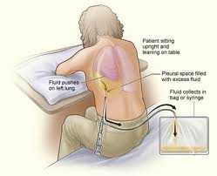

*What is the significance of a parapneumonic effusion?*

. A parapneumonic effusion is any effusion associated with pneumonia. Up to 40% of all pneumonias may be associated with a pleural effusion. Morbidity and mortality rates are higher in pneumonias with effusion than in pneumonia alone.

Most effusions resolve without specific intervention. However, the effusion may be complicated and require tube thoracotomy (chest tube) or surgical decortication

Single choice

Regarding pleural effusion: all false except.

1- The accumulation of non-serous fluid within the pleural space

2- Myxoedema is always bilateral and common cause

3- a pleural rub often precede the development of an effusion

4-Around 200 mL of fluid is required to be detectable on ultrasound or CT.

5- Pleural fluid protein:serum protein ratio > 0.5 represent transudate pleural effusion.

*Best Regards;*

*Saif AlDeen Adil Kamil*