|  |  |  |
| --- | --- | --- |
| **Fifth stage** | **Surgery** | **Lec-6** |
| **د.مثنى** | **8/3/2017** |

**LOWER LIMB TRAUMA AND FRACTURES**

**HIP DISLOCATION**

It is of three main types :

1- posterior.

2- anterior.

3- central.

*4/5 traumatic dislocation of the hip is of posterior type .*

**Posterior hip dislocation**

*It is the commonest type*

***Mechanism of injury*** :

It occurs in road traffic accident when someone seated in truck or car is thrown foreword striking the knee against the dashboard . The femur is thrust backward and the femoral head is forced out of its socket . Often a piece of bone of the acetabulum is sheared off making it a fracture – dislocation

***Clinically :***

On examination :

the leg is *short*  ,*adducted* , *internally rotated* and *slightly flexed* .

This injury is easily to be missed when associated with fracture femur .

The lower limb should be examined for sciatic nerve injury .

***X-ray :***  AP view : the femoral head is seen out of its socket and above the acetabulum . There may be associated fracture in the femoral head or in the rim of the acetabulum .

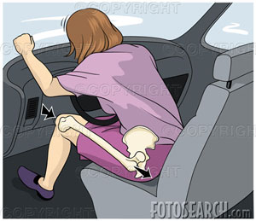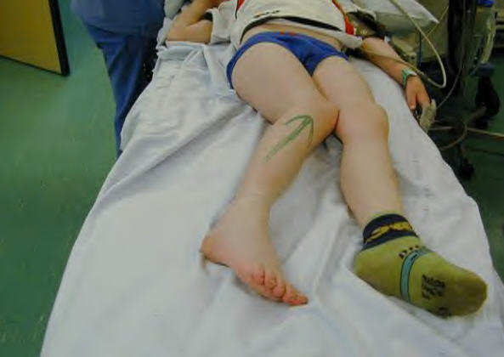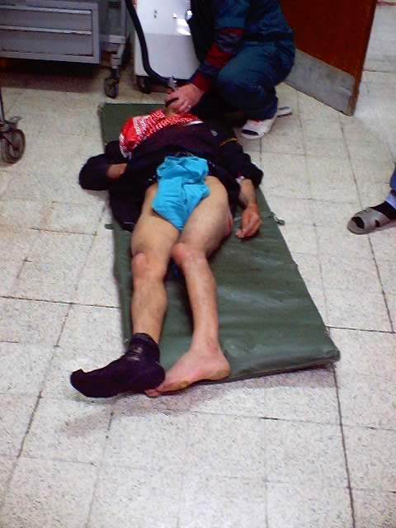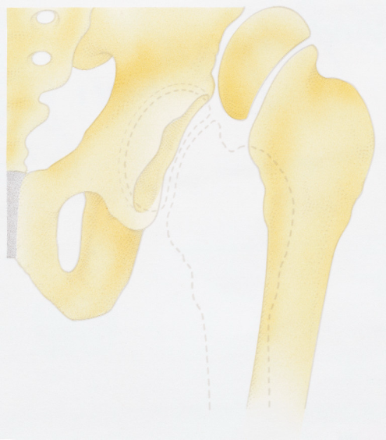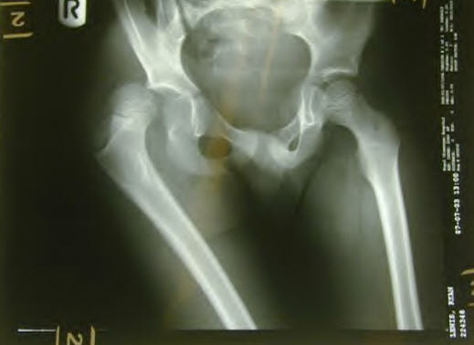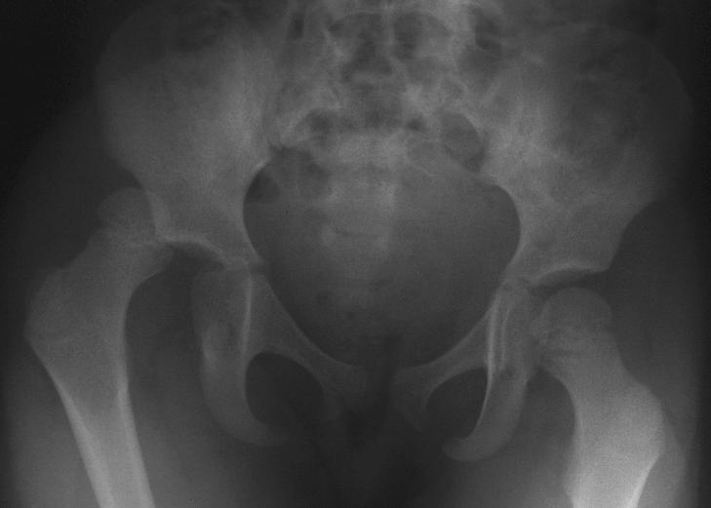

***Treatment :***

Dislocation must be reduced as soon as possible under general anesthesia .

The patient put on ground. The assistant steadies the pelvis , the surgeon start by applying traction in the line of the femur 90% flexion of both hip and knee , then a clunk terminate the maneuver . Followed by x-ray checking ; then put the injured limb in rest by applying skin or more beneficial skeletal traction for 3-6 weeks , the patient is allowed to walk by crutches ; if there is fracture rim of the acetabulum and the piece is large then internal fixation is mandatory .

**Complication :**

***Early* :**

1- sciatic nerve injury : it occurs in 10-20 % of the cases but fortunately it usually recover , if not , then nerve exploration must be considered.

2- vascular injury : superior gluteal artery .

3- associated fractures : acetabular , femoral head , femoral neck and femoral shaft and here the dislocation may be missed .

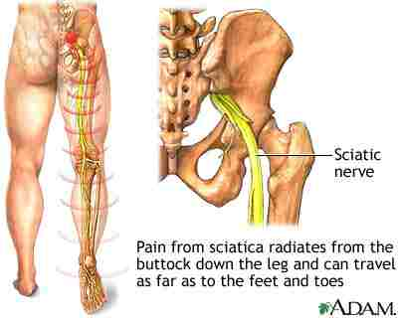

***Late :***

1- avascular necrosis of the femoral head ,appear in the x-ray as an increase in density of the femoral head , but it is not seen before 6 weeks and some time up to 2 years .

In early weeks , bone scan and MRI will be helpful in the diagnosis of ischemia .

**Treatment of avascular necrosis** *:*

in**younger** patient treated with realignment osteotomy if it is partial or by arthrodesis of the hip .

In **older** patient with acetabular changes then total hip replacement .

2- myositis ossificans.

3- unreduced dislocation

4- secondary osteoarthritis

**Anterior dislocation of the hip**

it is rare .

***Clinically :*** the leg is externally rotated , abducted and slightly flexed , not short .

sometimes the leg is abducted to right angle .

***X-ray :*** AP view , the dislocation is obvious , any doubt is resolved by lateral view .

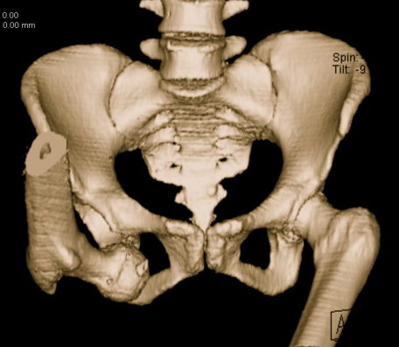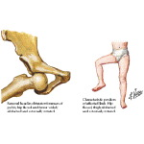

**Central dislocation of the hip**

fall on the side or blow over the greater trochanter may force the femoral head medially through the floor of the acetabulum .

Although it is called central dislocation of the hip , it is really a fracture of the floor of the acetabulum

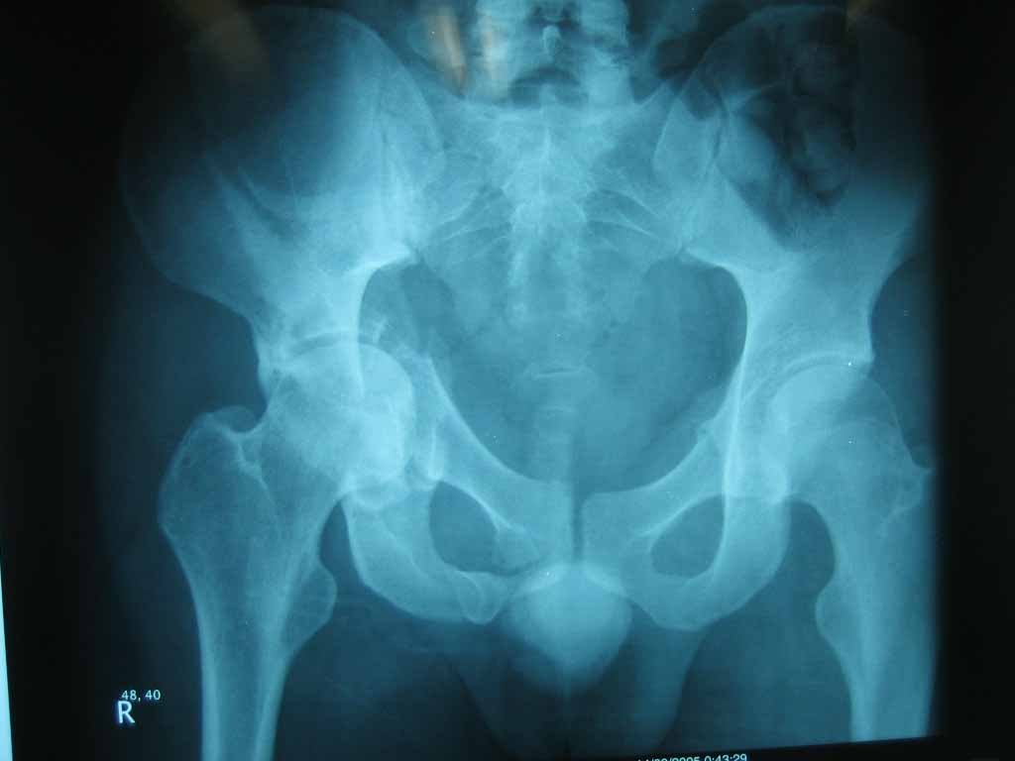

**Fractures of the femoral neck**

Neck of the femur is a commonest site of fracture in elderly .

Risk factors :

1- osteoporosis .

2- osteomalascia .

3- diabetes mellitus .

4- stroke (disuse) .

5- weak muscles and poor balance .

6- alcoholism .

7- debilitating diseases .

Generally fracture neck femur is classified in to :

*A – intra capsular fracture.*

*B - extra capsular fracture.*

***A-* intracapsular fracture neck of the femur :**

Mechanism of injury :

This fracture usually result from a fall directly on to the greater trochanter . In very osteoporotic patient less forced is required . Sometimes no more than catching a toe in the carpet and twisting the hip into external rotation .

In young people the cause is mainly car accident or fall from height .

***Classification :*** the most useful classification for intracapsular fracture neck of femur is that of (*Garden classification)* which based on the degree of displacement .

*Stage one :* is incomplete impacted fracture .

*Stage two :* is complete undisplaced fracture .

*Stage three :* complete fracture with moderate displacement .

*Stage four :* is severely displaced fracture .

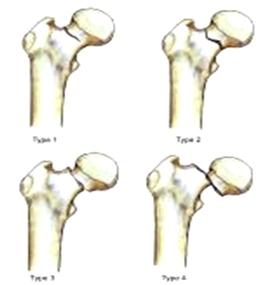

this fracture is complicated by two main problems which are :

1- ischemia of the head of the femur .

2- tardy union .

*The blood supply of the head of the femur are :*

1- intramedullary vessels in the femoral neck .

2- capsular vessels ; in the capsule of the joint .

3- the vessel in the ligamentum teres .

The first two vessels are interrupted by the fracture , and the third is present only in 20% of the elderly .

***Clinical feature :***

History of fall followed by pain in the hip .

If the fracture is displaced , the limb will be *externally rotated* ,*and short* .

***Treatment :***

The first measure is to apply skin traction to splint the fracture and to control the pain , and give analgesic for pain relieve .

Operative treatment is always mandatory .

Displaced fracture will not unite without internal fixation .

Old people should be got up and active without delay to avoid pulmonary complication and bed sore .

The operation should be done as early as possible to avoid risk of complications .

The principle is perfect reduction , secure rigid fixation and early mobilization .

the fixation should be done by internal fixators like compression screws , plate and screws , dynamic hip screw ……etc .

In patient above 65 years with displaced fracture , partial hip replacement or total hip replacement.

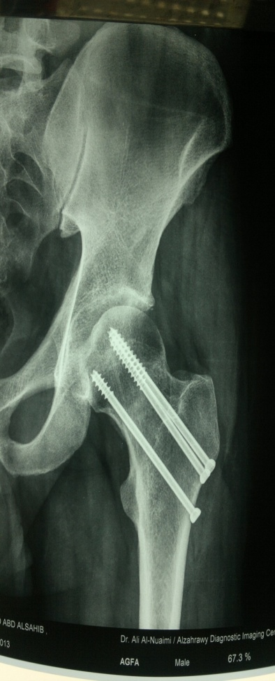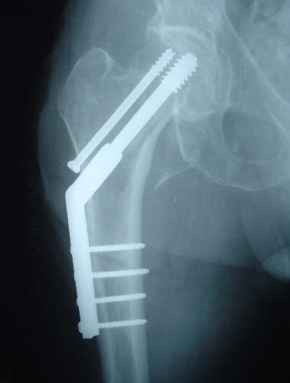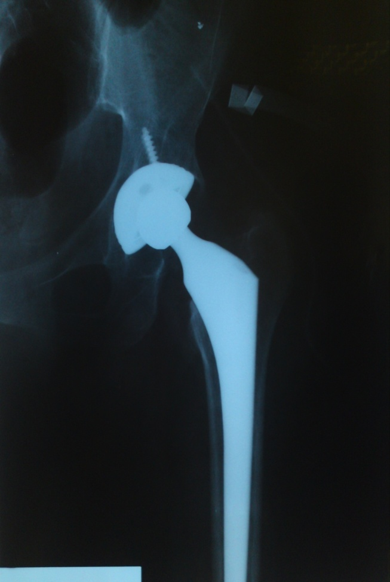

**Complications :**

*General complication* :

Most of these patients are elderly , and they are prone to general complication such as :

1- deep vein thrombosis .

2- pulmonary embolism .

3- pneumonia .

4- bed sore .

*Local complication :*

1- *a vascular necrosis of the femoral head* .

Early diagnosis by MRI

few weeks later we can diagnose it by bone scan .

X-ray changes may not show itself for months or even years.

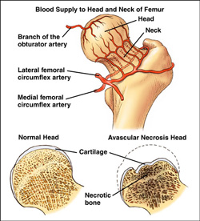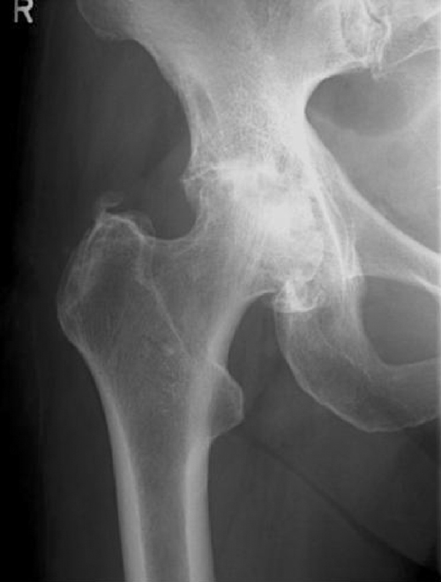

*Treatment of avascular necrosis* :

In patients over 45 years old , the treatment is by total hip replacement .

Below this age , the treatment will be by realignment osteotomy or arthrodesis .

*2- non union* :

More than 30% of all femoral neck fracture fail to unite , and increase in displaced fracture

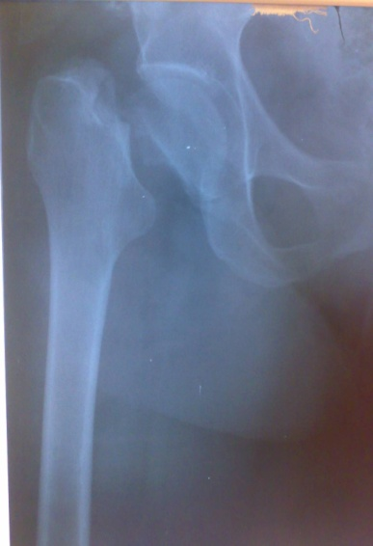

3- osteoarthritis of the hip joint .

Avascular necrosis of the femoral head will lead to osteoarthritis later on .

The treatment is by total hip replacement .

**Intertrochanteric fractures (Extracapsular)**

* Common in elderly, osteoporotic people;
* most of the patients are women in the 8th decade.
* In contrast to intracapsular fractures, extracapsular trochanteric fractures unite quite easily and seldom cause avascular necrosis.

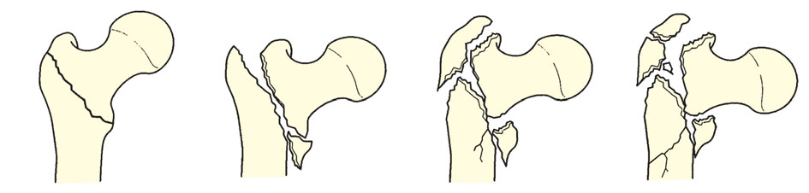

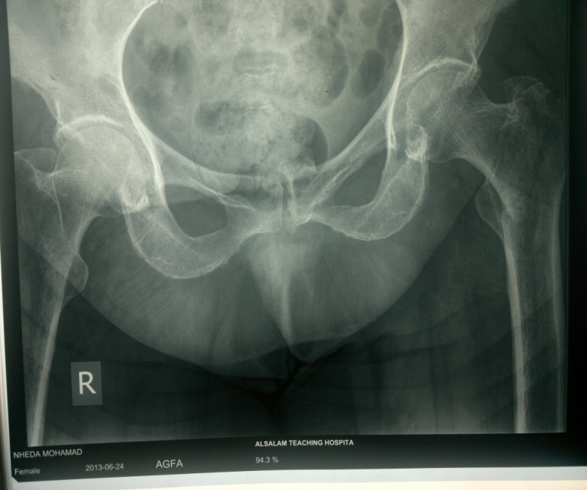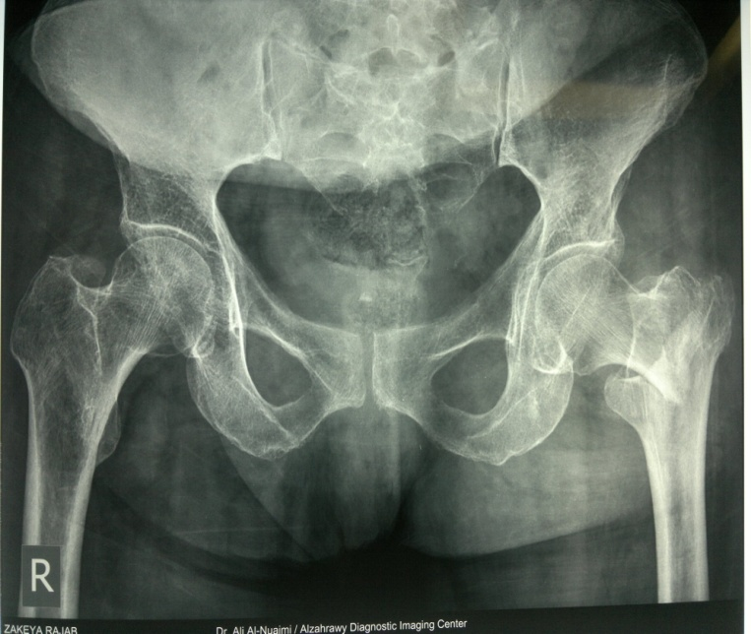

**Treatment**

* Intertrochanteric fractures are almost always treated by early internal fixation because :

(a) to obtain the best possible position And

(b) to get the patient up and walking as soon as possible and thereby reduce the complications associated with prolonged recumbency.

* The fracture is fixed with an angled device – preferably a sliding screw in conjunction with a plate (dynamic hip screw) or
* intramedullary nail. or
* 95 degree screw-plate (L-Plate)

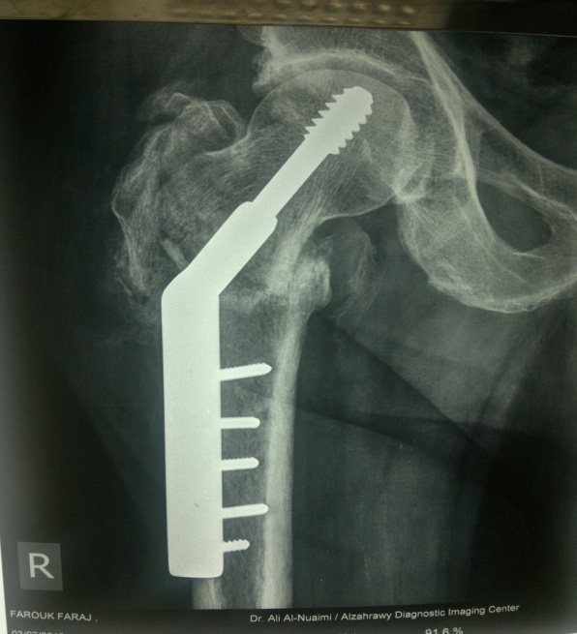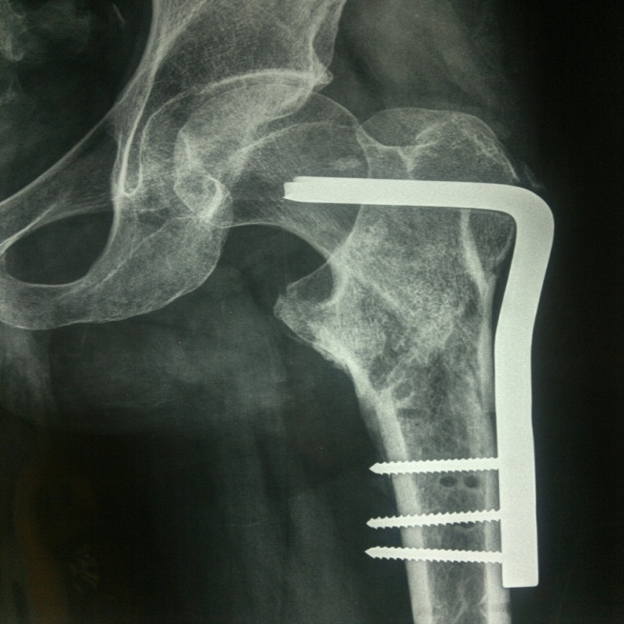

Dynamic hip screw

L-plate (fixed angle plate)

**Complications**

Early complications : are the same as with femoral neck fractures

Late Complications:

* Failed fixation
* Malunion Varus and external rotation deformities
* Non-union: Intertrochanteric fractures seldom fail to unite.

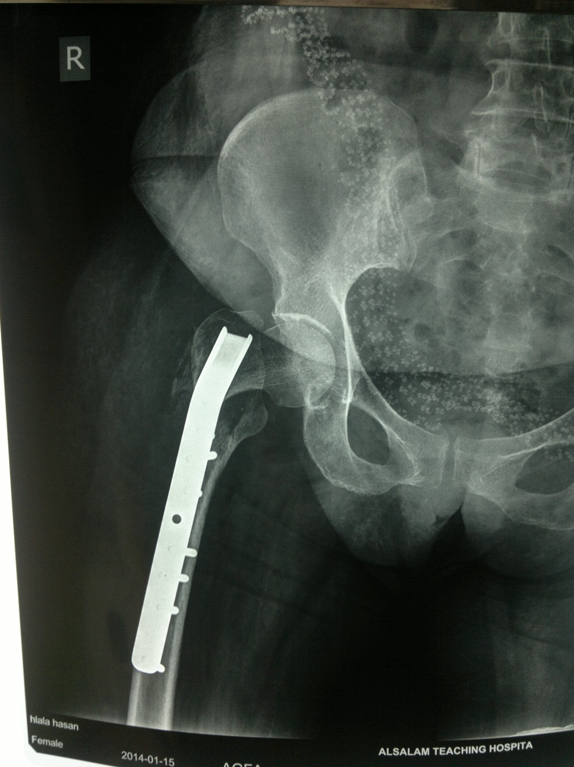

Failed internal fixation