|  |  |  |
| --- | --- | --- |
| **Fifth stage** | **Surgery** | **Lec-2** |
| **د.محمد نزار** | **13/4/2017** |

IRRITABLE HIP

Irritable hip: is a term referred to transient synovitis of the hip in children; in which the child complain from pain and limping . it is the commonest cause of hip pain in children .

Boys affected twice as often as girls (2:1)

**Clinically**

The child is usually between 6-12 years old .

Presentation : pain and limping in otherwise healthy child .

The pain is felt in the groin and in the front of the thigh .

On examination : restriction of all movements with pain .

The symptoms subside spontaneously within 1-2 weeks so it is called transient .

**Investigation**

* 1- blood investigation : NORMAL .
* 2- x- ray finding : NORMAL .
* 3- ultrasound ex. Of hip: MILD EFFUSION.

**Differential diagnosis of pain and limping in children**

1- transient synovitis (commonest cause) .

2- Perthes’ disease .

3- pyogenic infection(septic arthritis or osteomyelitis) .

4- T.B synovitis .

5-typhoid or brucillosis affecting the hip .

6-slipped femoral epiphysis .

7- Juvenile chronic arthritis .

**Treatment**

The child otherwise completely healthy .

1- in mild cases : rest in bed at home , analgesic anti inflammatory drugs .

2- in moderate to sever cases admission to the hospital rest in bed , skin traction , analgesic anti inflammatory drugs .

Weight bearing not allowed before acute attack is subside (usually take 1-2 weeks).

**PERTHES’ DISEASE**

**Introduction**

It is also called Legg – Calve’- Perthes’ disease .

It is painful disorder of childhood characterized by avascular necrosis of the femoral head .

It’s incidence is 1 : 10000 child .

More common in boys than in girls (4:1) .

Age incidence usually between 4-8 years

**Pathogenesis**

The precipitating factor of the disease is unknown .

The main step in pathogenesis is ischemia of the femoral head .

Up to the age of 4 months the femoral head is supplied by:

1- metaphyseal blood vessels .

2- lateral epiphyseal vessels .

3- vessels in the ligamentum teres .

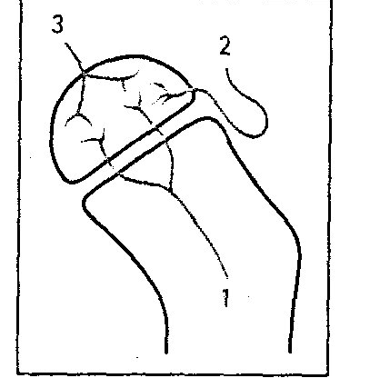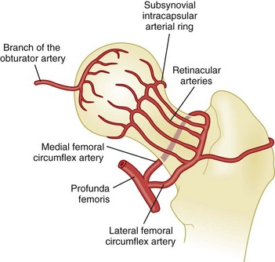

Pathogenesis (cont.)

The metaphyseal blood supply gradually decline until by the age of 4 year it will disappear …. The vessels in the legamentum teres develop at the age of 7 years old ; so between the age 4-7 years the blood supply depend on the lateral vessels which run into the capsule of the joint , make them susceptible to stretching and pressure from an effusion of the joint .

**pathology**

* Pathological process take 2-4 years to complete .
* Stage 1.. Ischemia and bone death .
* Stage 2.. Revascularization and repair .
* Stage 3.. Distortion and remodeling .

**Clinical features**

Typically a boy of 4-8 years complain from pain at the hip region associated with limping .

The attack take few weeks (more than 2 ) and it may recur intermittently .

The child’s general health is good .

At early stage the joint is irritable(all movements are restricted ) and their extremes are painful.

In late stages all movements are full apart from limitation in abduction and internal rotation

**X-ray**

1- at the beginning the x- ray look normal some time we can see asymmetry of the ossific centers ; bone scan is helpful at this stage (showing the avascular area) .

2- later on the increase density of the ossific nucleus will be clear ; and there is increase in the joint space .

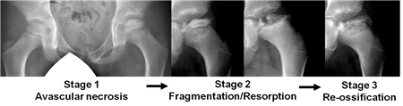

3- fragmentation of the epiphysis .

4- flattening and lateral displacement of the epiphysis .

5- widening of the metaphysis .

6- in sever and advance cases the head become mushroom shape .

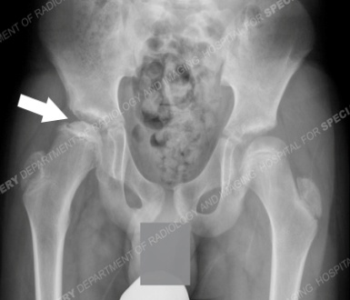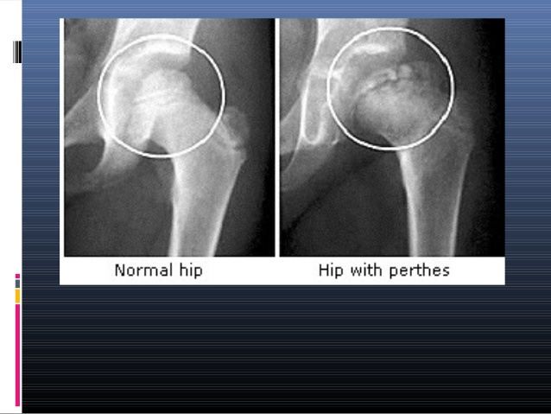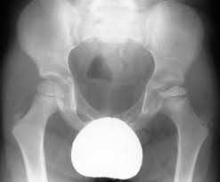

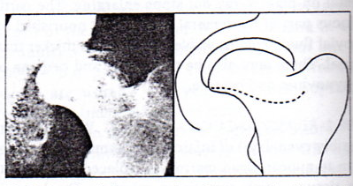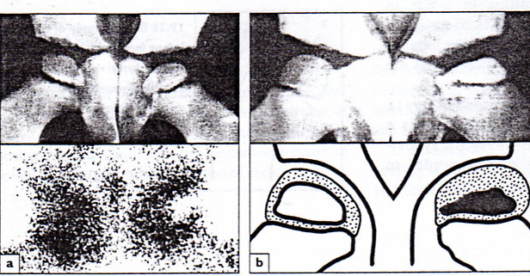

**prognostic factors**

1- age : below 6 years good prognosis .

2- sex : girls carry bad prognosis than boy

3- the greater the involvement of the femoral head the badest is the prognosis .

**Criteria of ahead at risk**

1- progressive uncovering of the epiphysis

2- calcification of the cartilage lateral to the ossific nucleus .

3- radiolucent area at the lateral edge of the epiphysis .

4- sever metaphyseal resorption .

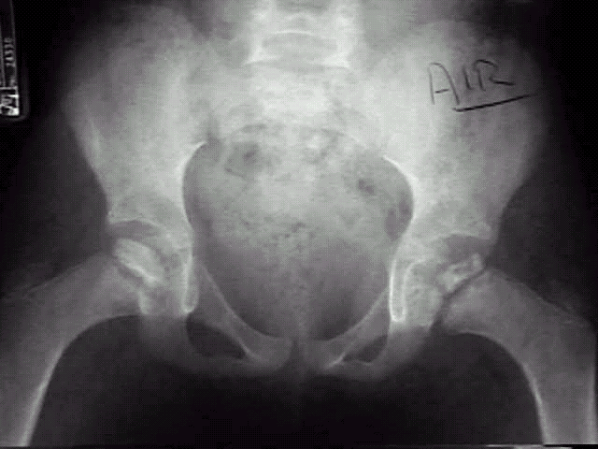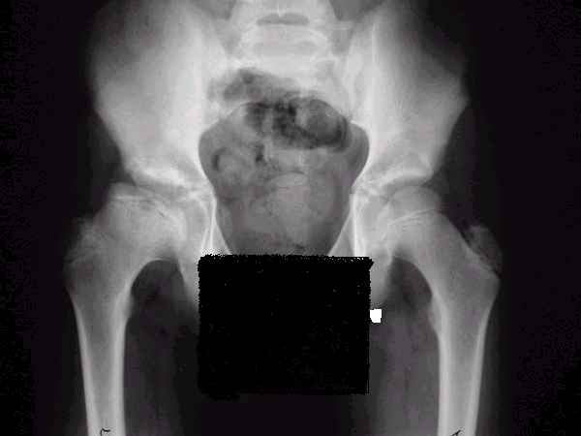

**Treatment of perthe’s disease**

As long as the head is irritable the child should be kept in bed with skin traction and the hip is in little flexion and external rotation . Once the irritability is subside which usually take three weeks then movements is encouraged .

Further treatment :

A – symptomatic treatment . B – containment.

**Symptomatic treatment :**

Include : pain control by simple analgesic and periods of traction and rest .

Regular assessment should be taken every few months i.e. (supervised – neglect) way.

Sport and heavy activities should be avoided

**containment :**

It mean taking active step to seat the head of the femur as fully as possible in the acetabular socket.

This achieved by :

A – holding the hip widely abducted in plaster or in removable abduction splint and the position maintained for at least one year .

B – operation by varus osteotomy of the femur or osteotomy of the innominate bone