**Major connector** :- is component of partial denture that connect the part of the prosthesis is located on one side of the arch with those on the opposite side...

**Type of Maxillary Major Connectors**

1-Single palatal strap

2-Single palatal bar

3-U shape palatal connectors

4-Combination anterior-posterior palatal strap

5-Anterior-Posterior Palatal bar

6-Full Palatal plate.

***1-Single Palatal Strap(Usually use for Class III modification I)***

Design:

Wide anterio-posteriorly,it should be at least 8mm wide for adequate rigidity.

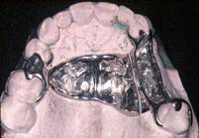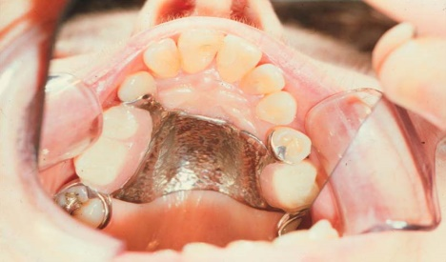

***2-Single Palatal Bar(Can be used only in classIII) .***

**Design**

1-It is bar shape running across the palate

2-It has Narrow(half-oval cross section) anterio-posteriorly

Thick occluso-gingivally

Type of single palatal bar

posterior palatal bar middle palatal bar

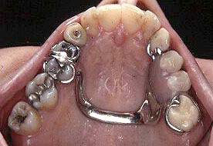

***3-Anterior Palatal Plate (cl I , II , IV)  
(U-Shaped or "Horse-Shoe" Palatal Connector)***

***Design:***

1.It consists of U-shaped thin band of metal of 6-8mm in width.

2.The borders must be either 6mm away from the gingival margin or extend onto the lingual surfaces of the teeth.

3.The connector should be uniform in thickness, symmetric, and with curved and smooth borders

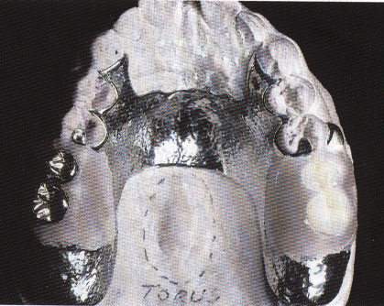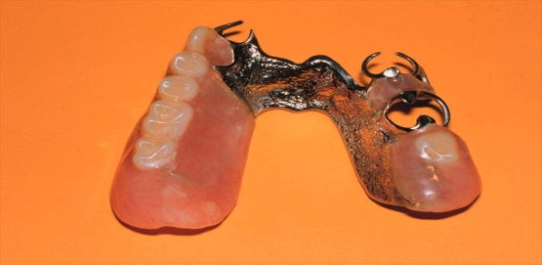

***Note: the u shape palatal major connector is least favorable design of all palatal major connectors, because its lacks the rigidity of the other type***

***4-Anteroposrerior palatal strap(( closed horseshoe)) (cl I, II, III)***

***Design***

1.The anterior strap should be positioned as back as possible on the rugae area.

2.The posterior strap should be placed as far back as possible on the hard palate.

3.The borders of the connectors should be placed 6 mm away from the gingival margins or should extend above the height of contour of the teeth

4-Relatively broad(8 to 10 mm) anterior and posterior palatal straps

5-Lateral palatal straps (7 to 9 mm) narrow and parallel to curve of arch.

6-Anterior palatal strap follows the valleys of the rugae at right angles to the median palatal suture.

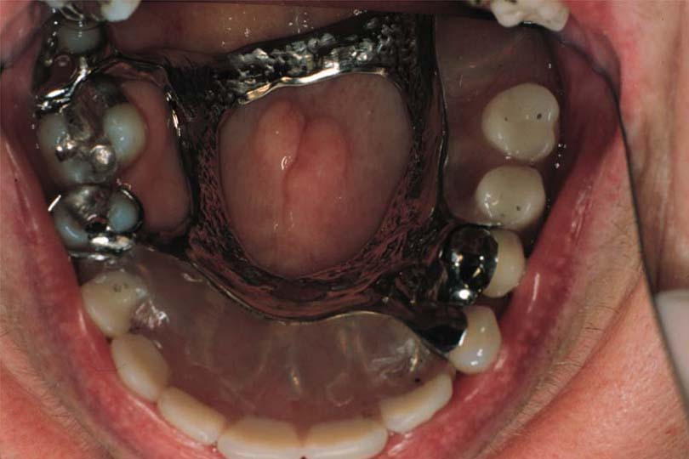

***5-Anterior-Posterior Palatal Bar ( cl II MOD I, IV)***

Design:-

-the anterior bar is relatively flat similar to palatal strap border.

-the posterior bar is half oval similar to the palatal bar major connector**.**

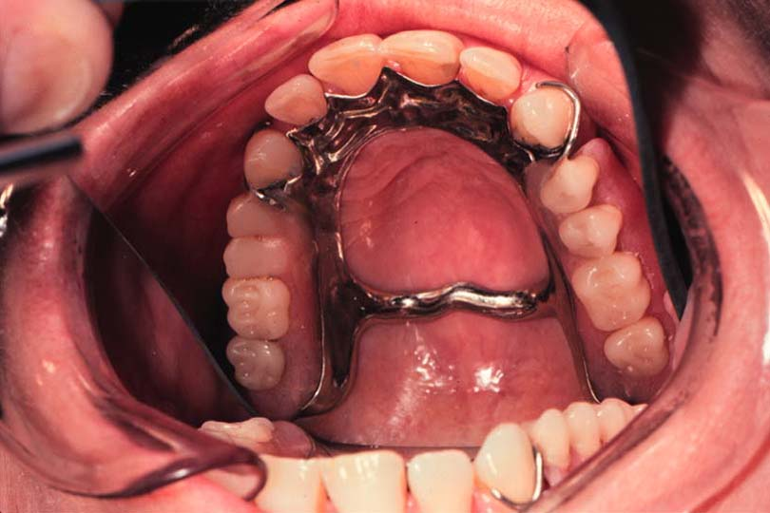

***6-Full Palatal Plate( cl I)***

***Design:***

1.The anterior border should be 6 mm away from the gingival margin.

2. Posterior borders are extended to the junction of movable and immovable soft palate.

3.The posterior border is beaded to prevent debris from collecting beneath the palate

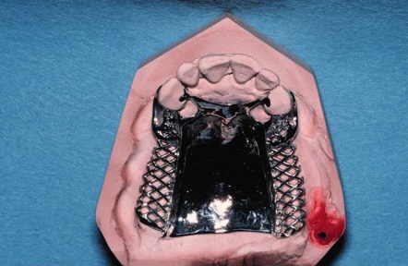

**Type of full palatal plate**

1-All metal

2- compensation (Acrylic and metal :metal extended over the half of the palate while acrylic is attached the border of the metal contain small (mesh work) for retention.

**Purposes of beading as follow**

1- To transfer the major connector design to the investment cast.

2- To provide a visible finishing line for casting

3- *Beading to prevent food accumulation between the palate and the connector*

***Thank you***