**د. شامل ادوية 15\2\2018**

**عدد الاوراق ( 7 ) م\3\موصل lec:11**

**Antihypertensive Drugs**

**Overview**

Hypertension is defined as an elevated systolic BP (SBP), diastolic BP (DBP) or both

SBP ≥140 mmHg and/or a DBP≥90mmHg

Causes:

Primary (Essential)

Secondary 10-15%

Treatment:

1.Nonpharmacological (Life-style modification)

2.Pharmacological

**Goal of Treatment**

Reducing hypertension-related complications (target organ damage) was the ultimate goal of treatment , particularly, coronary heart disease, stroke, heart failure, and renal insufficiency

Decisions about the management depend upon:

BP levels

Presence of other cardiovascular risk factors, Target organ damage,

Associated clinical conditions .

**BASIC PHARMACOLOGY OF ANTIHYPERTENSIVE AGENTS**

***Diuretics***

***Sympathoplegic drugs***

1. ß-adrenergic antagonists .

2. α-adrenergic antagonists .

3. Mixed adrenergic antagonists .

4. Centrally acting agents .

5. Adrenergic neuron blocking agents .

* ***Calcium channel blockers***
* ***Angiotensin-converting enzyme inhibitors***
* ***Angiotensin ІІ receptor antagonists***
* ***Vasodilators***

**Sympathoplegic agents:**

**Centrally acting agents**

**Mechanisms & Sites of Action:**

Reduce sympathetic outflow from vasopressor centers

Increase their sensitivity to baroreceptor control.

**A. Clonidine**

Alpha2-agonist

Reduce norepinephrine release onto relevant receptor sites

Act on presynaptic alpha2- adrenoceptors to inhibit activity of appropriate neurons

Binds to a nonadrenoceptor site, the imidazoline receptor,

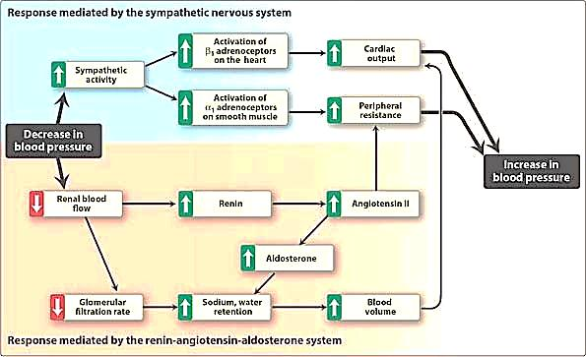

**Clonidine**

*Clonidine* does not decrease renal blood flow or glomerular filtration.

*clonidine* may be administered in combination with a diuretic

**Adverse effects**

Sedation

Drying of the nasal mucosa.

Rebound hypertension occurs following abrupt withdrawal.

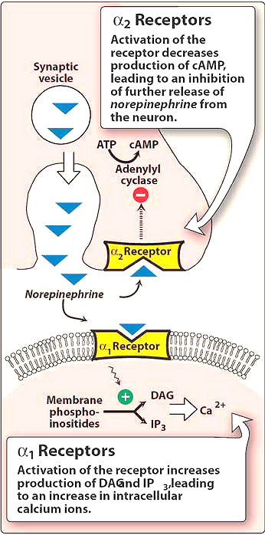

**B. Methyldopa**

Converted to alpha-methylnorepinephrine centrally to diminish the adrenergic outflow from the CNS

Reduced total peripheral resistance and a decreased blood pressure

Blood flow to the kidney is not diminished

**Adverse effects**

Sedation

Drowsiness

It has been used in hypertensive pregnant patients

**ADRENERGIC NEURON-BLOCKING AGENTS**

**A. GUANETHIDINE**

guanethidine can produce profound sympathoplegia.

Guanethidine can produce all of the toxicities expected from **"pharmacologic :sympathectomy**,”

marked postural hypotension,

diarrhea,

impaired ejaculation

**B.RESERPINE:**

Reserpine blocks the ability of aminergic transmitter vesicles to take up and store biogenic amines

Depletion of norepinephrine, dopamine, and serotonin in both central and peripheral neurons

Postural hypotension is mild

**Adverse effects**

Sedation

Mental depression

Parkinsonism symptoms

**Beta-Adrenoceptor Blocking Agents:**

1.The b-blockers reduce blood pressure primarily by decreasing cardiac output.

2.They may also decrease sympathetic outflow from the central nervous system.

3.Inhibit the release of rennin from the kidneys, thus decreasing the formation of angiotensin II and the secretion of aldosterone.



The prototype B-blocker is *propranolol*, which acts at both B1 and B2 receptors.

Selective blockers of B1 receptors, such as *metoprolol* and *atenolol* are among the most commonly prescribed B-blockers

***Therapeutic uses*:**

1. **Treatment of hypertension** .

2. **Hypertensive patients with concomitant diseases**

***Adverse effects***

**1.Common effects**

**2.Alterations in serum lipid patterns:**

**3.Drug withdrawal:**

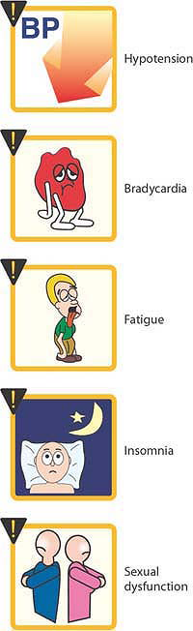

**Alpha- Adrenoceptor Blocking Agents:**

They decrease peripheral vascular resistance and lower arterial blood pressure by causing relaxation of both arterial and venous smooth muscle.

These drugs cause only minimal changes in cardiac output, renal blood flow, and glomerular filtration rate

* *Prazosin* , *doxazosin* , and *terazosin*  produce a competitive block of alpha1-adrenoceptors.

***Adverse effects:***

1. Reflex tachycardia

2. First-dose syncope

3. Postural hypotension may occur in some individuals

**Alpha and Beta-Adrenoceptor Blocking Agents:**

*Labetalol* and *carvedilol* block both ɑ1- and β1- and β2- receptors.

*Carvedilol,* although an effective antihypertensive, is mainly used in the treatment of heart failure.

**Vasodilators:**

**Hydralazine**:

This drug causes direct vasodilatation, acting primarily on arteries and arterioles.

This results in a decreased peripheral resistance, which in turn prompts a reflex elevation in heart rate and cardiac output.

It is almost always administered in combination with a beta-blocker, such as *propranolol* (to balance the reflex tachycardia), and a diuretic (to decrease sodium retention).

*Hydralazine*  monotherapy is an accepted method of controlling blood pressure in pregnancy-induced hypertension.

**Adverse effects** :

Headache, tachycardia, nausea, sweating, arrhythmia, and precipitation of angina.

lupus-like syndrome

**Minoxidil**

This drug causes dilation of resistance vessels (arterioles) but not of capacitance vessels (venules).

Reflex tachycardia and fluid retention may be severe and require the concomitant use of a loop diuretic and a beta-blocker

*Minoxidil* treatment also causes hypertrichosis

**Calcium-Channel Blockers**

**Classes of calcium-channel blockers**

**1. Diphenylalkylamines:**

*Verapamil* is the least selective of any calcium-channel blocker

**2.Benzothiazepines:**

*Diltiazem* affects both cardiac and vascular smooth muscle cells; however, it has a less pronounced negative inotropic effect on the heart compared to that of *verapamil*.

**3.Dihydropyridines:**

First-generation *nifedipine*  and five second-generation agents for treating cardiovascular disease: *amlodipine*, *felodipine* , *isradipin*, *nicardipin*, and *nisoldipine* .

All dihydropyridines have a much greater affinity for vascular calcium channels than for calcium channels in the heart.

*Amlodipine* and *nicardipine :*little interaction with other cardiovascular drugs, such as *digoxin* or *warfarin*,

**Mechanism of Actions:**

Calcium-channel antagonists block the inward movement of calcium by binding to L-type calcium channels in the heart and in smooth muscle of the coronary and peripheral vasculature.

This causes vascular smooth muscle to relax, dilating mainly arterioles.

**Therapeutic uses:**

Calcium-channel blockers have an intrinsic natriuretic effect and, therefore, do not usually require the addition of a diuretic.

These agents are useful in the treatment of hypertensive patients who also have asthma, diabetes, angina, and/or peripheral vascular disease .

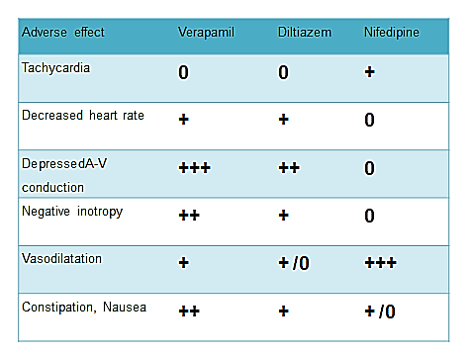

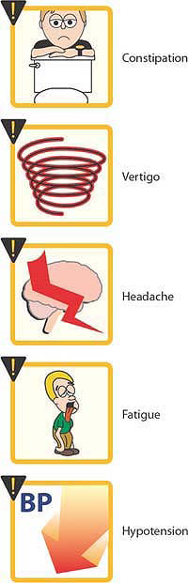

**Inhibitors of Angiotensin:**

There are four ways to reduce the activity of the Rennin Angiotesin Aldosterone System (RAAS) in human:

1.β-blockers

2.Rennin Inhibitors

3. ACE inhibitors

4. ARBs

**Angiotensin converting enzyme (ACE) inhibitors:**

ACE is a membrane-bound enzyme that is localized on the plasma membranes of various cell types, including:

1.Vascular endothelial cells,

2.Renal proximal tubular cells,

3.Neuroepithelial cells

4.Lung, which has a vast surface area of vascular endothelium

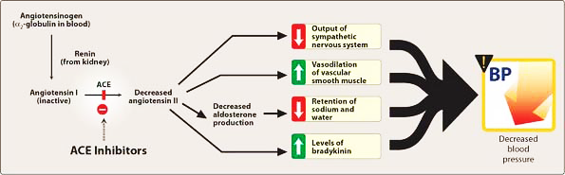

**Pharmacological actions:**

Benazepril, Captopril, Enalpril, Fosinopril, Lisinopril, Moexipril, Perindopril, Quinapril, Ramipril and Trandolapril.

The essential effect of these agents on the RAAS is to inhibit the conversion of the relatively inactive Ang І to the active Ang ІІ .

This action reduces Ang ІІ –mediated vasoconstriction and aldosterone secretion, and ultimately lowers BP

**Factors contributed to their antihypertensive effect**

1.An increase in bradykinin .

2.An increase in the activity of the 11β-hydroxysteroid dehydrogenase enzyme, which could increase the renal sodium excretion by protecting the nonselective MR from cortisol.

3.Blunting of the expected increase in SNS activity

4.Improvement in endothelial dysfunction

**Therapeutic uses:**

1. Treatment of hypertension.

2. With diuretics is considered the standard regimen for patients with systolic heart failure.

3. Reno- protective effect, through its protienuric-sparing action in type 2 diabetic hypertensive patients.

4.Reduce overall mortality in acute MI**.**

**Adverse effects:**

1. Dry cough, rash, fever, altered taste, hypotension, and Hyperkalemia.

2. Angioedema

3. Reversible renal failure can occur in patients with severe bilateral renal artery stenosis.

4. ACE inhibitors are fetotoxic and should not be used by women who are pregnant.

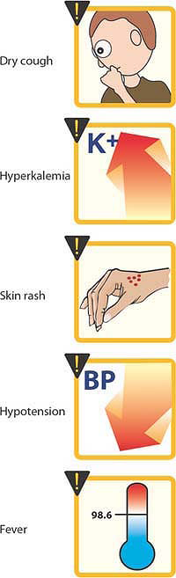

**Drug interactions:**

1.Antacids may reduce the bioavailability .

2.Potassium sparing diuretics and potassium supplements may exacerbate hyperkalemia.

3.ACE inhibitors may increase plasma level of digoxin and lithium.

4.NSAIDs may impair the hypotensive effects by blocking bradykinin –mediated vasodilatation.

**Angiotensin receptor blockers (ARBs):**

The effects of Ang ІІ are mediated via specific membrane-bound receptors.

Ang ІІ is known to interact with at least two distinct Ang ІІ receptor subtypes:

AT1 and AT2 receptors.

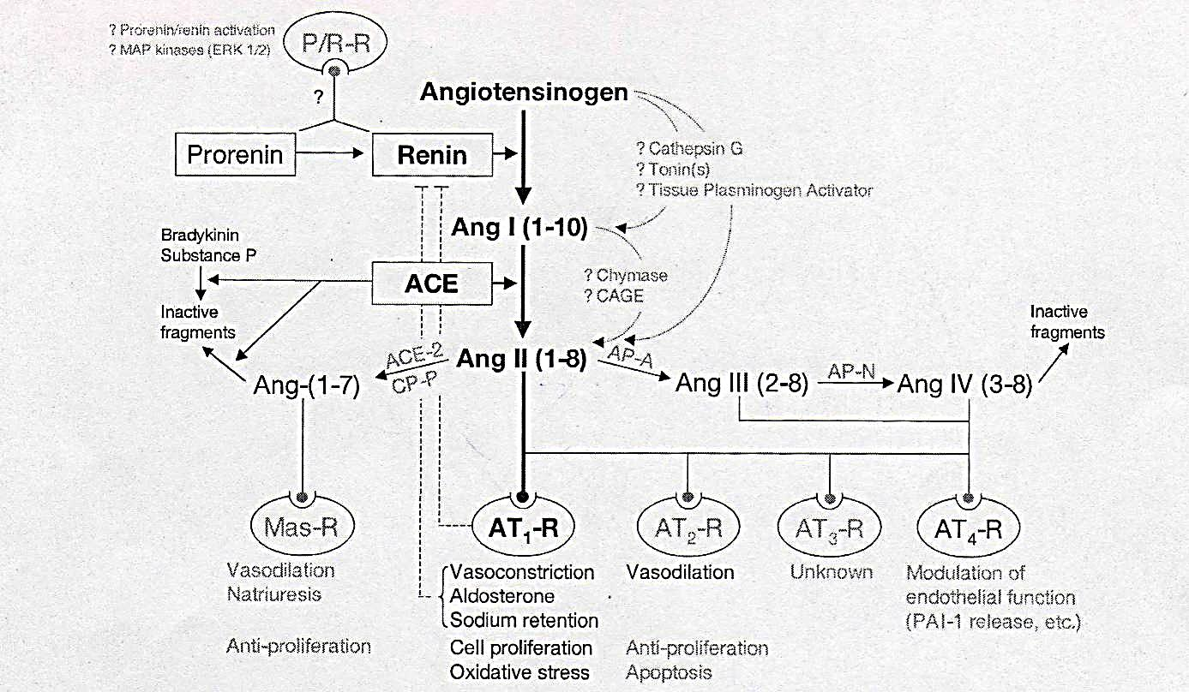

**Mechanism of action:**

Losartan, candesartan, irbesartan, valsartan, telmisartan, eprosartan

Specifically bind to Ang ІІ receptors in vascular smooth muscle, adrenal gland and other tissues, with more than 10000-fold selective for AT1 receptor than AT2 receptor .

Thereby, relaxing smooth muscle, increasing salt and water excretion, reducing plasma volume, and decreasing cellular hypertrophy.

**Therapeutic uses:**

1. ARBs are used in patients with mild to moderate hypertension

2. ARBs are as effective as ACEIs in reducing mortality in high risk post-MI survivors.

3. ARBs can reduce the combined morbidity and mortality in patients with systolic heart failure

4. ARBs can be used safely in portal hypertension treatment.

**Side effects:**

1. Common adverse effects

2.Angioneurotic edema is relatively rare . ARBs does not cause cough.

3. First dose hypotension and rebound hypertension on abrupt withdrawal have not been encountered.

**Drug interactions:**

1. Cimetidine increases the Cmax of ARBs (due to enhanced absorption)

2. Concomitant ingestion of excess potassium and potassium sparing diuretics, NSAIDs and ß-receptor antagonists may result in hyperkalemia.

**Renin Inhibitors:**

**Aliskiren**

Directly inhibits rennin and, thus, acts earlier in the RAAS than ACE inhibitors or ARBs.

It lowers blood pressure about as effectively as ARBs, ACE inhibitors, and thiazides.

It can also be combined other antihypertensive, such diuretics, ACE inhibitors, ARBs, or calcium-channel blockers.

**Adverse effects:**

1.Aliskiren can cause diarrhea, especially at the higher doses.

2.Aliskirencan also cause cough and angioedema but probably less often than ACE inhibitors.

3.The drug is contraindicated during pregnancy.

4. Hyperkalemia was significantly more common in patients who received both ARBs and aliskiren

**TREATING HYPERTENSION**

If the patient is young (age <55 years) or non-black, use either an **A**CE inhibitor (or **A**RB) (**A**).

For older patients start with either a **C**alcium channel blocker or thiazide **D**iuretic as first-line therapy (**C** or **D**).

If the blood pressure is not controlled at 4 weeks, a second agent should be added:

if the patient is on an **A**CE inhibitor add a **C**alcium channel blocker or thiazide **D**iuretic (**A+C** or **A+D**),

If blood pressure control is still inadequate on dual therapy, **A+C+D** is the ideal triple regimen.

If additional therapy is required, ɑ-blockade is effective at this stage Patients whose blood pressure remains substantially above target on triple therapy are likely to have aldosterone-sensitive hypertension that responds well to spironolactone

