**Lec. 3**

**Coll. Medicine \3rd stage**

**Parasitology**

**Assist. Prof. Dr. Amal KH. KH.**

**Other intestinal amoebae**

***Entamoeba coli:-***

Is usually the most common amoebic parasitic of man . Although it is a harmless in the lumen of the caecum and lower levels of the large intestine , its presence is concrete evidence that the host has ingested fecal material.

1. All typical life-cycle stages are found in *Entamoeba coli* *as*, trophozoite, precyst, cyst and metacystic stages.
2. The trophozoite is a sluggish , quite viscous protoplast . The pseudopodia are broad , short and do not typically extend any considerable distance from the main mass of protoplasm .nucleus with peripheral karyosome. Bacteria and other enteric microbes , which are seen within food vacuoles , constitute the food of *E. coli* . Trophozoites of *E. coli* and other amoeba are rarely seen in the stool except when it is frankly diarrheic .
3. The cyst is usually larger than that of *E. histolytica* . When first formed the cyst has a single nucleus but as it matures it passes through successive stages with 2 to 8 nuclei , occasionally reaching the extraordinary number of 16 to 32 or more . However, there are usually one or more dense masses of glycogen with foggy edges and sharp- ended chromatoidal splinters. There is no clinical indication for treatment since *Entamoeba coli* is harmless.

***Endolimax nana:-***

It is found in the lumen of the caecum and lower levels of the large intestine and produced no lesions, but like *E. coli* its presence indicates that polluted material has been ingested . As the species name *nana* (dwarf) suggests, this amoeba is small compared with *E. histolytica* .

1. The trophozoite has endoplasm that is finely granular with numerous minute vacuoles , so that it has a foggy appearance . In contrast, the ectoplasm, with one or more short finger- like pseudopodia when the organism displays activity , is hyaline and almost transparent . The nucleus is ovoidal or sub spherical . There is a relatively large karyosome , consisting of a mass of granules , commonly eccentric in position ,
2. In preparation for encystation *Endolimax nana* discards all undigested inclusions and consolidates into an ovoidal or sub spherical mass. A delicate cyst wall is then secreted . The mature cyst contains four nuclei . Masses of glycogen with a hazy margin may obscure the nuclei. Chromatoidal bodies , if present in the cytoplasm are coccoid or short curved rods.

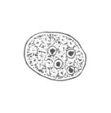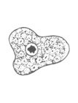

***Iodamoeba buetschlii:-***

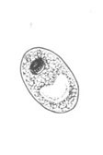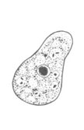

it is a harmless commensal living in the lumen of the large intestine .

1. The trophozoite is sluggish , with little evidence of pseudopodial extension and the thin layer of ectoplasm is not easily distinguished from the endoplasm except that the latter is denser and has a more viscous , granular composition . This trophozoite has a diameter of 8 to 20 microns . The nucleus is spherical , has a rather thick membrane , a karyosome which is central or somewhat eccentric in position and contains an inner chromatic granule surrounded by achromatic globules , all anchored to the nuclear membrane by radial filaments . Minute chromatin granules have also been described as lining the nuclear membrane. In addition to food- containing vacuoles this amoeba is unique in its trophozoite stage in having in its cytoplasm one or two distinct rounded masses of glycogen. When the organism encysts it discharges undigested material, becomes somewhat condensed and secretes a cyst wall.
2. The cyst is irregularly rounded and usually contains only one .The clearly outlined glycogen mass which stains a deep mahogany brown with iodine readily differentiates *Iodamoeba buetschlii* from the other intestinal amoeba.

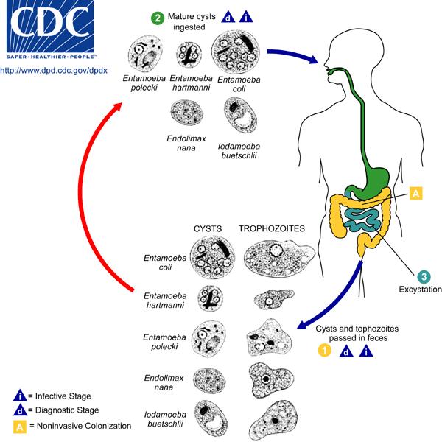

**Extra- intestinal amoebae**

***Entamoeba gingivalis:-***

It is a parasite of the mouth of man and is most commonly found as a phagocyte in diseased gums and tonsils. Only the trophozoite stage has been described; the only plausible method of transmission is through droplet spraying of saliva or during more intimate oral contact.

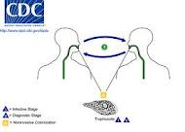  *E. gingivalis* is closely resembles *E. histolytica*, with a few to several finger-like pseudopodia, finely granular endoplasm and clear ectoplasm. the nucleus contains a small karyosome which is central or slightly eccentric in position and is surrounded by a thin halo .

**Facultative amoeba parasites**

***Naegleria fowleri***

This free living amoeba exist as either an amoeboid trophozoite , a biflagellate trophozoite, and a cyst . it multiplies in the amoeboid trophozoite form , the only form found in human being . the amoeboid trophozoite appears elongate. this form is actively motile , that this, it moves more than two body length per minute. The cytoplasm shows a pulsating vacuole . the nucleus is visible only in the stained preparation . it has a large central karyosome . this soil amoeba convert from amoeboid trophozoite to a biflagellate trophozoite when it reaches water . this non feeding , non dividing , biflagellate form helps the spread of *Naegleria fowleri*to fresh pools when it rains . the biflagellate form not multiply . it has convert back to amoeboid form for multiplication . a smooth walled cystic stage occurs only in the external environment . cysts never form in human body.

**Life cycle :**

 The entire life cycle of *Naegleria fowleri* completed in the external environment . excystation occur in favorable condition . the amoeboid trophozoite form multiply by binary fission . this form encyst under unfavorable condition . the biflagellate trophozoite form helped in the spread of *Naegleria fowleri* to new water bodies . human primarily contract this amoeba by swimming in contaminated water . the amoeboid form enter human body through nasal mucosa and often migrate to the brain , causing rapid tissue destruction . some infection result by inhaling dust contaminated with *Naegleria fowleri* cysts .

**Pathogenesis and clinical features :**

The disease is common in young adults and children . the parasite reach the brain through the cribriform plate, along the olfactory nerves after initial lodgment in the nose . the incubation period ranges from 2 to 15 days . the amoeboid trophozoite form multiplies in the gray matter of the brain . the patient has sever headache , cranial nerve palsies and signs of meningism . most patients die within a week . A few patients have survived after treatment with Amphotericin B and rifampicin .

***Naegleria fowleri*** and related organisms also cause humidifier fever , a form of allergic alveolitis resulting from inhaling air from air- coolers. . these amoeba grow in water of the air- coolers .

**Diagnosis :**

Wet mount preparation of CSF may appear the amoeboid trophozoite . fixed preparation stained with iron heamatoxilin will reveal the trophozoite along with their nuclear details .

***Acanthamoeba* sp**

There are seven species of *Acathameoba*  known to infect human . *Acathameoba* *culberttsoni*  is most common .

**Morphology :**

*Acathameoba* sp in two forms trophozoite and cyst. Both the forms occur in infected tissue . the nuclear characteristic of trophozoite are similar to that of *Naegleria fowleri* . they produce fine, tapering , hyaline pseudopodia called acanthopodia . motility is sluggish . A flagellate stage is absent and the cyst have double wall , the inner wall is smooth and the outer is wrinkled and and ragged . the cyst survive in dust for many years.

**Life cycle , pathology and clinical features :**

*Acanthameoba* occur in soil and water . trophozoite and cysts are infective to human beings. The infection is through contaminated traumatized skin or eyes and by inhalation . in primary infection the skin and lungs are involved . heamatophagous spread from these sites leads to involvement of the CNS producing granulomatous amoebic encephalitis (GAE) .patient with lymphoproliferative disease , lupus erythromatous , AIDS and those on glucococorticoids or chemotherapy are at an increased risk . GAE usually present as space – occupying lesion. Rarely, the cysts of *Acanthamoeba* rapidly transform into trophozoite in the nasal mucosa to reach brain through the cribriform plate along the olfactory nerve and may lead to meningoencephalitis .

*Acanthameoba* can produce keratitis . contact – lens users are at increase risk . risk factors include the use of home- made saline for clearing lenses , wearing lenses while swimming and inadequate disinfection . deeper corneal invasion with perforation and lose of vision may follow *Acanthameoba* keratitis.

**Diagnosis :**

examination of CSF for trophozoite may be helpful. The cyst of *Acanthameoba* are present in corneal scraping .

**Treatment :**

No satisfactory treatment is available for GAE . cases of *Acanthameoba* keratitis respond to a combination of neomycin drops, dibromopropamide ointment and propamide isethionate drops .

**Prevention :**

Prevention of CNS infection by *Acanthameoba* if difficult because the life cycle is poorly understood . removing contact-lenses and proper cleaning and disinfection of lenses prevent eye infection.



**Class (2) : The Flagellated Protozoa**

The flagellates are members of subphylum mastigophora and have the following characters:

1. they move with the help of flagellum or flagella .
2. reproduction is by binary fission .

**Flagellates of medical importance :**

Flagellata includes three basic group and classified according to their location in the body of the host :

**Intestinal species**

* *Giardia lamblia*
* *Trichomonas hominis*
* *Chilomastix mesnili*
* *Enteromonas hominis*
* *Retortamonas intestinalis*

**Oral and vaginal species .**

* *Trichomonas tenax*
* *Trichomonas*  *vaginalis*

**Blood species**

* *Leishmania donovani*
* *Leishmania tropica*
* *Leishmania brazielinses*
* *Trypanosoma cruzi*
* *Trypanosoma gambiense*
* *Trypanosoma rhodesience*

***Giardia lamblia***

The infection of *Giardia lamblia* is world wide and it is more common in children . *Giardia lamblia*, a protozoan flagellate, inhabits (duodenum and jejunum) of man. This protozoan is the only intestinal flagellate known to endemic and epidemic diarrhea in man.

**Morphology :**

*Giardia lamblia* has a trophozoite and cystic stage.

1. Trophozoite stage : It is pear-shaped with broad rounded anterior end and a tapering posterior end. Dorsal surface is convex while ventral surface is concave .A sucking disc, the organ of attachment because presence of Giardin protein, occupies one-third to one-half of the ventral surface. Trophozoite is bilaterally symmetrical and has two nuclei, **axostyle** and four pairs of flagella. Two **median bodies** are present on the axostyle at its origin.
2. ***Cyst*** : the oval cyst measuring 8-12μm in length and 7-10μm in breath . A thick wall surrounds it. The cyst consists of cytoplasm, which is finely granular and is separated from the cyst wall by a clear space. This gives an appearance of the cyst being surrounded by a halo. The mature cyst consists four nuclei, which may remain clustered at one end or are present in pairs at two opposite ends. Also it consists of an axostyle and margins of the sucking disc. The axostyle and the remains of flagellum is placed diagonally in the cyst. The four nuclei cyst is the infective stage of *G. lamblia.*.



**life cycle :**

The life cycle of *G. lamblia* is simple and is completed in a single host, the man .Cysts are resistant forms and are responsible for transmission of giardiasis. The cysts are hardy, can survive several months in cold water. Infection occurs by the ingestion of cysts in contaminated water, food, or by the fecal-oral route (hands or fomites). Cysts pass through the stomach and excyst to trophozoites in the duodenum within 30 minutes of ingestion, Excystation process is trigged by exposure of the cysts to pancreatic enzymes . In duodenum and jejunum, the trophozoite multiply asexually by binary fission thereby producing a large numbers of daughter trophozoites. Trophozoites browse on the mucosal surface, to which they are attached by an oval sucker. When the intestinal contents leave the jejunum and begin to lose moisture, the trophozoites retract their flagella, cover themselves with a thick wall and encyst. These encysted trophozoites undergo another phase of nuclear division and produce four nucleated mature cysts. The four nucleated mature cysts are the infective forms of the parasites, they are excreted in stool and the cycle is repeated. trophozoites may be present in stool of patient with diarrhea but they are not infective.

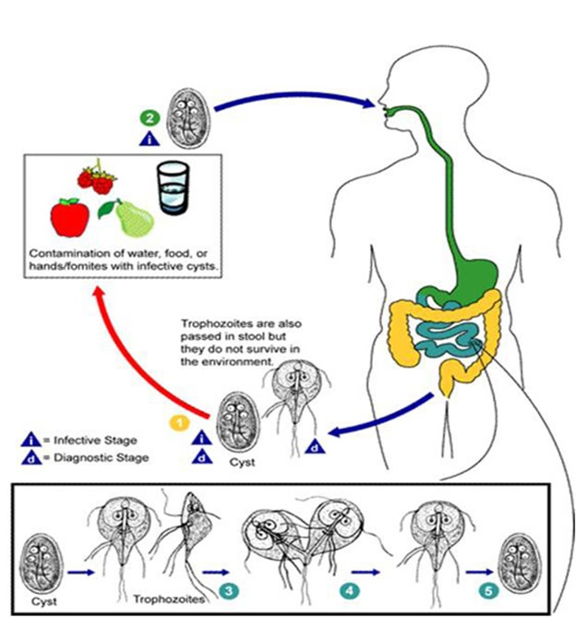

**Pathology and symptoms:-**

*Giardia lamblia* causes **Giadiasis (steatorroea or fatty diarrhea).** A great majority of persons harboring*Giardia lamblia* are asymptomatic but some have symptoms referable to the duodenum and a few to the gallbladder , in which the only plausible etiology is the infection with *Giardia* . Although this flagellate does not invade tissues , it causes intestinal malabsorption of fat and carbohydrates, steatorroea and weight loss by forming a tightly attached , pavement –like sheet of trophozoite over the mucosal surface . The most common symptoms in these cases are epigastric or right upper quadrant pain and persistent fatty diarrhea.

**Diagnosis , treatment and prevention:-**

The gold – standard diagnosis for *Giardia lamblia* is microscopic demonstration of the trophozoite , cyst or both in stool . in acute Giardiasis the trophozoite show the typical falling leaf motility in wet mount examination of stool . Trophozoites may also be obtained by duodenal aspiration.

In at least 90 % of cases the infection is eradicated following quinacrine (Atabrine) therapy . Metronidazole is nearly as effective and is somewhat better tolerated . The adult dose is 250 mg .t.i.d. for 5 to 10 days.

Infection with *Giardia lamblia* is prevented by not eating or drinking contaminated food and water , respectively . Adequate cooking of contaminated food and boiling or filtering contaminated water , prevent infection.