**Endocrine system Dr.Razzaq L1**

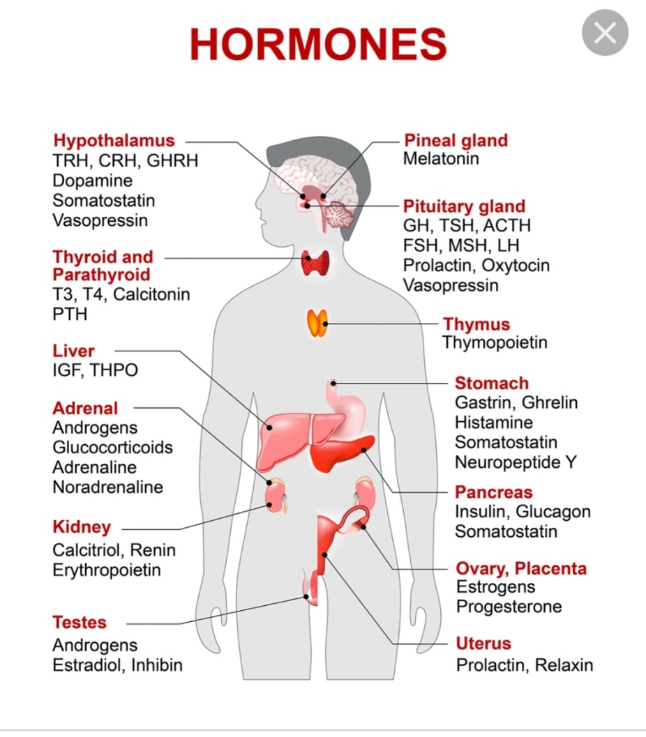

**Hormones of hypothalamus and pituitary**

**The pituitary gland receive signals from hypothalamus & respond by sending pituitary hormones to target glands which produce hormones that provide negative feedback at level of hypothalamus and pituitary**

|  |  |  |  |
| --- | --- | --- | --- |
| **Hormones** | **Location** | **s\I(stimulate .inhibit)** | **Function** |
| **ACTH** | Ant. pituitary | S | Production of glucocorticoid **MC.**miniralocorticoid.  androgen |
| **ADH** | Post. Pituitary | S | Water reabsorption from renal tubules |
| **CRH**. corticotropin releasing hor. | Hypothalamus | S | Secretion of ACTH |
| **FSH** (female) | Ant. Pituitary | I | Secretion of estrogen from ovary |
| **FSH** (male) | Ant. Pit | S | Production of sperm from testes |
| **GnRH** | Hypothalamus | S | Secretion of LH &FSH |
| **LH(female )** | Ant. Pit | S | Ovulation and development of corpus luteum |
| **LH(male )** | Ant. Pit | S | Production and secretion of testosterone |
| **Oxytocin** | Post. Pit | S | Contraction of uterus at birth &release of milk from breast |
| **TSH** | Ant. Pit | S | Secretion of T3.T4 |
| **PRL prolactin** | Post. Pit | S | Promotion of milk synthesis |
| **Somatostatin** | Hypothalamus | I | Secretion of GH&TSH |
| **TRH( thyrotropin releasing hormone)** | Hypothalamus | S | Secretion of TSH & prolactin |

**Growth hormone deficiency &insensitivity (hypopituitarism )**

**Hypopituitarism : denotes underproduction of GH growth hormone alone or in combination with deficiency of other pituitary hormones .**



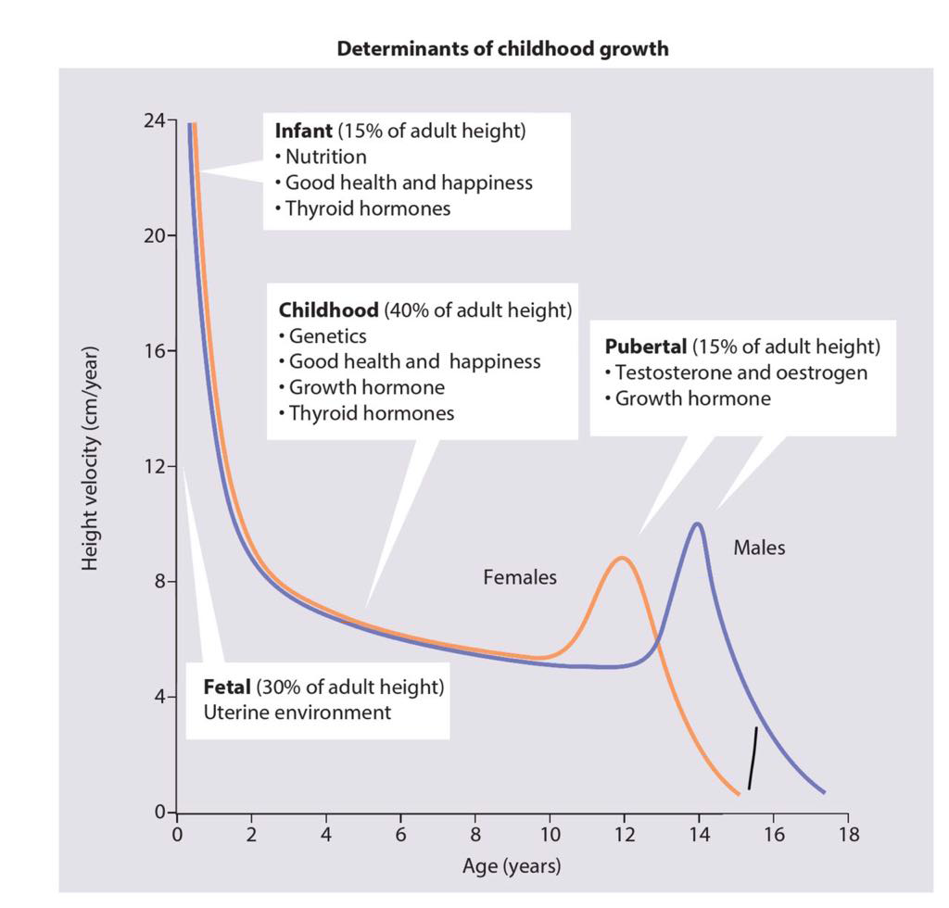

**Congenital hypopituitarism growth hormone defciency )**

* **Clinical features :**
* **The child usually normal size and weight at birth .may have neonatal emergencies like apnea .seizures .jaundice, cyanosis or Sever hypoglycemia with or without seizures prolonged neonatal jaundice is common .nystagmus may suggest septooptic dysplasia . micropenis in boys can be clue for GH def.**

**Physical exam:**

* **head is round & face is short & broad ,prominent frontal bones eyes somewhat are bulging .mandible and chin are underdeveloped ,delayed teeth eruption and often crowded , short neck and small larynx , high pitch voice which remain high after puberty**

**Evaluation of suspected growth hor. Def.**

|  |  |
| --- | --- |
| Growth related history &physical exam | * Growth failure * Short stature * GHD affect 1in 3500 child |
| Image & other evaluation | * Clinical diagnosis * Bone age ( delayed ) * MRI,CT evaluate hypothamic pituitary region |
| Lab . finding | * Measures GH with stimulation , IGF-1 test |
| Rationale for treatment | * Replacement with GHTshould be started as soon as GHD is diagnosis |

**Diagnosis :**

**determined by low or absent level of GH in response to stimulation with insulin , arginine clonidine ,or glucagon to establish low level of GH <10 ng\ml and also necessary to evaluate others pituitary hormones deficiency like ACTH, TSH cortisol ,gonadotropin .**

**Treatment**

**recombinant hGH available since 1982 usually given in a dose 0.18-0.3 mg/kg/wk during childhood and higher dose needed during puberty. Therapy should continued until near final height is achieved and treatment discontinued if he or she tall enough or growth rate < I inch /year and bone age >14 yr in girls &>16 years in boys**

**Indication of GH therapy :**

**1-GHD 6-Prader willi syndrome**

**2-Turner syndrome 7-SHOX gene abnormality**

**( short stature homebox)**

**8-Noonan syndrome**

**3-Chronic renal failure 5-Small for gestational age**

**4-Idiopathic short stature**

* **Adverse effect of GH therapy .include**
* **pseudotumor cerbri .gynecomastia ,slipped capital femoral epiphysis & worsening scoliosis**

**Growth hormone insensitivity (*LARON syndrome)***

* **autosomal recessive disease.**
* **Is a condition that occur when the body unable to utilize GH , and characterized by short stature ,hypoglycemia ,near normal at birth ,delayed puberty & short limbs (arms &legs) with obesity .other signs include small genitals ,thin fragile hair those people have low risk of cancer and type II diabetes .**

**Diagnosis :**

* **S&S , GH usually high and reduced level of IGF1 & genetic study to show abnormality in GH gene**
* **Treatment : no current cure for Laron syndrome & only available treatment is subcutaneously injection of IGF1 (mecasermin)(Iplex)**
* **Prognosis :generally good d not affect life span**

**Constitutional Growth delay**

* **: one of the variant of normal growth . length & weight normal at birth , growth is normal for the first 4-12 months , height sustained at low percentile during childhood .**
* **., the pubertal growth spurt delayed and eventual normal stature , normal bone age . GH response to provocative test tend to be lower than in children with a more typical timing of puberty . the prognosis of those children to achieve normal adult height is guarded**

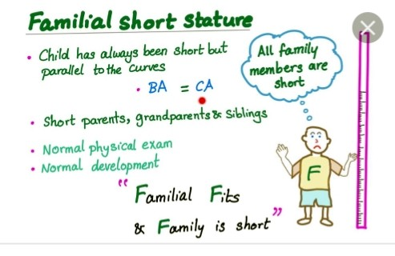

**HYPERPITUITARISM ( TALL STATURE )**

* **Either primary or secondary**
* **Table showed differential diagnosis of tall stature & overgrowth syndromes**
* **FETAL OVERGROWTH :**
* **Maternal DM**
* **cerebral gigantisim (Sotos syndrome)**
* **Beckwith Wiedemann**
* **Postnatal overgrowth leading to childhood tall stature**

1. **Nonendocrine causes** 
   * **Familial (constitutional tall stature )**
   * **Exogenous obesity**
   * **Cerebral gigantism sotos syndrome**
   * **Marfan synd.**
   * **Bekwith wiedmann synd.**
   * **Klinfelter syndrome**
   * **Homocystinuria**
2. **Endocrine cause** 
   * **Excess GH secretion**
   * **Precocious puberty**
   * **Hyperthyroidism**
   * **Mc Cune –Albright syndrome**



**Postnatal overgrowth leading to adult tall stature**

* + **Familial**
  + **Marfan**
  + **Klinfelter**
  + **Excess GH**
  + **XXY**
  + **ACTH or cortisol deficiency**

**Test question**

* + **Regarding Growth hormone** 
    - **A - hypopitiutarism mean deficiency of all pituitary mormones**
    - **B- growth hormone deficient child usually small at birth**
    - **C- high pitch voice of GH deficient child usually corrected after puberty**
    - **D—treatment with GH usually stopped after 15 yr of age**
    - **E—laron syndrome have low risk of cancer**