**Biochemistry**

**2nd stage**

**Dr.Lamees Majid Al-Janabi**

**OXIDATION OF THE FATTY ACIDS**

Fatty acids stored in adipose tissue, in the form of neutral TAG, serve as the body's major fuel storage reserve. TAGs provide concentrated stores of metabolic energy because they are highly reduced and largely anhydrous.

The entry of long chain fatty acids to the cell is mediated by fatty acid binding proteins. The fatty acids must be converted into active intermediates by a reaction with ATP before they can undergo any further metabolism. Long-chain fatty acids are required for energy production during the fasting state.

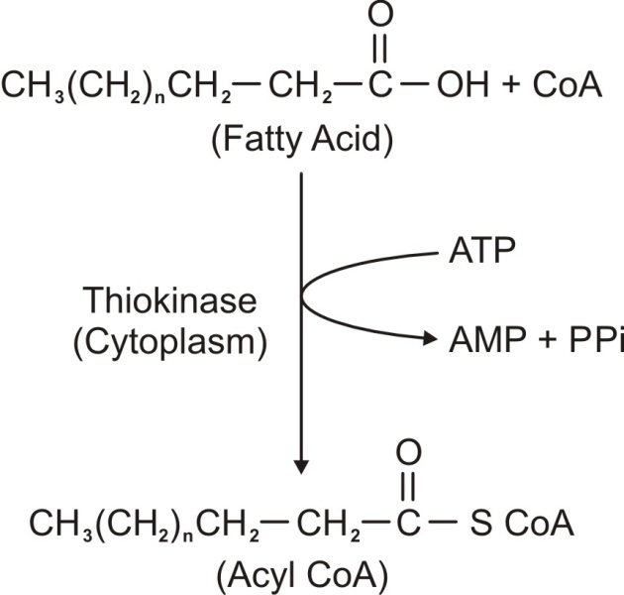

This is the only step in the fatty acid oxidation that requires ATP and it is irreversible step because the PPi is hydrolyzed by the pyrophosphatase enzyme to yield two inorganic phosphates.



The subsequent steps in the oxidation of the fatty acids occur in the mitochondrial matrix. Since the mitochondrial membrane is impermeable to acyl-CoA, therefore a special mechanism is required for the transport of acyl-CoA from the cytoplasm to the mitochondrial matrix. This mechanism involves a compound called ***Carnitine*,** and the process is known as ***carnitine shuttle*.**

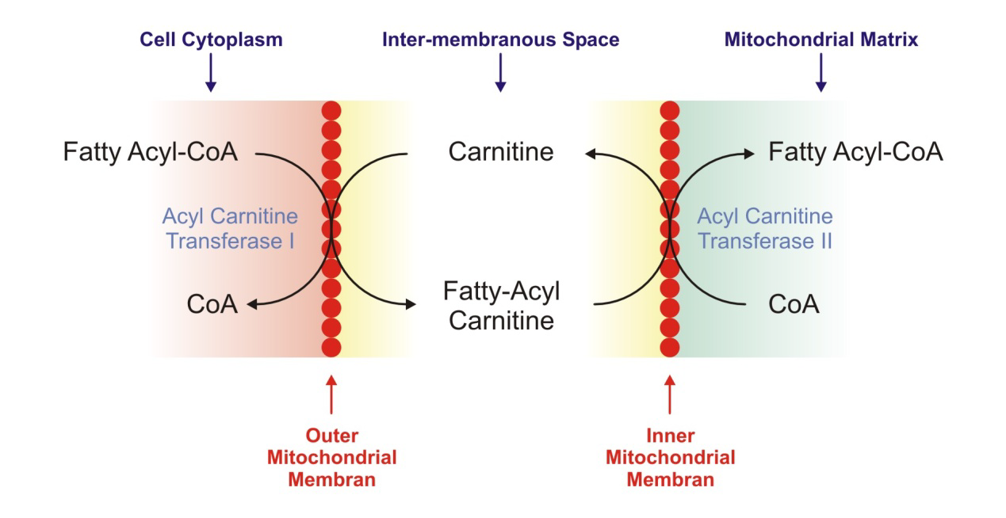

Medium chain fatty acids (shorter than 12 carbon atoms) can cross the mitochondrial membrane without the aid of carnitine, and even its entry to the cell does not require fatty acid binding proteins .

Carnitine could be obtained either from the diet (meat and meat products) or by being synthesized inside the body (from amino acids lysine and methionine) through an enzymatic system found in the liver and the kidneys.

**The deficiency** **of carnitine** occurs due to many reasons :

-Could be congenital

-Could occur in newborn babies (especially pre-mature) and this is due to immaturity of the enzymatic system which will lead to inadequate synthesis of carnitine.

-Malnutrition and those on strictly vegetarian diet

-Liver disease (because it is a main site for the synthesis).

-Increased requirement to carnitine

*Pregnancy.

*Severe Infection.

*Severe Burns.

*Trauma.

*Hemodialysis.

The effect of carnitine deficiency is decrease in the ability of oxidizing long chain fatty acids and this may lead to weight loss, fatty liver, and hypoglycemia.

**Beta oxidation pathway**

The oxidation of the fatty acid will take place on the β carbon atom, so in each oxidation for (n carbon atoms) fatty acyl CoA the product is acetyl CoA (two carbon atoms) and (n-2) fatty acyl CoA, and it will also produce one FADH2 and one NADH.

The new fatty acyl CoA will undergo the same reaction again and againuntil all the carbon atoms are converted into acetyl-CoA.

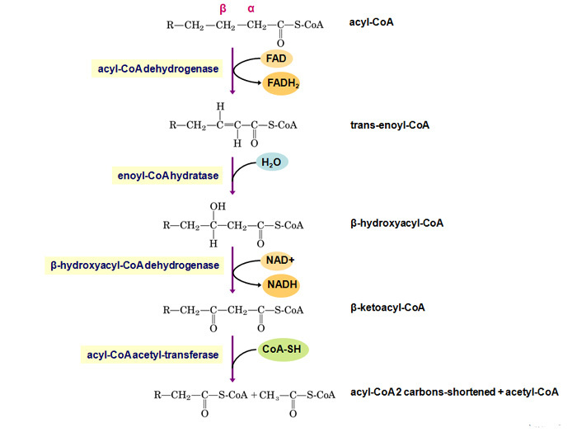

The FADH2 and NADH formed from oxidation of the fatty acid that has even number of carbon atoms equal :

( The number of Carbon atoms / 2 ) – 1

ex. Palmatic acid(16C)→ 8 acetyl CoA+ 7 FADH2+ 7NADH

**Oxidation of the Fatty Acids with Odd Number of C atoms**:

The β oxidation of the fatty acid chains that have odd number of carbon atoms will use the same reaction steps until the final three carbon acids are reached and they are called here propionyl-CoA. The propionyl-CoA will be converted into methyl-malonyl-CoA by a step that requires the use of one ATP. Then the methyl-malonyl-CoA will be converted into the final product which is the succinyl-CoA.

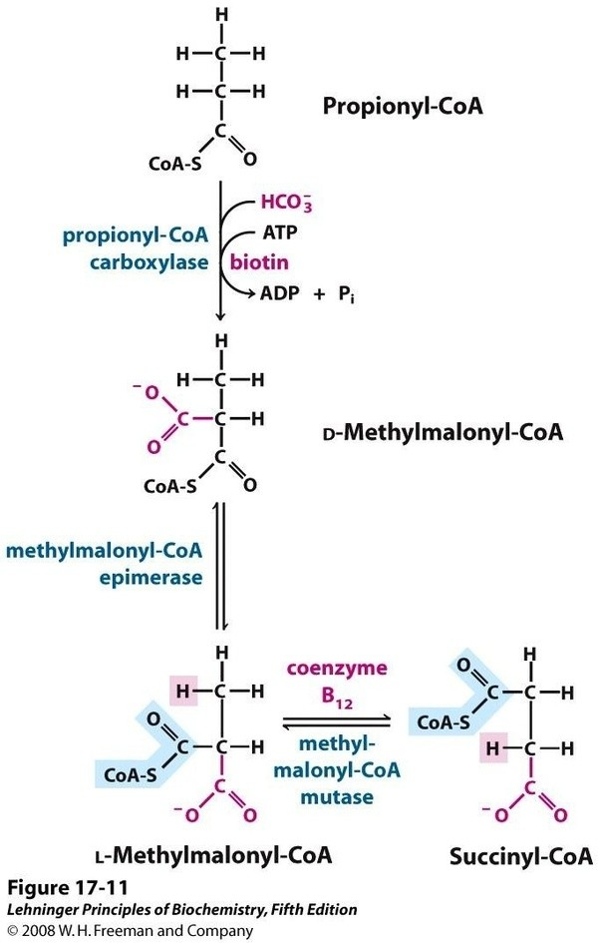

**OXIDATION OF UNSATURATED FATTY ACIDS:**

Undergo the same sequence of reaction as saturated fatty acid until we reach to the double bond between carbon 3 & 4.Usually the configuration around the double bond is cis. In the saturated fatty acid we make a double bond between C2 & C3 but in the unsaturated fatty acid the last double bond is found between C3 & C4 so we will transfer the double bond to put it between the C2 & C3 by the enzyme **Enoyl CoA isomerase**. This enzyme transfer the double bond and change the configuration from cis to trans.

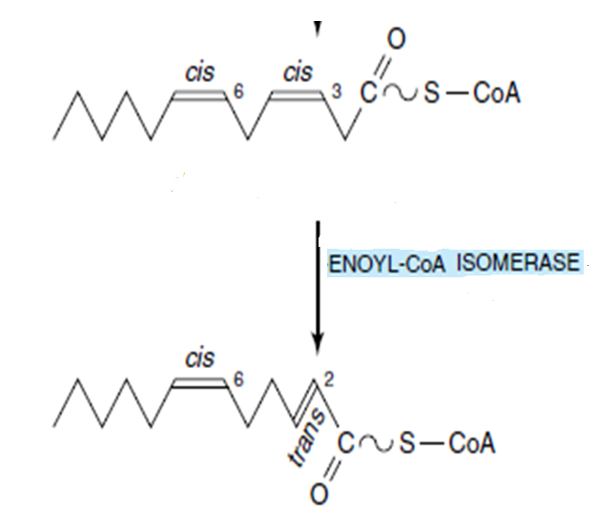

After the transforming of the double bond to C2-C3 position now the fatty acid will undergo the same reaction of β oxidation but it will not pass in the first step that yield the FADH2.{so the oxidation of unsaturated fatty acid with 16 carbon atom will give only 6 FADH2 and not 7 FADH2). So removal of acetyl CoA in this step will produce only 3ATP not 5ATP.

**PROBLEMS**

**Q.1.**  saturated fatty acid contain 16 carbon atom {palmatic acid} how many the ATP produced after the oxidation of it ?

Answer: by β oxidation pathway it will give:

7 FADH2 and each FADH2 will give 2 ATP (so 7*2=14 ATP).

7 NADH2 and each NADH2 will give 3ATP (so 7*3=21 ATP).

8 acetyl CoA and each one will enter the citric acid cycle and give 12 ATP (so 8*12=96 ATP).

14+21+96= 131 ATP.

But we need 2ATP IN THIOKINASE REACTION thus the no. Of ATP 131-2= 129 ATP produced from palmatic acid

**Q.2.** unsaturatedfatty acid contain 16 carbon atom how many the ATP produced after the oxidation of it?   
Answer: by β oxidation

6 FADH2 (so 6*2= 12 ATP).

7 NADH2 (so 7*3=21 ATP).

8 Acetyl CoA (so 8*12=96 ATP).

12+21+96=129 ATP.

129-2= 127 ATP.

**Q.3.**  saturated fatty acid contain 17 carbon atom how many the ATP produced after the oxidation of it?

7 FADH2 ( 7x2=14 ATP).

7 NADH2 ( 7x3= 21 ATP).

7 Acetyl CoA ( 7x12= 84 ATP).

14+21+84= 119 ATP.

119-2 = 117 ATP.

5 ATP from succinyl-CoA

117+ 5= 122 ATP

**Q.4.** unsaturated fatty acid contain 17 carbon atom how many ATP produced after its oxidation ?

6 FADH2 (6x2=12 ATP).

7 NADH2 (7x3=21 ATP).

7 Acetyl CoA (7x12=84 ATP).

12+21+84= 117 ATP.

117-2= 115 ATP.

5 ATP from succinyl-CoA

115+ 5= 120 ATP