**بسم الله الرحمن الرحيم**

**Lecture 2- Neurophysiology Dr. Noor Jawad**

**2nd stage Monday 18 / 1/ 2021**

**……………………………………………………………………**

**Cortical areas**

**Objectives :**

***1. what are cortical areas?***

***2. what are the areas for language comprehension, word formation?***

The cortex is commonly described as comprising three parts: sensory, motor, and association areas.

**Sensory areas**

The sensory areas are the [cortical areas](https://en.wikipedia.org/wiki/Cortical_area) that receive and process information from the [senses](https://en.wikipedia.org/wiki/Senses). Parts of the cortex that receive sensory inputs from the [thalamus](https://en.wikipedia.org/wiki/Thalamus) are called primary sensory areas. The senses of vision, audition, and touch are served by the primary [visual cortex](https://en.wikipedia.org/wiki/Visual_cortex), primary [auditory cortex](https://en.wikipedia.org/wiki/Auditory_cortex) and primary [somatosensory cortex](https://en.wikipedia.org/wiki/Somatosensory_cortex) respectively.

In general, the two hemispheres receive information from the opposite (contralateral) side of the [body](https://en.wikipedia.org/wiki/Human_body). For example, the right primary somatosensory cortex receives information from the left limbs, and the right visual cortex receives information from the left visual [field](https://en.wikipedia.org/wiki/Receptive_field). The organization of sensory maps in the cortex reflects that of the corresponding sensing organ, in what is known as a [topographic map](https://en.wikipedia.org/wiki/Topographic_map_(Neuroanatomy)).

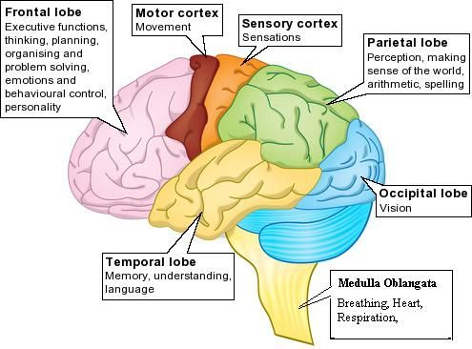

**Motor areas**

The motor areas are located in both hemispheres of the cortex. The motor areas are very closely related to the control of voluntary movements, especially fine fragmented movements performed by the hand. The right half of the motor area controls the left side of the body, and vice versa. The motor cortex can be divided into three areas:

1. The [primary motor cortex](https://en.wikipedia.org/wiki/Primary_motor_cortex) is the main contributor to generating neural impulses that pass down to the spinal cord and control the execution of movement. However, some of the other motor areas in the brain also play a role in this function. It is located on the anterior paracentral lobule on the medial surface.

2. The [premotor cortex](https://en.wikipedia.org/wiki/Premotor_cortex) is responsible for some aspects of motor control, possibly including the preparation for movement, the sensory guidance of movement, the spatial guidance of reaching, or the direct control of some movements with an emphasis on control of proximal and trunk muscles of the body. Located anterior to the primary motor cortex.

3. The [supplementary motor area](https://en.wikipedia.org/wiki/Supplementary_motor_area) (or SMA), has many proposed functions including the internally generated planning of movement, the planning of sequences of movement, and the coordination of the two sides of the body such as in bi-manual coordination. Located on the midline surface of the hemisphere anterior to the primary motor cortex.

* 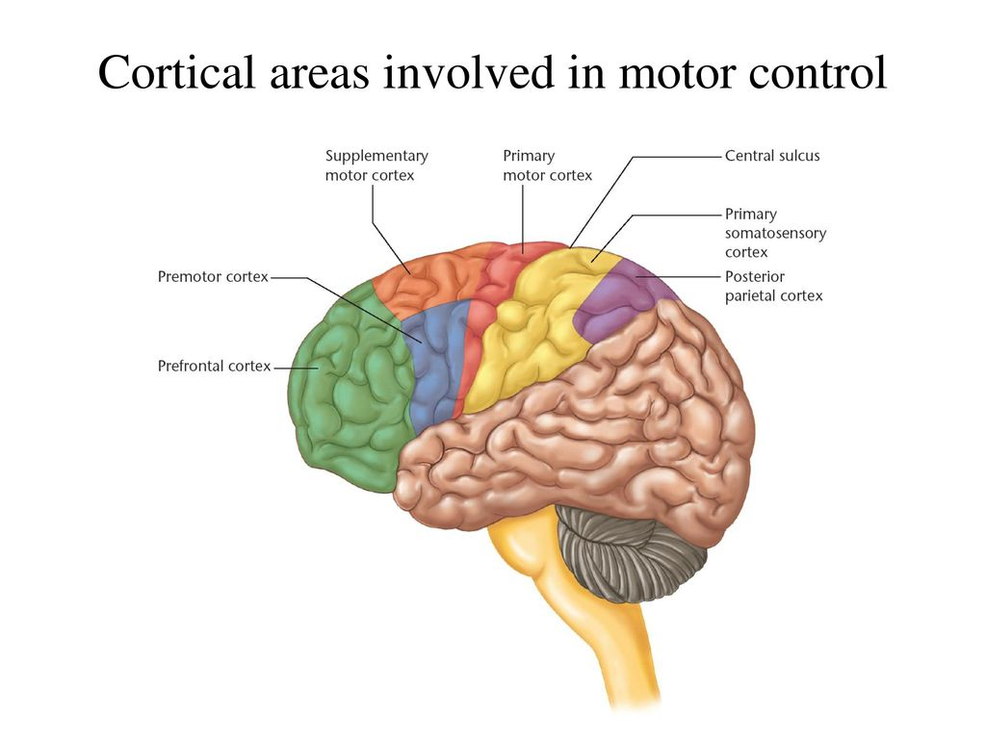

**Association areas**

The association areas are the parts of the cerebral cortex that do not belong to the primary regions. They function to produce a meaningful [perceptual experience](https://en.wikipedia.org/wiki/Perception) of the world, enable us to interact effectively, and support abstract thinking and language. The [parietal](https://en.wikipedia.org/wiki/Parietal_lobe), [temporal](https://en.wikipedia.org/wiki/Temporal_lobe), and [occipital lobes](https://en.wikipedia.org/wiki/Occipital_lobe) - all located in the posterior part of the cortex - integrate sensory information and information stored in memory. The [frontal lobe](https://en.wikipedia.org/wiki/Frontal_lobe) or prefrontal association complex is involved in planning actions and movement, as well as abstract thought.

Globally, the association areas are organized as distributed networks. Each network connects areas distributed across widely spaced regions of the cortex. Distinct networks are positioned adjacent to one another yielding a complex series of interwoven networks. Cortical association areas include:

1. **Parieto- occipito temporal Association Area**
2. **Prefrontal Association Area**
3. **Limbic Association Area**

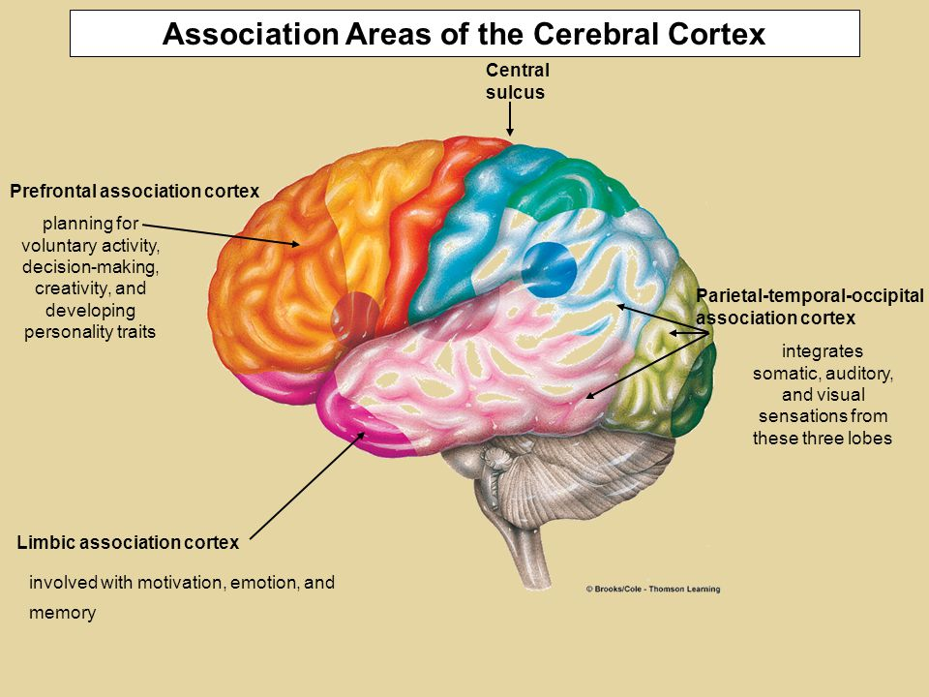

**1. Parieto-occipitotemporal Association Area**

The parieto-occipitotemporal association area lies in the large parietal and occipital cortical space bounded by the somatosensory cortex anteriorly, the visual cortex posteriorly, and the auditory cortex laterally. As would be expected, it provides a high level of interpretative meaning for signals from all the surrounding sensory areas.

Wernicke’s Area Is Important for Language Comprehension. The major area for language comprehension, called *Wernicke’s area,* lies behind the primary auditory cortex in the posterior part of the superior gyrus of the temporal lobe.

The Angular Gyrus Area

Is Needed for Initial Processing of Visual Language (Reading). Posterior to the language comprehension area, lying mainly in the anterolateral region of the occipital lobe, is a visual asso­ciation area that feeds visual information conveyed by words read from a book into Wernicke’s area, the lan­guage comprehension area. This so-called *angular gyrus area* is needed to make meaning out of the visually per­ceived words. In its absence, a person can still have excel­lent language comprehension through hearing but not through reading.

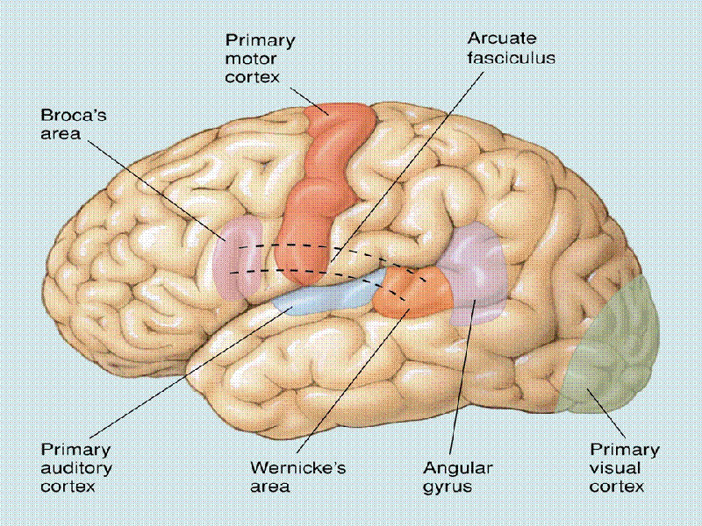

Area for Naming Objects.

In the most lateral portions of the anterior occipital lobe and posterior temporal lobe is an area for naming objects. The names are learned mainly through auditory input, whereas the physical natures of the objects are learned mainly through visual input. In turn, the names are essential for both auditory and visual language comprehension.

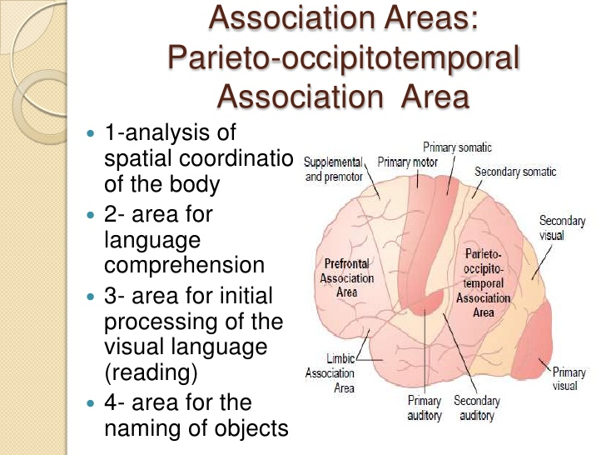

**2. Prefrontal Association Area**

Prefrontal association area functions in close association with the motor cortex to *plan complex patterns and sequences of motor move­ments*. To aid in this function, it receives strong input through a massive subcortical bundle of nerve fibers connecting the parieto-occipitotemporal association area with the prefrontal association area.

Through this bundle, the prefrontal cortex receives much preanalyzed sensory information, especially information on the spatial coordi­nates of the body that is necessary for planning effective movements. Much of the output from the prefrontal area into the motor control system passes through the caudate portion of the basal ganglia–thalamic feedback circuit for motor planning, which provides many of the sequential and parallel components of movement stimulation.

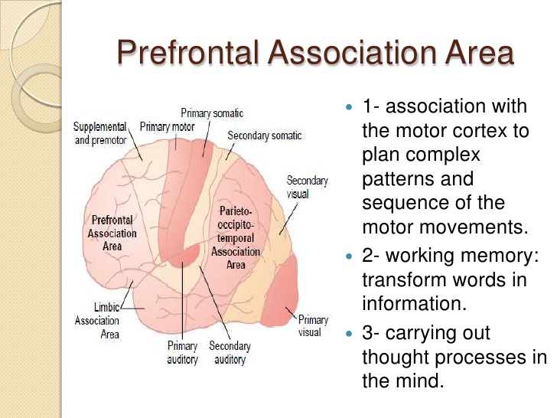

The prefrontal association area is also essential to car­rying out *“thought” processes.* This characteristic presum­ably results from some of the same capabilities of the prefrontal cortex that allow it to plan motor activities. It seems to be capable of processing nonmotor and motor information from widespread areas of the brain and therefore to achieve nonmotor types of thinking, as well as motor types. In fact, the prefrontal association area is frequently described simply as important for elaboration of thoughts, and it is said to store on a short-term basis *“working memories”* that are used to combine new thoughts while they are entering the brain.

**Broca’s Area Provides the Neural Circuitry for Word Formation**

*Broca’s area*, is located partly in the posterior lateral prefrontal cortex and partly in the premotor area. It is here that plans and motor patterns for expressing individual words or even short phrases are initiated and executed. This area also works in close association with the Wernicke language comprehension center in the temporal association cortex.

**3. Limbic Association Area**

This area is found in the anterior pole of the temporal lobe, in the ventral portion of the frontal lobe, and in the cingulate gyrus lying deep in the longitudinal fissure on the midsurface of each cerebral hemisphere. It is concerned primarily with *behavior, emotions,* and *motivation.* This limbic system provides most of the emotional drives for activating other areas of the brain and even provides motivational drive for the process of learning itself.

***Thank you***

***References : Guyton and Hall textbook of medical physiology, thirteen edition***