**Biochemistry**

**2nd stage**

**Dr.Lamees Majid Al-Janabi**

**The oxidative deamination of amino acids**

**Glutamate dehydrogenase**

Oxidative deamination by glutamate dehydrogenase results in the liberation of the amino group as free ammonia . These reactions occur primarily in the liver and kidney. They provide α-keto acids that can enter the central pathway of energy metabolism, and ammonia, which is a source of nitrogen in urea synthesis.

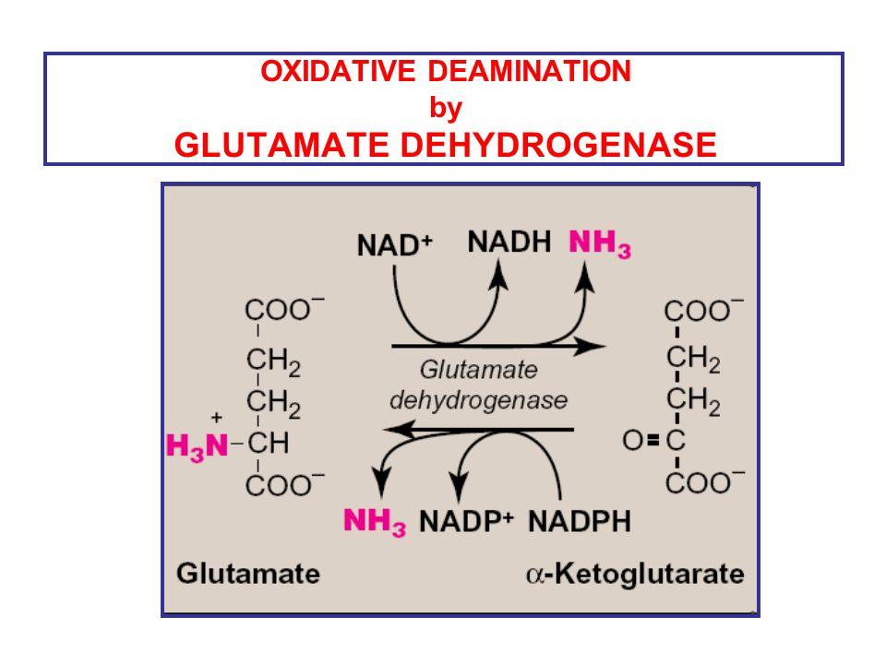

The reverse reaction can function to provide glutamate from alpha ketoglutarate . The glutamate can then be utilized for the biosynthesis of a.as from the corresponding ketoacids by transamination reaction

**Nonoxidative deamination**

Certain a.a ex. serine , threonine, & cysteine are deaminated by specific lyases that require pyridoxal phosphate .

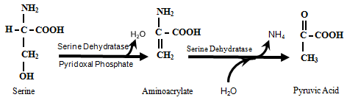

**Transport of ammonia to the liver**

Two mechanisms are available in humans for the transport of ammonia from the peripheral tissues to the liver for its ultimate conversion to urea.

1. found in most tissues, uses glutamine synthetase to combine ammonia with glutamate to form glutamine—a nontoxic transport form of ammonia . The glutamine is transported in the blood to the liver where it is cleaved by glutaminase to produce glutamate and free ammonia .

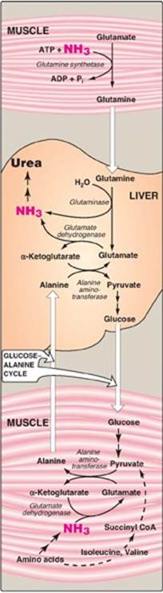

1. The second transport mechanism, used primarily by muscle, involves transamination of pyruvate (the end product of aerobic glycolysis) to form alanine . Alanine is transported by the blood to the liver, where it is converted to pyruvate, again by transamination. In the liver, the pathway of gluconeogenesis can use the pyruvate to synthesize glucose, which can enter the blood and be used by muscle—a pathway called the glucose-alanine cycle.

